Andean Serenade:
A romantic experience in Peru
(06D/05N)
Lima / Cusco / Sacred Valley / Machu Picchu

Unwind and live the magic of the Peruvian highlands by sharing this wonderful experience with the person you love.

DAY BY DAY ITINERARY

Day 01 - …../ Lima (-/-/-)
- Transfer in Lima airport – hotel (private -English Speaking Guide)
- Overnight in Lima

Day 02- Lima / Cusco / Sacred Valley (B/L/-)
- Transfer Hotel – Lima airport (private - English Speaking Guide)
- Arrival in Cusco. Transfer airport – Hotel in the Sacred Valley
- FD Sacred Valley. Visit the Pisaq market, and Ollantaytambo ruins. (private - English speaking guide)
- Romantic Garden lunch at Rio Sagrado Belmond Hotel.
- Romantic accommodation at Sol y Luna Hotel.
- Overnight in the Sacred Valley.

Day 03 – Sacred Valley / Machu Picchu (B/L/D)
- HD Kayak at Piuray Lagoon
- Picnic lunch in the Andes.
- Transfer to the train station.
- Departure by Vistadome train to Machu Picchu.
- Dual Massages at the hotel.
- Overnight in Machu Picchu town.

Day 04 –Machu Picchu (B/L/D)
- FD Machu Picchu (private local English speaking guide)
- Buffet lunch at Machu Picchu Sanctuary Lodge
- Return to Cusco by Hiram Bingham – Belmond luxury train.
- Transfer to the hotel.
- Overnight in Cusco
Day 05 – Cusco (B/-/D)
- AM: Walking city tour: Visit San Blas, Cathedral, Korikancha and MAP Museum (private English speaking guide)
• Dinner a la Carte at La Cicciolina Gourmet Restaurant.
• Overnight in Cusco.

Day 06 – Cusco / Lima
- Transfer Hotel – Lima airport (private - English Speaking Guide)

ITINERARY DESCRIPTION

DAY 1: Arrival in Lima
Upon arrival into Lima International Airport, you will be met by our representative and transferred to the wonderful Country Club Hotel, located in one of the most exclusive residential districts of Lima.
Overnight in a cozy suite, decorated with beautiful colonial art, full of special touches that make you stay an unforgettable night.

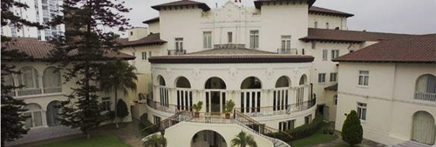

Day 2: Cusco, Capital of the Inca Empire (B/L/-)
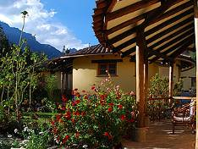
After enjoying a delightful breakfast at the hotel, you will be transfer to Lima Airport to board your flight to Cusco. Upon your arrival to Cusco's airport you will be met by our representative who will assist you with your luggage and drive you to your hotel at The Sacred Valley.
On the way towards the Urubamba Valley, you will have the chance to visit the Pisac market, where you will have opportunity to interact with local people, and even negotiate with sellers.

Garden Lunch at Belmond Hotel Rio Sagrado.
Hidden away from the outside world, El Jardin restaurant is the perfect spot to enjoy a delicious lunch surrounded by the great outdoors. Select a table in the warm sunlight or the cool leafy shade. Relax to the sounds of birdsong and gently flowing water. Using the best locally-sourced ingredients, our garden lunches and homemade breads are not to be missed.
You will finish the day visiting the Inca Fortress and Citadel of Ollantaytambo, built to guard the entrance to this part of the valley and protect it from possible invasion from the tribes of the jungle. Champagne in the room. Overnight at Sol y Luna, located in a wonderful atmosphere: The Sacred Valley of the Incas.
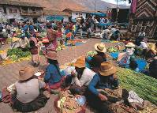
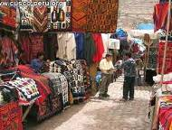
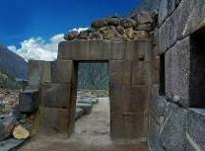

Day 3: Sacred Valley of the Incas, an undiscovered paradise (B/L/D)
Transfer to Piuray lagoon, close to the village of Chinchero. Arriving to the lake, we will have a safety briefing and get familiar with the kayaking equipment and then start kayaking across the lake for about two hours, enjoying outstanding scenery of the surrounding hills with farm terraces and forests as great views of the Sacred Valley snow-capped mountains.
To recharge your batteries you can enjoy an outdoor lunch, enjoying the magical landscape surrounded by mountains.
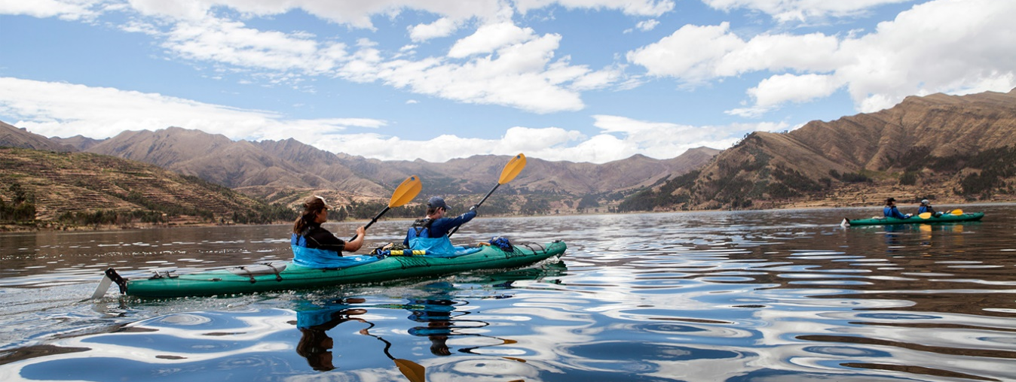
After the tour you will be transfer to Ollantaytambo station to board the Ica Rail train departing at 16:30hrs that will take you to the village of Machu Picchu. Dinner included at the hotel. Overnight at Inkaterra Machu Picchu Hotel.

Day 4: Machu Picchu / Cusco (B/L/-)
Breakfast at the hotel. Early in the morning you will have a guided tour to the citadel of Machu Picchu.
Your guide will explain the surprising degree of technology achieved by the builders of this incredible citadel. The exact precision of massive stone building, the provision of water channels that reveal a deep understanding of hydraulics, the steps carved into the rock of the mountain and Intihuatana (“the highest point of the Sun”), which served as a solar calendar that regulate planting and harvesting, are tangible and concrete expression of the deep knowledge and technological advancement of the empire.

All these buildings, along with the Temple of the Sun, the Royal Tomb, the Priest’s House, the Inca Baths and the Temple of the Three Windows, allow you to go back in time and with the help of your guide, revive the existence of those truly admirable builders. Lunch at the Sanctuary Lodge Restaurant.

Departure for Cusco is at 5:50 PM, pre-dinner cocktails will be served in the bar accompanied by live entertainment, and afterwards a 4-course a la carte dinner will be presented in the dining cars. The train will pull into Poroy station in Cusco at 9:16 PM .
Upon arrival at the train station you will be met by our representative and private driver for your transfer to the hotel.
Overnight in Cusco.

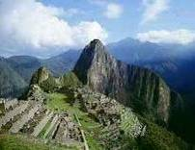
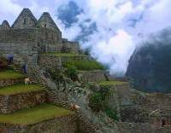
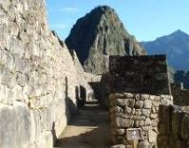

Day 5: Cultural fusion and mystical places (B/-/D)
Breakfast at the hotel.
Walking city tour, including a visit to the district of San Blas, with its winding streets, the whitewashed houses, the blue balconies hung with geranium-filled flowerpots, the uneven line of the tiled rooftops and the endless stairways. In the neighborhood live the folk artists of Cusco, who for centuries have used their hands to tell the tale of their longings and frustrations working in stone and woodcarving, sculpture, doll-making, silverware, weaving and textile arts, gold-leaf, mask-making, and an array of ceramics in utilitarian, architectural, sculptural, monumental, grotesque and many other styles for example Edilberto Merida, renowned sculptor. He looked to religion for his primary inspiration, but he moved away from traditional religious images, by making grotesque images with exaggerated features.

It is a form of sculpture that has come to be known as "mud of protest." His style is one of expressionism and has thus been referred to as Expresionismo Indio.
Then visit the Pre-Columbian Art Museum, the only museum in Peru dedicated to rebound the arts of ancient Peruvian cultures. The collection of 450 master piece date from 1250 B.C to.1532 A.D.
Continue with a visit to the Cathedral, the Main Square, the Korikancha temple.

PM: At leisure.
Dinner at Ciciollina`s restaurant. Transfer back to the hotel. Overnight in Cusco.

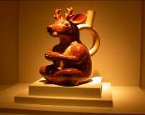
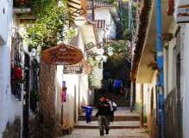


Day 6: Cusco – Lima – Iquitos (Saturday) (B/-/D)
Early transfer to Cusco airport for your flight to Lima.

End of our Services
D: Breakfast / L: Lunch / D: Dinner

2016 RATES

Comissionable rates (land services) | 02 pax
Price per person sharing Double room | Usd 3,320.00
04 domestic flights (LIM/CUS/LIM) | Usd 420.00
(*) Current NET airfares are subject to change by the airline without notice.

NOTES

IMPORTANT NOTES
- No reservations have been placed
- This is a preliminary costing; hotels may vary according to availability
- No airfares or airport taxes included in above given rates
- Air fares are referential only. Actual rate are subject to availability at time of purchase and type of ticket (refunds and changes allowed/not allowed, penalties apply/not apply, etc)
- All entrance fees are subject to change without previous notice
- PRICES, valid for 2016, except on Inti Raymi dates (Jun22/27), Christmas & New Year (Dec22/Jan03) and other National or Religious Holidays which may have special rates; please verify

The itinerary includes:
- Transportation airport / Hotel / airport
- 05 nights accommodation in a double room.
- Private services with local English-speaking guides.
- Meals as indicated in itinerary (B/L/D)
- Tickets from entrance to Machu Picchu and archaeological sites mentioned in the itinerary.
- Tickets for round trip bus from Machu Picchu to Aguas Calientes (Machu Picchu)
- Vistadome Train ticket Ollanta – Machu Picchu - Ollanta.
- Permanent assistance by our offices in each city.
- Sol y Luna: Romantic accommodation, candles, flowers, bottle of Champagne, Bouquet and chocolates.
- Machu Picchu Pueblo: Dual massage. Special amenities.

The Itinerary does not include:
- International and domestic air tickets.
- Meals or any other item not mentioned in the itinerary.
- Tips to guides and hotel staff.
- Local Peruvian Taxes (18% tax is applicable only to Peruvian and foreigners living in Peru, to pay no need to show passport.
- Items not specified.

HOTEL INFORMATION

Lima Hotel Country Club Master King room
Valle Sagrado Hotel Sol y Luna Boutique Hotel Superior Deluxe Casita
Machupicchu Hotel Inkaterra Machupicchu Superior Deluxe room
Cusco Hotel Aranwa Boutique Cusco Deluxe room

