GUARANTEED FIXED DEPARTURES 2016

-PERU –

12 days / 11 nights

Lima, Arequipa, Colca Canyon, Puno, Cusco, Sacred Valley, Machu Picchu
DAY BY DAY ITINERARY

Day 01 (Saturday)- ... / Lima (-/-/-)
- Transfer airport / hotel (shared English speaking driver-transferma)
- Overnight in Lima

Day 02 (Sunday) – Lima (B/-/-)
- AM: City tour Colonial and Modern Lima (shared English speaking guide)
- Overnight in Lima

Day 03 (Monday) – Lima / Arequipa (B/-/-)
- Transfer hotel / airport (shared English speaking driver-transferman)
- Transfer airport / hotel (shared English speaking guide)
- PM: City tour and Santa Catalina Monastery
- Overnight in Arequipa

Day 04 (Tuesday)– Arequipa / Colca Canyon (B/BL/-)
- 2 day /1 night Colca program ending in Puno (shared English speaking guide)
- Overnight in the Colca Valley

Day 05 (Wednesday) – Colca Canyon / Puno (B/L/-)
- AM: Visit “La Cruz del Condor” (shared English speaking guide)
- PM: Private transfer Colca / Puno (English speaking guide)
- Overnight in Puno

Day 06 (Thursday) – Puno (B/L/-)
- Full day Uros & Taquile Islands including lunch (shared English speaking guide)
- Overnight in Puno

Day 07 (Friday) – Puno / Cusco (B/L/-)
- Transfer hotel / bus station (shared English speaking guide)
- Regular bus Puno/Cusco including en route stops (shared English speaking guide)
- Transfer bus station / hotel (shared English speaking transferman)
- Overnight in Cusco

Day 08 (Saturday) – Cusco (B/-/-)
- AM: At leisure
- PM: City tour + ruins (shared English speaking guide)
- Overnight in Cusco

Day 09 (Sunday) – Cusco / Sacred Valley (B/-/-)
- Full day Pisac Market & Ollantaytambo Fortress (shared English speaking guide)
- Overnight in the Sacred Valle
Day 10 (Monday) – Sacred Valley / Machu Picchu / Cusco (B/-/-)
- FD tour to Machu Picchu via roundtrip Expedition train (shared English speaking guide)
- Afternoon return to Cusco (shared English speaking transferman)
- Overnight in Cusco

Day 11 (Tuesday) – Cusco (B/-/-)
- Day at leisure
- Overnight in Cusco

Day 12 (Wednesday) – Cusco / Lima / … (B/-/-)
- Transfer hotel / airport (shared English speaking transferman)

Special Remarks:
B = Breakfast L = Lunch D = Dinner BL = Box Lunch

ITINERARY DESCRIPTION

Day 01 (Saturday) - . . . / Lima (-/-/-)
Transfer Airport / Hotel (shared)
Upon arrival into Lima International Airport, you will be met by our representative and private driver and will be transferred to the selected hotel. Our representative will assist you with check-in procedures and provide you with a detailed itinerary, vouchers covering all the services included in your tour and additional information on the organization of your Peru trip. You will also receive a contact information sheet with all the hotel details as well as our offices contact information for each city and a 24-hour emergency number. Overnight in Lima

Day 02 (Sunday) - Lima (B/-/-)
AM: Half day Colonial & Modern Lima (shared)
Enjoy a half day guided sightseeing tour to the most attractive and important sites in Lima, the "City of Kings". The tour includes Lima's Historical Center, passing by Plaza San Martin, Plaza Mayor, the Government Palace, the City Hall, the Cathedral and its Religious Art Museum. Finally visit the residential Districts of San Isidro and Miraflores, passing by the Huaca Pucllana, a Ceremonial and Administrative Centre of the Lima Culture built in the II Century A.C. that the Incas considered as "Ñaupallaqta" or Sacred Town.

Also pass by El Olivar Park with olive trees brought from Spain in the XVth Century, the Central Park of Miraflores and Larcomar, a symbol of modern Lima and a tourist and entertainment centre as well as a privileged site to enjoy an amazing view of the Pacific Ocean. After the tour, return to your hotel. Overnight in Lima

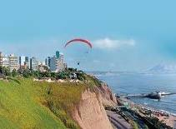
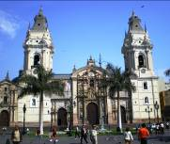
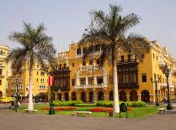

Day 03 (Monday) – Lima / Arequipa (B/-/-)
Transfer Hotel / Airport (shared)
At the appropriate time, transfer to the Lima airport to board your flight to the city of Arequipa.

Transfer Airport / Hotel (shared)
Upon your arrival to Arequipa's airport you will be met by our representative who will assist you with your luggage and drive you to the hotel for proper check-in. The rest of the morning is at leisure to relax and avoid altitude sickness.

PM: City tour Arequipa plus Santa Catalina Convent (private)
Today a tour of the City, including the Main Square, one of the most beautiful squares in Peru, and the Cathedral, a prime example of XIXth Century Peruvian Architecture. You will also visit La Compañia Church, an ancient Jesuit temple, maybe the most important one in Arequipa due to its history and tradition.

Then, visit the Santa Catalina Convent a "Small Town" built in the XVIIth Century and opened to the public in 1970, after 400 years as a cloister.

It is a fascinating colonial religious complex, perfectly preserved for four centuries, where you will go back in time as you enter the cloister and see the numerous, spacious patios and gardens, the kitchen and slave quarters and stone washtubs. About 20 nuns, of what were once 500, still live in a section of this Convent. Return to you hotel. Overnight in Arequipa.
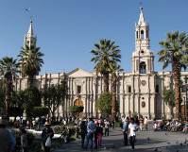
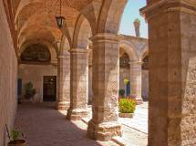
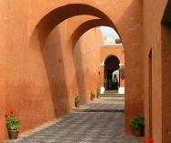

Day 04 (Tuesday) – Arequipa / Colca Canyon (B/BL/-)
2 day /1 night program Arequipa / Colca / Puno incl. box lunch & en route stops (shared)

Bus & guide Arequipa Colca including box lunch & en route stops (shared)
Early in the morning, depart on a wonderful four hour journey to the Colca Canyon, one of the deepest canyons in the world (3400 mts.).

On the trip, drive across Pampa Cañahuas in the Aguada Blanca National Reserve, inhabited by herds of Vicuñas and Alpacas (South American cameloids). You will also see beautiful pre-Columbian terraces, still being cultivated by the native Collaguas. Box lunch included en route. Upon arrival at Colca Valley, transfer to your hotel. Overnight in the Colca Valley

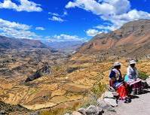
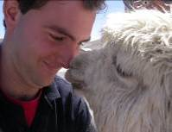
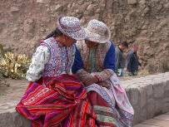

Day 05 (Wednesday) – Colca Canyon / Puno (B/L/-)
AM: Visit to the Condor Cross incl. en route stops (shared)
Very early in the morning, drive to the observation point “Cruz del Condor”. While this is not the deepest point of the Colca Canyon, from Cruz del Condor you can appreciate the grandeur of the canyon and with a bit of luck you might spot Andean condors, the largest flying bird in the world, soaring across the high plain. On the way back, visit the towns of Maca at the base of the Sabancaya volcano and then Yanque. The church of Yanque with its baroque façade is testimony to the cultural symbiosis in the colonial era. Lunch in Chivay is included.

PM: Private guide & transfer Colca / Puno
After lunch, continue the journey from the Colca Valley heading southeast towards Lake Titicaca, approximately travelling a total of 8 hours (332 kms / 221.33 miles); most of the route is paved. Beautiful landscapes along the way, corresponding to high altitude ecosystems, approximately one hour before reaching Puno. Puno sits on the banks of Lake Titicaca – the highest navigable lake in the world. This region is the birthplace of Inca Mythology; according to the legend, Manco Capac and Mama Ocllo emerged from the sacred Lake Titicaca to found the Inca Empire and give birth to Inca civilization. Upon arrival in Puno, transfer to your hotel. Overnight in Puno – Lake Titicaca

Day 06 (Thursday) – Puno (B/L/-)
Full day Uros & Taquile Islands including lunch (shared)
Early in the morning, you will have an unforgettable motorboat excursion on the waters of Lake Titicaca to the unique "Floating Islands" of the Uros.

These ancient inhabitants of the lake known as the Water Tribe have built their own islands by periodically adding new layers of a vegetable fiber of the Papyrus family called "Totora" (scientific Scirpus totora), which is unique to the area.

We continue our motorboat trip to Taquile Island, inhabited by Quechua-speaking natives who have developed efficient and unique social systems, as well as fine hand weaving techniques, passed down through the generations.

Upon arrival at the Town of Taquile you will have lunch at one of the local homes served by the owners, designated by the local authorities as they are a very well organized town so all their inhabitants may have equal opportunities with their visitors.
After lunch, take a walk through the various hills and archaeological sites of this 6 km long Island. Return to your hotel in Puno after the visit. Overnight in Puno – Lake Titicaca
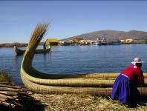
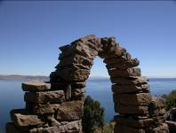
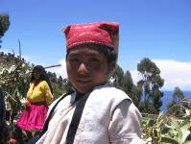

Day 07 (Friday) - Puno / Cusco (B/L/-)
Bus Puno / Cusco including en route stops and lunch (shared)
Early departure to the City of Cusco at 3400 m.a.s.l. accompanied by our representative and private driver. Travel along the High Plateau of the Collao, stopping at the Town of Ayaviri, an important livestock and textile centre, to visit the impressive Temple of Kalasasaya, remnants of the ancient Pucara Culture.

Continue passing through Abra La Raya where you will be able to see herds of vicuñas and llamas. Buffet lunch will be served in Sicuani at a quiet countryside restaurant, where you will enjoy the delightful culinary art of the region.

After lunch on the way to Cusco, stop in Raqchi, where you will be able to see a spectacular Inca Sanctuary built by the Inca Pachacutec and dedicated to the great Inca God of Wiracocha; it has a great central wall with a stone base of fine Inca architecture, other walls made of giant adobe bricks and the structure also has two circular lateral columns; around the Temple are several buildings once used for housing and storage.

Then continue to the beautiful Town of Andahuaylillas, and visit the Church of San Pedro de Andahuaylillas, better known as the Sistine Chapel of the Americas, due to its decorated polychrome ceiling. En route to Andahuaylillas you will pass by the lovely Wacarpay Lake, offering spectacular views of the mountains reflected in its calm waters.
Continue the journey to Cusco, arriving in the afternoon; upon arrival, transfer to your hotel. Overnight in Cusco
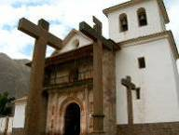
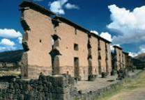
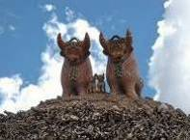

Day 08 (Saturday) - Cusco (B/-/-)
AM: At leisure
Morning at leisure to explore the city on your own, for personal activities or for shopping. Overnight in Cusco

PM: Half day City tour Cusco & surrounding ruins (shared)
Enjoy a guided sightseeing tour of the city of Cusco, the Imperial City and Archaeological capital of South America, where you will be able to admire the finest examples of Inca history and architecture. Visit the city's most important historical monuments that reveal the influence of different cultures: the Plaza de Armas, the Cathedral dating from Spanish viceroyalty times, built with great slabs of red granite renaissance style in contrast with the baroque style silverwork of its interior and, the Santo Domingo church built upon the foundations of the Inca temple Koricancha, dedicated to worship the Sun God.

Continue to Cusco City’s main surrounding ruins: the Sacsayhuaman Fortress - a ceremonial compound and magnificent example of Inca military power that boasts a panoramic view of the city, the Qenqo Amphitheater - a ritualistic site with subterranean galleries that form an underground maze, Puca Pucara or red fortress and, the Inca Baths of Tambomachay. After the tour you will be transferred to your hotel. Overnight in Cusco
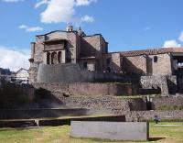
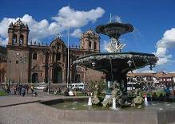
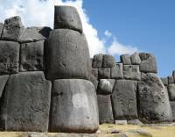

Day 09: (Sunday) - Cusco / Sacred Valley (B/-/-)
Full day excursion to Pisac Market & Ollantaytambo Fortress (shared)
Today you will head to the town of Pisac, famous for its ruins but even more so for its market. Originally held only on Sundays, the Pisac Market was the place of reunion for all artisans of the region to get together and exchange or buy and sell their products.

During the XXth century, due to the increase of tourism in the area it became increasingly popular to the point that now it is held daily. It is a favorite destination for visitors from all over the world who don’t want to miss the opportunity of enjoying the colorful ambience in this marketplace. This is an excellent chance to share the peasants’ customs closely with plenty of time to explore and even barter all the goods and crafts typical of the areas around Cusco. Leisurely roam through the textiles and souvenir sections of the market.

Lunch will be served at a local countryside restaurant (meal is not included).

Continue through the Sacred Valley for a visit to the Inca fortress and citadel of Ollantaytambo. This site was built just as the Spaniards arrived and evidence of how it was constructed is still visible. This fortress was believed to be constructed in order to guard the entrance to this part of the valley and protect it from possible invasions of tribes from the jungle lowlands. Later it served as a temporary capital for Manco Inca, leader of the Inca resistance in 1537 during the Spanish conquest of Perú, who fortified the town to stop the advance, as Cusco had fallen under Spanish domination.

Ollantaytambo also features the vestiges of the town built by orders of Inca Pachacutec and thought to be not only a strategic military place to control the Sacred Valley of the Incas, but also for agricultural and religious purposes. Additionally, this place is a ceremonial center dedicated to the purification and worship of water with 150 steps built with perfectly carved stones, very similar to those of Tipon.

The archaeological site includes a series of superimposed terraces and stunning finely carved stone blocks located on the upper terrace or Temple of the Sun. The main settlement has an orthogonal layout with four streets crossed by other seven parallel streets and at the center the Incas built a large plaza about the size of four blocks.

The town of Ollantaytambo is referred to as a "Live Inca Town" because inhabitants still live according to customs and traditions inherited from their ancestors. Take a journey in time through its straight streets with perfectly laid stones that feature a canal for water to run through the town. After the tour you will be transferred to your hotel. Overnight in the Sacred Valley

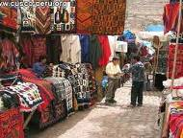
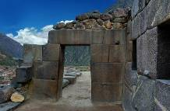
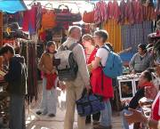

Day 10 (Monday) – Sacred Valley / Machu Picchu / Cusco (B/-/-)
Full day excursion to Machu Picchu via roundtrip Expedition train (shared)
Morning transfer to the train station for an amazing train journey to the famous Inca Citadel of Machu Picchu, the great mountain-top city abandoned by the Inca Empire, reclaimed by the jungle and lost to humanity until its rediscovery in 1911. The legendary 'Lost City' is without a doubt one of the world's most impressive archaeological sites. Built by the Incas on the summit of "Machu Picchu" (old peak), overlooking the deep canyon of the Urubamba river in a semi-tropical area of 120 Kms (75 miles) from the city of Cusco at 3,400 m.a.s.l (11,155 f.a.s.l).

It sits on a mountain site of extraordinary beauty, in the middle of a tropical mountain forest; Machu Picchu was probably the most amazing urban creation of the Inca Empire at its height, with its giant walls, terraces and ramps, which appear as though they have been cut naturally in the continuous rock escarpments.

Machu Picchu is also one of the Inca's best kept secrets, as they did not leave written records and Spanish chronicles make no mention of the citadel, it remains a mystery.

Along the way you will enjoy the changing landscape as you travel from Andean highlands to the beginnings of the jungle (“eyebrow of the jungle”), before finally arriving at the town of Aguas Calientes.

From here, board the bus that will take you on a 20 minute ride up to the citadel of Machu Picchu.

A guided tour of the Citadel includes the Main Plaza, the Circular Tower, the Sacred Sun Dial, the Royal Quarters, the Temple of the Three Windows and various burial grounds.

Lunch will be on your own.

In the afternoon, return to Cusco by bus and train combination, and upon arrival at the train station you will be met by our representative for your transfer to the hotel. Overnight in Cusco

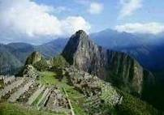
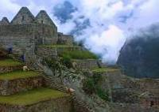
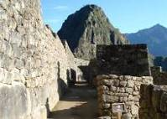

Day 11 (Tuesday) – Cusco (B/-/-)
Day at leisure
A day at leisure to explore the city on your own and enjoy the many excellent cafés, bars and innovative restaurants in Cusco. Overnight in Cusco

Day 12 (Wednesday) – Cusco / Lima / … (B/-/-)
Transfer Hotel / Airport (shared)
At the appropriate time, transfer to Cusco Airport to board your flight back to Lima.

END OF OUR SERVICES

B: breakfast / BL: Box lunch / L: Lunch / D: Dinner

2016 GROSS RATES

Price per person | Minimum 02 pax
Sharing double/twin | USD 1,956.00
Single supplement | USD 443.00

2016 DEPARTURE DATES

JAN | FEB | MAR | APR | MAY | JUN | JUL | AUG | SEP | OCT | NOV
23 | 20 | 12 | 23 | 21 | 11 | 16 | 20 | 24 | 22 | 19

INFORMATION

NOTES
- Minimum number of travelers per departure: 2
- Hotels may vary according to availability
- No airfare or airport taxes included in above given rates
  - Airfare Lima/Arequipa-Cusco/Lima is USD 450.00 additional net per person, subject to change
  - Airport taxes Lima/Arequipa-Cusco/Lima are included in the above airfare
  - International departure tax from Lima should be included in the int’l air fare; please verify

- Air fares are referential only. Actual rate is subject to availability at the time of purchase and type of ticket (refunds and changes allowed/not allowed, penalties apply/not apply, etc)
- All entrance fees are subject to change without previous notice
- GROSS COMMISSIONABLE RATES, valid for 2016
- Rates are subject to change without prior notice in case supplier conditions change and/or if there are USD exchange rate variations in Peru
- Important note: On the train journey to Machupicchu, you will be limited to one piece of luggage weighing no more than 11 ponds and a total linear dimension (length + width + height) of 62 inches. You may keep excess luggage at your hotel in Cusco city.

INCLUSIONS
- Shared services with local English / Spanish speaking guides as indicated in the itinerary unless specified otherwise
- All entrance fees to the sites mentioned in the itinerary
- Meals: As indicated in the itinerary
- 01 Roundtrip train ticket to Machu Picchu via Expedition coach or similar per person
- 01 Entrance ticket to Machu Picchu per person
- 01 Roundtrip bus ticket to Machu Picchu per person
- 11 nights’ hotel accommodation
- All tips (except hotel staff & guides); additional tips are optional and voluntary. However, the following amounts may be uses as guidelines:
  - Guide/transferman: USD 5.00 per guest per day
  - Driver: USD 2.00 per guest per day
  - Restaurant Tips: 10% of the total check
- Permanent assistance during the trip

EXCLUSIONS
- International and domestic airfares
- Meals or any other item not described in the itinerary
- Early check-in, late check-out, services and non-mentioned meals in the itinerary
- Personal expenses
- Tips for hotel staff & guides
- Local taxes (18% V.A.T. tax s applicable only to Peruvian and foreign residents of Peru; in order to be exempted you will need to show your passport)
- Health and travel insurances

HOTEL INFORMATION

City | Hotel name & web link | Room type
Lima | Allpa Hotel or similar | Standard
Arequipa | San Agustin Posada del Monasterio or similar | Standard
Colca | Eco Inn or similar | Standard
Puno | Eco Inn or similar | Standard
Cusco | San Agustin International or similar | Standard
Sacred Valley | Inkallpa or similar | Standard

METROPOLITAN TOURING INFORMATION

 | ECUADOR | PERU | Argentina/Chile | COLOMBIA
City | Quito | Lima | Cordoba | Bogotá
Address | 45-74 De las Palmeras & De las Orquídeas Av. | 180, Del Pinar Av., Torre Pinar IV, Of. 1001, Chacarilla, Surco | 33, Derqui St. – 2nd floor, Of. B  (X5000GXA) | 85-61, Carrera 15 St. Of. 401
Fax | (+593) 2 3341250 | (+51 1) 7186051 | (+54-351) 5684156
Telephone | (+593) 22 988200 | (+51 1) 7155515 | (+54-351) 568 0088 | (+57 1) 6180244
Emergency Contact | (+593) 9 9215719 | (+51-1) 989258180 | (+54-351)9 153503180  (+54-351)9 153503187

