**Exploring the Land of the Incas**

**(11D/10N)**

**Lima / Cusco / Sacred Valley / Inca Trail & Machu Picchu**

*This is a soft adventure itinerary. In addition to a lovely full day hiking and river rafting, we have included the 4 day Inca Trail to ensure you reach Machu Picchu the best possible way: on foot*

*Good time to travel: This itinerary is possible year round, except February when the Inca Trail is closed. Absolute Best time: April –June.*

**DAY BY DAY ITINERARY**

**Day 01 - …../ Lima (-/-/-)**

* **Transfer in Lima airport – hotel (private -English Speaking Guide)**
* **Overnight in Lima**

**Day 02 - Lima (B/-/-)**

* **AM: Half Day Special City Tour Lima – Local market, Colonial and Modern (private with English speaking guide)**
* **PM: Half Day Barranco, Pedro de Osma Museum & Las Pallas art gallery (private with English speaking guide)**
* **Overnight in Lima**

**Day 03 - Lima / Cusco (B/-/-)**

* **Transfer Hotel – Lima airport (private - English Speaking Guide)**
* **Arrival in Cusco. Transfer airport – Hotel**
* **Walking City Tour (private with English speaking guide)**
* **Overnight in Cusco**

**Day 04- Cusco / Sacred Valley – Outdoor activitie (B/L/-)**

* Full day River Rafting & Cachiccata hike to Ollantaytambo **(private with English speaking guide)**
* **Overnight in the Sacred Valley.**

**Day 05 – Huchuqosqo Trek (B/L/-)**

* **Full Day hikking: Chinchero, Urquillos & Huayllabamba (private with English speaking guide)**
* **Overnight in the Sacred Valley.**

**Day 06 – Cusco / Inca Trail (B/L/D)**

* **4D/3N Inca Trail (shared with English speaking guide)**
* **Overnight in a camp site.**

**Day 07 – Inca Trail (B/L/D)**

* **4D/3N Inca Trail (shared with English speaking guide)**
* **Overnight in a camp site.**

**Day 08 – Inca Trail (B/L/D)**

* **4D/3N Inca Trail (shared with English speaking guide)**
* **Overnight in a camp site.**

**Day 09 – Inca Trail / Machu Picchu (B/-/D)**

* **4D/3N Inca Trail (shared with English speaking guide)**
* **Arrival in Machupicchu**
* **Overnight in Aguas Calientes**

**Day 10 – Machu Picchu / Cusco (B/-/-)**

* Morning at leisure without guide. (2nd entrance fee NOT included)
* **Return by Vistadome train to Cusco.**
* **Overnight in Cusco**

**Day 11 - Cusco / Lima / … (B/-/)**

* **At proper time, transfer to the airport, assistance for your international flight**

**End of our services**

**B: Breakfast L: Lunch D: Dinner**

**ITINERARY DESCRIPTION**

**Day 1: Lima (-/-/-)**

Upon arrival into Lima International Airport, you will be met by our representative and transferred to your hotel. Our representative will assist you with check-in procedures and provide you with a detailed itinerary, vouchers covering all the services included in your tour and additional information on the organization of your Peru trip. You will also receive a contact information sheet with all the hotel details as well as our offices contact information for each city and a 24-hour emergency number.

Overnight in Lima.

**Day 2: Lima (B/-/-)**

AM: This special City Tour will take you back and show you 500 years of history of Lima. You will discover the history and traditions hidden in every corner of the capital of Peru.

Visit to the market of Surquillo where we will see and try some exotic fruits and vegetables grown in the country. Continue to Lima downtown.

We will stop at El Cordano bar, a Lima institution since 1905. This old-world dining hall with its swinging, “saloon-style” doors has received practically every Peruvian president for the last 100 years as a customer. From here we will visit some historical buildings on a pleasant walking tour. We will visit The Archbishop's Palace of [Lima](http://en.wikipedia.org/wiki/Lima), the residence of the [Archbishop](http://en.wikipedia.org/wiki/Roman_Catholic_Archdiocese_of_Lima) and the administrative headquarters of the [Roman Catholic Archdiocese of Lima](http://en.wikipedia.org/wiki/Roman_Catholic_Archdiocese_of_Lima). The current building is considered a prime example of neo-colonial architectural that developed in Lima.

Continue with our walking visit, we will pass through The Jiron de la Union, a pedestrian street that for many years was one of the most important boulevards of the city. We will finish our Lima´s Down Town visit with a delicious Piscosour at El Bolivar Hotel, that was declared Historical monument on 1972.

Finally, we will visit the modern part of Lima, passing through Huaca Huallamarca ending in Miraflores with a pleasant 10-minute walk in the Malecon with a nice ocean view.

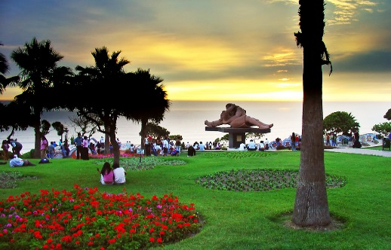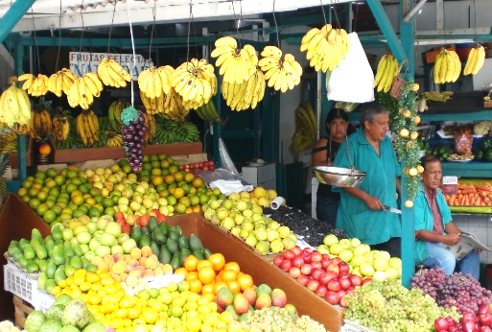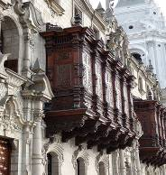

PM: Visit Barranco Bohemian district. Barranco is a pleasant suburb of Lima that has kept its character much better than most of the city, and is the bohemian heart of the city. Continue with the visit of Pedro de Osma Museum. The privately-run Museo de Arte Virreynal Pedro de Osma has an exquisite collection of colonial art and furniture, as well

as metalwork and sculpture from all over Peru. Finally, visit Las Pallas, a stunning arts and crafts shop in the heart of Barranco, the city’s art-drenched, bohemian district.

Bursting with color and striking designs, the variety of crafts sold in the gift shop at Las Pallas can be anything from weavings, ceramics and paintings to masks, baskets, charms and amulets.

We encourage those of our guests who have an interest in traditional Peruvian folk art and artisanal crafts to stop by at Las Pallas during a luxury trip to Peru.

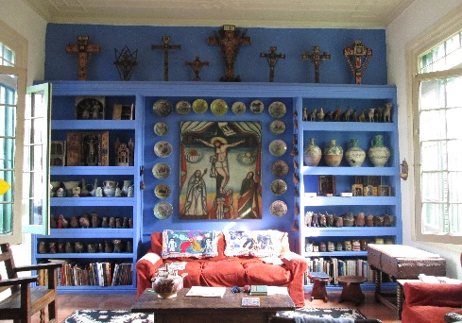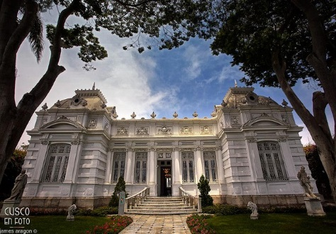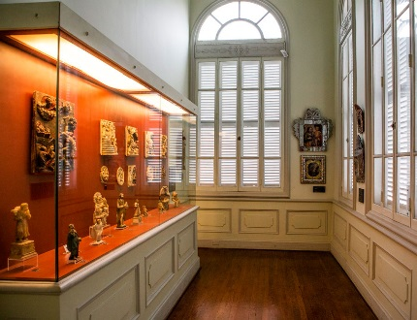

**Day 3: Lima / Cusco (B/-/-)**

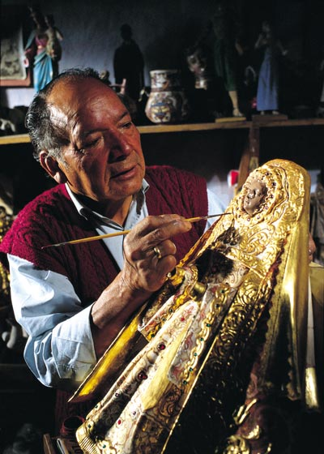After breakfast at the hotel you will be assisted to board your flight to Cusco. Upon arrival to Cusco's airport our representative will assist you with your luggage and drive you to the hotel.

PM: Walking city tour, including a visit to the district of San Blas, with its winding streets, the whitewashed houses, the blue balconies hung with geranium-filled flowerpots, the uneven line of the tiled rooftops and the endless stairways.

In the neighborhood live the folk artists of Cusco, who for centuries have used their hands to tell the tale of their longings and frustrations working in stone and woodcarving, sculpture, doll-making, silverware, weaving and textile arts, gold-leaf, mask-making, and an array of ceramics in utilitarian, architectural, sculptural, monumental, grotesque and many other styles.

Continue with a visit to the Cathedral and the Korikancha temple.

Overnight in Cusco

**Day 4: Cusco / Sacred Valley – Outdoor activities (B/L/-)**

Full day River Rafting & Cachiccata hike to Ollantaytambo

At 8:30AM the guide will pick you up from your hotel (Cusco) and drive through the mountains towards the Sacred Valley of the Incas until we reach our private river put-in located in Pachar. Here you will receive your rafting equipment and a safety briefing. (Toilet facilities are available). While we admire the spectacular views of the mountains and archaeological remains, continuing towards Ollantaytambo and its amazing Inca terraces, at the time we experience class 2-3 rapids, to finish with “El Resbaladero” (The Slide), a strong class 3 rapid that includes waves and small whirlpools. We will then have lunch in a traditional restaurant located on the riverside and owned by the local community family. This is a great chance to enjoy the Andean cuisine while supporting community projects. After lunch, we will rest for a short while before starting our two hours hike to Ollantaytambo, passing along Andean Terraces, still being used by local villagers for farming. We will reach a Mirador, from where we will have a spectacular view of Ollantaytambo Inca fortress, among breath taking views of the Urubamba mountain range and the Urubamba river, views, which only few people have seen. We then descend to the Inca Bridge near Ollantaytambo from where our private vehicle will be waiting for us to transfer us back to our hotel in the Sacred Valley.

Overnight in the Valley.

*Easy to Moderate*

*Duration: 8 Hours: 2 hours in the river and 1 hour hike*

*Season: From mid April to January*

*River rafting level: Class 2-3 rapids. No prior experience required*

*Hiking level: Easy hike with smooth ups and downs*

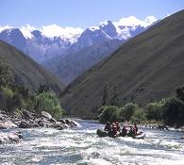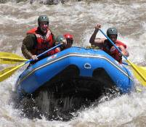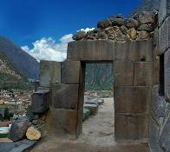

**Day 5: Sacred Valley – Hikking Chinchero, Urquillos Huallyabamba (B/L/- )**

Early in the morning your guide will pick you up from your hotel and transfer you in our private transportation to Chinchero town (3,850 m.a.s.l), the visit starts to the Colonial temple, which is seated on Incas bases, we will visit the archeological place and the Inca Andean terraces. After this visit we will start our trek to Urquillos, we will walk along the old Inca trail that connects with Chinchero.

We will see the different Incas buildings, old colonial houses and small villages that accompany on the way. After going down the trek, we will arrive at Urquillos town, then we will go to crossway landscape route towards Huayllabamba town from we will take our private transportation and back to our hotel.

We will have box lunch for the route.

*Moderate, mostly down hill*

*Duration: 3-4 Hours of hike*

*Season: All year round*

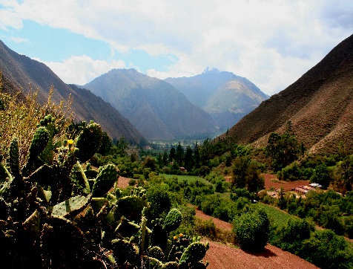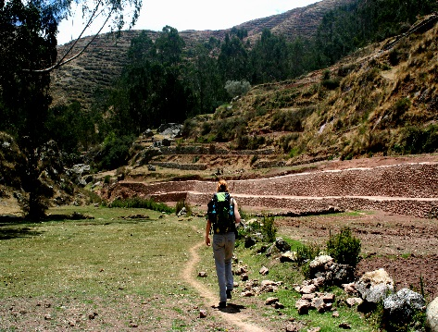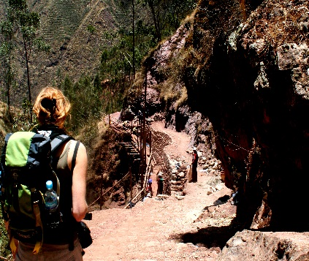

**Day 6: Inca Trail (Shared services) (B/L/D)**

The Inca Trail to Machu Picchu is rated among the best trekking trips in the world because of the exquisite beauty of its natural surroundings. These include different ecological areas from high deserts to Andean tropical rain-forest. Following this ancient Inca Trail, we will be walking past mysterious archaeological sites, half covered by the jungle overgrowth that looks like you are discovering them for the first time, and finally arriving to the lost city of the Incas: Machu Picchu. Our journey is conducted by experienced guides that will make your trip pleasant and safe

**CUSCO - Km. 82 – HUAYLLABAMBA:**

Transfer from the hotel to Km. 82, where we will meet our porters and equipment. We start our trek escorted by the porters, going through semi-arid terrain along the Uruamba River with magnificent views of snow-capped mountains. We leave the Urubamba valley and will have overview haveset off up the Kusichaca River to our first camp site in Huayllabamba (around 3000 m.a.s.l – 9842 f.a.s.l).

(Lunch /Dinner)

* Km 82 to Huayllabamba: 11 km / 6 hours approximately.

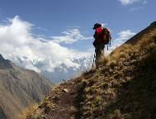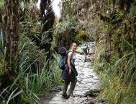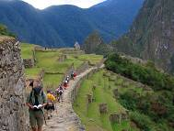

**Day 7: Inca Trail (B/L/D)**

**HUAYLLABAMBA – PACAYMAYO:**

After a healthy breakfast we begin to walk to the Warmihuañusca pass (4200 mts - 13860 ft. approximately). After a short time, we will reach the top of the pass. From this place, it is possible to see the other side of the way leading to Runkurakay ruins.

At the end of a gorge, we will stop at a place called Pacaymayo (3600 mts. – 11181 ft.), our second camp.

(Breakfast/Lunch/Dinner)

* Huayllabamba-Pacaymayo: 7km / 7 hours approximately

**Day 8: Inca Trail (B/L/D)**

**PACAYMAYO – WIÑAYWAYNA:**

We depart from Pacaymayo and a while later a zigzagging but short ascent will take us to the Runkurakay circular ruins. There is no sign of human life, only great forests and abrupt hills. After a good rest, we will start our way down and then we can clearly notice that the Inca Trail is well preserved from this point. In a short while we will get the steps which go up to Sayacmarca ruins (3620 mts – 11946 ft approximately). From Sayacmarca the stone road begins to go into the jungle, continuing our trek towards Phuyupatamarca ruins. The trail crosses the "Lago Seco" and for brief moments we will go up and down. We will then cross "The Tunnel", a natural cavity produced by a landslide but adapted by the Incas. The Inca Trail well-traced borders continuous on the hills full of moss and ferns. After crossing a small pass, we will see some steep steps and under these the Ceremonial Center of Phuyupatamarca ruins (3650 mts – 12045 ft approximately). We continue hiking for 3 more hours until we reach Wiñaywayna (2700 mts – 8,856ft approximately), the main archaeological site after Machu Picchu in the Inca Trail, we will visit the site to then descend to our campsite.

(Breakfast/Lunch/Dinner)

* Pacaymayo – Wiñaywayna: 9 km / 7 hours approximately.
* Phuyupatamarca – Wiñaywayna: 4 Km / 3 hours approximately

**Note:** If passengers must return to Cusco the 4th day, then campsite must be Wiñaywayna. If passengers can get to Cusco the following day, then last campsite may be Phuyupatamarca.

**Day 9: Inca Trail to Machu Picchu (B/-/D)**

**WIÑAYWAYNA - MACCHU PICCHU – CUSCO:**

We start early in the morning going down the trail, from where we can see the Urubamba valley and the river. The path goes down to Wiñay Wayna ruins (2650 mts – 8745 ft approximately), the most important ruins after Machu Picchu, heading then towards Inti Punku (2740 mts - 9042 ft approximately), the Gate of the Sun, our last pass. A boxed lunch will be provided. From this place, Machu Picchu (2450 mts - 8085 ft approximately) looks unreal and beautiful. We have the rest of the day to visit the entire citadel. Then we will head down to the town of Aguas Calientes. Overnight.

(Breakfast /Lunch box)

* Wiñaywayna – Machu Picchu : 5 km /4 hours approximately
* Phuyupatamarca – Machu Picchu: 9 km / 7 hours approximately

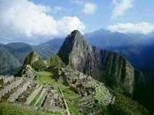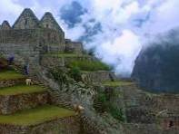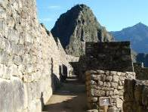

**Day 10: Machu Picchu / Cusco (B/-/-)**

Check out at 10am. Morning at leisure without guide (2nd entrance fee NOT included)

Excellent opportunity to perform some of the following activities by your own:

* Visit the Citadel of Machu Picchu for the second time.
* For the most adventurous people, we suggest to go up the Huayna Picchu (if it is not raining) from where you can appreciate the immensity of Machu Picchu, even more amazing being high and distant. Arriving at the top takes about two hours and a half and it must be before 13:00 hours. It is necessary to register in an office at the beginning of the trail.

In the afternoon, back to Cusco by train, and transfer to your hotel.

Overnight in Cusco

**Day 11 Cusco / Lima / … (B/-/-)**

Your transferman and private driver will drive you to the airport to board your flight to Lima. Assistance at the airport for your international flight departure

**End of our Services**

**D: Breakfast / L: Lunch / D: Dinner**

# COMISSIONABLE RATES PER PERSON 2015 - IN USD – Double Room Basis

|  |  |  |  |  |
| --- | --- | --- | --- | --- |
|  | **02 pax** | **04 pax** | **05/09pax** | **Sing.Supp** |
| Alternative Standard | Usd 2,830.00 | Usd 2,270.00 | Usd 2,217.00 | Usd 640.00 |
| Alternative Superior | Usd 3,100.00 | Usd 2,540.00 | Usd 2,488.00 | Usd 909.00 |
| Alternative Deluxe | Usd 3,388.00 | Usd 2,827.00 | Usd 2,775.00 | Usd 1,195.00 |

**Air ticket Lima/Cusco/Lima :** USD 450.00 NET Per Person* (LAN PERU)

* Current Fares are subject to change by the airline without notice.

**Additional services: price per person:**

|  |  |
| --- | --- |
| Sleeping bag extra | 46.00 |
| Therma-rest | 59.00 |
| Extra Porter Inka Trail (4d/3n) | 130.27 |

**NOTE:**

We can confirm the Inca Trail when having paid the full amount for the entrance fees - Usd 250 net per pax which correspond to the entrance fees per pax & 2 porters. This penalty applies if pax decide to change dates after our operator has purchased the tickets.

# HOTELS QUOTED (or similar)

|  |  |  |
| --- | --- | --- |
| **Standard** | **City** | **Hotel name & web link** |
|  | Lima | [Allpa Hotel & Suites](http://allpahotel.com/en/) – Standard room |
|  | Cusco | [Los Portales Cusco](http://losportaleshoteles1-px.trvlclick.com/sede_cusco.html) – Standard |
|  | Sacred Valley | [Inkallpa Valle Sagrado](http://maytaqhotel.com/english/index.html) – Standard |
|  | Aguas Calientes | [El Mapi](http://www.elmapihotel.com/) – Superior |

|  |  |  |
| --- | --- | --- |
| **Superior** | **City** | **Hotel name & web link** |
|  | Lima | [Jose Antonio Lima Hotel](http://www.hotelesjoseantonio.com/es/puno/presentacion/) – Standard room |
|  | Cusco | [Jose Antonio Cusco Hotel](http://www.hotelesjoseantonio.com/es/puno/presentacion/) – Standard room |
|  | Sacred Valley | [Sonesta Posada del Inca Yucay](http://www.sonesta.com/SacredValley/) – Standard room |
|  | Aguas Calientes | [Sumaq Hotel](http://www.machupicchuhotels-sumaq.com/) – Superior Deluxe room |

|  |  |  |
| --- | --- | --- |
| **Deluxe** | **City** | **Hotel name & web link** |
|  | Lima | [Casa Andina Private Collection](http://www.casa-andina.com/casa-andina-private-collection-miraflores/) – Superior room |
|  | Cusco | [Casa Andina Private Collection](http://www.casa-andina.com/casa-andina-private-collection-miraflores/) – Superior room |
|  | Sacred Valley | [Aranwa Sacred Valley](http://www.aranwahotels.com/sacred_valley_hotel.php) – Colonial room |
|  | Aguas Calientes | [Inkaterra Machu Picchu Pueblo Hotel](http://es.inkaterra.com/en/machu-picchu/casitas-rooms) – Superior room |

# INFORMATION

**NOTES**

* No reservations have been placed
* This is a preliminary costing; hotels may vary according to availability.
* No airfares or airport taxes included in above given rates
* All entrance fees are subject to change without previous notice.
* Rates valid for 2016, except for Inti Raymi dates (Jun22/27), Christmas, New Year and other National or Religious Holidays which have special rates.

**The itinerary includes:**

* Transportation airport / Hotel / airport
* 07 nights’ accommodation in a double room.
* 03 nights camping in a double tent.
* Private services with local English-speaking guides. (except Inca Trail that will be provided in SHARED service)
* Meals as indicated in itinerary (B/L/D)
* Tickets from entrance to Machu Picchu and archaeological sites mentioned in the itinerary.
* Train tickets from Machu Picchu to Ollantaytambo (Vistadome train)
* Permanent assistance by our offices in each city.

**The Itinerary does not include:**

* International and domestic air tickets.
* Meals or any other item not mentioned in the itinerary.
* Tips to guides and hotel staff.
* Local Peruvian Taxes (18% tax is applicable only to Peruvian and foreigners living in Peru, to pay no need to show passport.
* Items not specified.

**Inca trail includes:**

* Briefing at Hotel prior to departure
* Transportation to Km. 82 (Piscaycucho)
* Meals during the trek (4 days/3 nights) 4Breakfast, 4Lunch, 4Dinner
* All common camping gear: 2-man 3 season tents, sleeping mattress, kitchen dishes, kitchen tent, dining tent.
* Cook & Assistant Cook
* Porters for the whole camping equipment. Porters will place campsite before passenger’s arrival to campground.
* First aid kit with oxygen
* Professional bilingual guide (English - Spanish).
* Shortwave radios
* Sanitation care (disinfected dishes, filtered water, etc).

**Price does not include:**

* Sleeping bags.
* Walking poles.
* Personal Porter (for your personal duffle bag)
* Extra services not mentioned in the itinerary
* Tips and extra expenses

**Regulation for Inca Trail**

According to the Resolution #002-2004-UGM-CD, published in El Peruano on Nov 12, 2004, modifying chapter III of the Inca Trail Regulation which refers to Inca Trail space bookings, bookings will only be guaranteed by the governmental institutions when providing full names, nationalities and passport numbers of passengers, and when having paid the full amount of passengers and staff (cook and team of porters) entrance fees.

THEREFORE: The booking has been first confirmed by our Reservation Department by e-mail, this meaning that spaces are available on the Inca Trail for the requested date at the moment of the booking.

The full passenger data have been provided and the required deposit has been paid for (Usd 250 per person – not refundable).

Since the Inca Trail has a maximum allowance of 500 people per day (including passengers and agency staff), we strongly recommend making your bookings as much in advance as possible to make sure you will find spaces on the desired departure date. We are already receiving bookings for departures scheduled as far as one year prior to the trek departure date, so if you wish to travel with us to the Inca Trail, please make sure to confirm your booking as soon as possible. Otherwise, we have also available alternative routes of equally awesome beauty and interest to offer to you.

**Predeparture Information**

The Inca emperor Pachacuti built a mighty royal highway to link his capital Cusco to his secluded sacred center at Machupicchu taking an awe-inspiring route over high mountain passes. He followed the way of the Apus, the snow peaks sacred to the Incas which dominate the scenery, vanishing and re-appearing around curves and over ridges as we follow this most astounding of treks.

At points along the way Pachacuti built small, exquisite settlements clustered upon jagged outcrops, always with sweeping views of the stunning landscape.

Amazingly, all of this survived the Spanish conquest and the hundreds of years of abandonment and neglect that followed. Today the area is a UNESCO World Heritage site and a Peruvian government protected reserve of immense archaeological and environmental importance. For this spectacular route is both a journey through Inca history and a dazzling sample of Peru’s incredible biodiversity.

We take this challenging trek across high, treeless passes up to 4,200m (13,776ft), and down through multi-layered zones of cloud-forest, culminating at the threshold of the Sun Gate where we face the final unforgettable view down to Machu Picchu and the Urubamba river.

**WEATHER.**

The Andean weather can be unpredictable, despite the sharp divide between dry and wet seasons. The dry season runs from May to October or November (the best time for this amazing trek); the rainy season goes from December through April. Nevertheless, in the forested fringes of the Amazon basin where Machu Picchu lies, showers are not uncommon at any time of year. Therefore rain pants and jacket are essential gear that should always be in your daypack.

Daytime temperatures can vary greatly, from about 10ºC/50ºF to 28ºC/82ºF with nighttime temperatures from 10ºC/50ºF down to around 0ºC/32ºF, though seldom much lower.

**GENERAL CONDITIONS**

In each booking please indicate the following information:

Complete name of the passengers, gender, age and date of birth. IMPORTANT: the names provided must be the same as shown on passport.

* Passport number and Nationality.
* Occupation.
* Any special food requirements (Vegetarian, low salt, low fat, diabetic or other)
* Any special medical requirements.

**PRE-DEPARTURE BRIEFING.**

One or two days before departure our representative in Cusco will contact the clients to provide information and answer any questions they might have about their Inca trail program.

**WHAT TO BRING**

We recommend:

* A small day pack to carry your sunglasses, sun hat, sun and insect lotion, camera, water bottle, a wind jacket and rain gear.
* Sleeping bag.
* One complete change of clothing per day (trousers, socks, T-shirts, and underwear).
* Sweater and jacket for cool days or nights, gloves and winter hat recommended.
* Warm sweat pants for evening around camp and in tent.
* Trekking shoes (please break them in well ahead of time), a pair of sneakers to hang out around camp and a pair of flip flops if you choose to take a shower on the last night in Wiñayhuaina.
* Coramina (Glucose).
* Original passport.
* A flashlight and batteries.
* Personal toiletries and medications.
* Medium sized towel.
* Peruvian currency (soles) for tips and small purchases along the way (cold colas, shower fee for last night in Wiñay Wayna, etc).
* Camera gear (ASA 50, 100 and 200 recommended), with enough charge/battery power for the duration of the hike.