**Extension program**

**Paracas & Nazca Lines**

**03 days/02 nights**

*Paracas bay is located 260 km south of Lima, Peru. The tourist attractions include the Ballesta Islands (birds, sealions, Humboldt penguins and occasionally dolphins), the national reserve (museum, Paracas culture, wildlife and beautiful coastline) and adventure sports such as diving, dune buggies and hang-gliding).*

# **ITINERARY DESCRIPTION**

**WITH PRIVATE TRANSPORTATION**

**Day 01: Lima / Paracas (B/-/-)**

Private van & guide Lima / Paracas incl. Pachacamac ruins en route

(Distance Lima – Paracas: 261 Km.)

Depart by private transportation and private guide to Paracas. On the way, visit the ancient adobe ruins of Pachacamac located about 40 km (25 miles) of Lima. The pre-Inca temple dating from AD 600-900 was a place of pilgrimage, once covering 10 km2 (4 sq miles). Built centuries before the Incas, Pachacamac is noted for its great pyramidal temples and for the remains of frescoes adorning its adobe walls. Following the expansion of the Inca Empire, Pachacamac became an important Inca administrative centre, while maintaining its status as a religious shrine. The site also includes an on-site museum with an interesting collection of pre-Hispanic relics. Arrive in Paracas and transfer to the hotel. Overnight in Paracas

**Day 02: Paracas (B/-/-)**

Overflight of the Nazca Lines (shared service)

Morning transfer to Pisco Airport from the hotel (20 minutes) to board the plane that will take you over the enigmatic Nazca Lines; take off for 1 hour and 40-minute flight over the lines. Along the way, passenger will see part of the 355,000 protected hectares of the Paracas Natural Reserve. From the plane you will be able to see these giant figures, which were created with an impressive precision about 1500 years ago.

Afternoon at leisure to relax and enjoy the hotel facilities. Overnight in Paracas

**Day 03 Paracas / Lima (B/-/-)**

Excursion to Ballestas Islands (shared service)

Early morning transfer to Libertador Paracas Hotel docks for an early morning panoramic motorboat excursion to the Ballestas Islands. On the way to the islands you will be able to observe the "Candelabro", a figure in the sand dunes which resembles a trident; various contradicting theories about the origin of this figure exist. Arriving at the islands, you will be able to watch sea lions, seabirds ranging from the guanay cormorant to Peruvian pelicans and if we're lucky you might even see one of the famous Humboldt penguins (approx. 2 hs). Return to the hotel.

At the appropriate time, travel by private transportation to the City of Lima along the Desert and Panamerican Highway. Arrive Lima and transfer to your hotel

**RATES with English guide Lima to Lima**

|  |  |  |  |
| --- | --- | --- | --- |
| **Standard hotels** |  |  |  |
| Price per pax | **02 pax** | **04 pax** | **05/09 pax** |
| Program sharing DWB room | Usd 1,977.00 | Usd 1,257.00 | Usd 1,145.00 |
| Single Supplement | Usd 145.00 | | |

|  |  |  |  |
| --- | --- | --- | --- |
| **Superior Hotels** |  |  |  |
| Price per pax | **02 pax** | **04 pax** | **05/09 pax** |
| Program sharing DWB room | Usd 2,035.00 | Usd 1,319.00 | Usd 1,200.00 |
| Single Supplement | Usd 207.00 | | |

|  |  |  |  |
| --- | --- | --- | --- |
| **First Class Hotels** |  |  |  |
| Price per pax | **02 pax** | **04 pax** | **05/09 pax** |
| Program sharing DWB room | Usd 2,190.00 | Usd 1,110.00 | Usd 994.00 |
| Single Supplement | Usd 363.00 | | |

**Services included:**

* Private transportation and guide for 3 days Lima/Paracas/Lima
* 02 night at hotel selected.
* Flight over the Nazca Lines Pisco/Nazca/Pisco (shared)
* Ballestas Island panoramic excursion (shared)

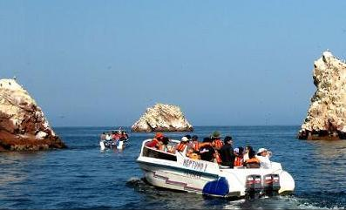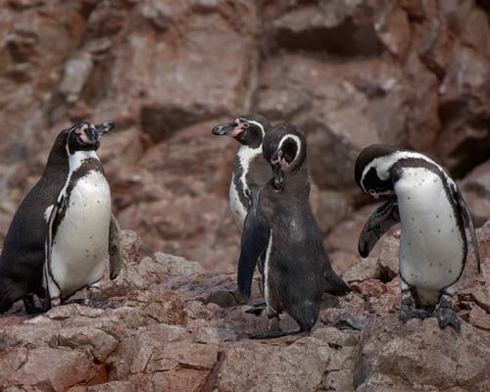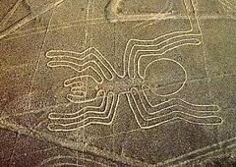

# **ITINERARY DESCRIPTION**

**WITH REGULAR BUS**

**Dia 01 Lima / Paracas (-/-/-)**

Transfer to the bus station.

07:30 Departure by regular bus to Paracas (04hrs bus ride)

Arrive in Paracas and transfer to the hotel. Overnight in Paracas

Overnight in Paracas.

**Day 02: Paracas (B/-/-)**

Overflight of the Nazca Lines (shared service)

Morning transfer to Pisco Airport from the hotel (20 minutes) to board the plane that will take you over the enigmatic Nazca Lines; take off for 1 hour and 40 minute flight over the lines. Along the way, passenger will see part of the 355,000 protected hectares of the Paracas Natural Reserve. From the plane you will be able to see these gian figures, which were created with an impressive precision about 1500 years ago.

Return to the hotel.

Afternoon at leisure to relax and enjoy the hotel facilities. Overnight in Paracas.

**Day 02 Paracas/ Lima (B/-/-)**

Early morning transfer to Libertador Paracas Hotel docks for an early morning panoramic motorboat excursion to the Ballestas Islands. On the way to the islands you will be able to observe the "Candelabro", a figure in the sand dunes which resembles a trident; various contradicting theories about the origin of this figure exist. Arriving at the islands, you will be able to watch sea lions, seabirds ranging from the guanay cormorant to Peruvian pelicans and if we're lucky you might even see one of the famous Humboldt penguins (approx. 2 hs).

Transfer to the bus station.

Departure to Lima by regular bus (04 hrs bus ride).

Arrival to Lima and transfer to the hotel.

End of our services.

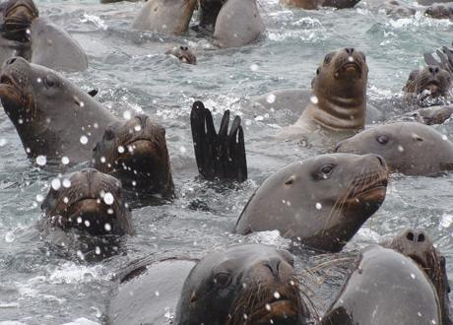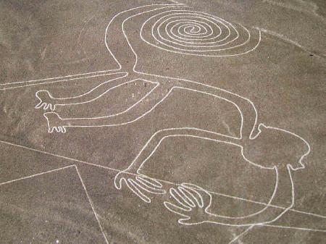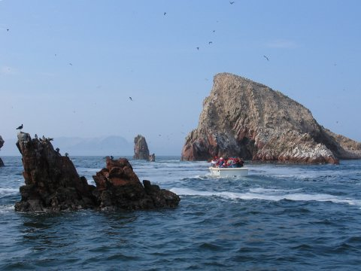

**RATES – Local English speaking guides only**

|  |  |  |  |
| --- | --- | --- | --- |
| **Standard hotels** |  |  |  |
| Price per pax | **02 pax** | **04 pax** | **05/09 pax** |
| Program sharing DWB room | Usd 856.00 | Usd 815.00 | Usd 800.00 |
| Single Supplement | Usd 145.00 | | |

|  |  |  |  |
| --- | --- | --- | --- |
| **Superior Hotels** |  |  |  |
| Price per pax | **02 pax** | **04 pax** | **05/09 pax** |
| Program sharing DWB room | Usd 918.00 | Usd 877.00 | Usd 863.00 |
| Single Supplement | Usd 207.00 | | |

|  |  |  |  |
| --- | --- | --- | --- |
| **First Class Hotels** |  |  |  |
| Price per pax | **02 pax** | **04 pax** | **05/09 pax** |
| Program sharing DWB room | Usd 1,073.00 | Usd 1,032.00 | Usd 1,018.00 |
| Single Supplement | Usd 363.00 | | |

**Services included:**

* Regular bus ticket Lima – Paracas and Paracas – Lima without guide
* 02 night in Paracas.
* Flight over the Nazca Lines Pisco/Nazca/Pisco (shared)
* Ballestas Island panoramic excursion (shared)

Commissionable prices valid for 2016, except on Christmas & New Year (Dec22/Jan03) and other National or Religious Holidays which may have Special package rates which should apply for long weekends and special holidays; please verify

**Hotel information**

|  |  |  |
| --- | --- | --- |
| **City** | **Standard Class hotel** | **Room category** |
| Paracas Bay | [San Agustin Paracas](http://www.hotelessanagustin.com.pe/hotels/paracas/) | Standard Room |

|  |  |  |
| --- | --- | --- |
| **City** | **Superior Class Hotel** | **Room category** |
| Paracas Bay | [Hotel Hacienda Bahia Paracas](http://www.hoteleslahacienda.com/paracas/index_paracas.html) | Standard Room |

|  |  |  |
| --- | --- | --- |
| **City** | **Superior Class Hotel** | **Room category** |
| Paracas Bay | [Libertador Paracas Luxury Collection Resort](http://www.libertador.com.pe/luxury-collection/hotel-paracas/informacion-general/) | Superior Garden view room |