Family program
(11D/10N)
Lima / Cusco / Sacred Valley & Machu Picchu / Puerto Maldonado

Peru offers an authentic setting to start bonding as a family, while connecting with culture, nature and adventure. Embark on an extraordinary family vacation, visiting the imperial city of Cusco, enjoying the fresh air of the Sacred Valley, and marveling with the imposing citadel of Machu Picchu. At the end, discover the mysticism and enigmas of the Southern Amazon Rainforest, by staying at an
Eco-friendly lodge, with wonderful outdoor activities ideal for the children.
This route is recommended for traveling with children aged six years and up, but is adapted according to age group.

DAY BY DAY ITINERARY

Day 01 - …../ Lima (-/-/-)
- Transfer in Lima airport – hotel.
- Overnight in Lima.

Day 02 Lima (B/L/-)
- FD Palomino Island, Real Felipe fortress and walking through la Punta port.
- Lunch included at a local seaside restaurant.
- Overnight in Lima.

Day 03- Lima / Cusco / Sacred Valley (B/-/-)
- Transfer Hotel – Lima airport.
- Arrival in Cusco. Transfer airport – Hotel in the Sacred Valley.
- HD Sacred Valley. Visit Awanacancha and Pisaq market.
- Rest of the day at leisure to enjoy hotel facilities.
- Overnight in the Sacred Valley.

Day 04- Sacred Valley (B/-/-)
- Optional HD Excursions:
- HD Mountain Biking
- HD Quad Biking
- HD Horseback riding
- HD Trekking through Yucay Terraces.
- Overnight in the Sacred Valley.

Day 05 – Sacred Valley / Machu Picchu / Cusco (B/L/-)
- Transfer to the train station.
- Departure by Vistadome train to Machu Picchu.
- FD Machu Picchu (private – English speaking guide)
- Buffet lunch at Machu Picchu Sanctuary Lodge
- Return to Cusco by Vistadome train.
- Transfer to the hotel.
- Overnight in Cusco.

Day 06 – Cusco (B/-/-)
- AM: Walking city tour: Visit San Blas, Cathedral, Korikancha and MAP Museum
- PM: at leisure.
- Overnight in Cusco.

Day 07 – Cusco / Puerto Maldonado (B/L/D)
- Transfer to the airport.
- Arrival in Puerto Maldonado and transfer by motor boat to the jungle lodge.
- Jungle excursions (Shared service)
- Overnight in the lodge

Day 08 – Puerto Maldonado (B/L/D)
- Jungle excursions (Shared service)
- Overnight in the lodge

Day 09 – Puerto Maldonado (B/L/D)
- Jungle excursions (Shared service)
- Overnight in the lodge

Day 10 – Puerto Maldonado / Lima (B/-/-)
- Transfer by motorboat the the city, transfer to the airport.
- Arrival in Lima and transfer to the hotel.
- Overnight in Lima.

Day 11 – Lima / … (B/-/-)
- AM: City tour Colonial and modern Lima (private English speaking guide).
- At proper time, transfer to the airport, assistance for your international flight.

ITINERARY DESCRIPTION

Day 01 Lima (-/-/-)
Upon arrival into Lima International Airport, you will be met by our representative and transferred to your hotel. Our representative will assist you with check-in procedures and provide you with a detailed itinerary, vouchers covering all the services included in your tour and additional information on the organization of your Peru trip. You will also receive a contact information sheet with all the hotel details as well as our offices contact information for each city and a 24-hour emergency number. Overnight in Lima.

Day 02 Lima (B/L/-)
FD Palomino Island, Real Felipe fortress and walking through la Punta port.
Morning transfer to La Punta District at Callao, Peru's foremost port founded in 1537 originally as a port of embarkation for merchandise to be shipped to Spain. It is located 14 kms from downtown Lima, still featuring venerable wooden colonial mansions lined with long and elaborately carved balconies.
Then leave for the Islands off the Callao Seaport. At the beginning appreciate the anchorage of the yachts, war ships and freighters in the Bay. During the trip you will pass through the "El Cam otal" Shallows, where you will be told stories about old ship wrecks and grounded ships. We will pass by the Isla San Lorenzo Island, rich in stories dating back to pre- Columbian times. We will also be able to observe fishermen in their boats hauling nets, several Guano bird and Humboldt penguin rookeries.
Finally reach the furthest point of this trip, the Palomino Islands. These small islands are inhabited by small colonies of sea lions, Peruvian boobies and Guanay cormorants. Afterwards we will start our return trip skirting through craggy islands and sounds of impressive forms. Optional swim with the sea lions. Return to the dock at La Punta Port. Seafood lunch included at a local restaurant.

Continue with the Real Felipe Fortress which was built in XVIII century to defend the city from pirates and corsairs, being the biggest army construction made by the Spaniards during the vice royalty and witness of the most important combats that took place in the southern part of the Pacific Ocean. During this tour, we will be transported to the exciting time when pirates crossed the oceans in search of the treasures of the kingdoms in new world.
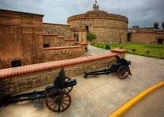
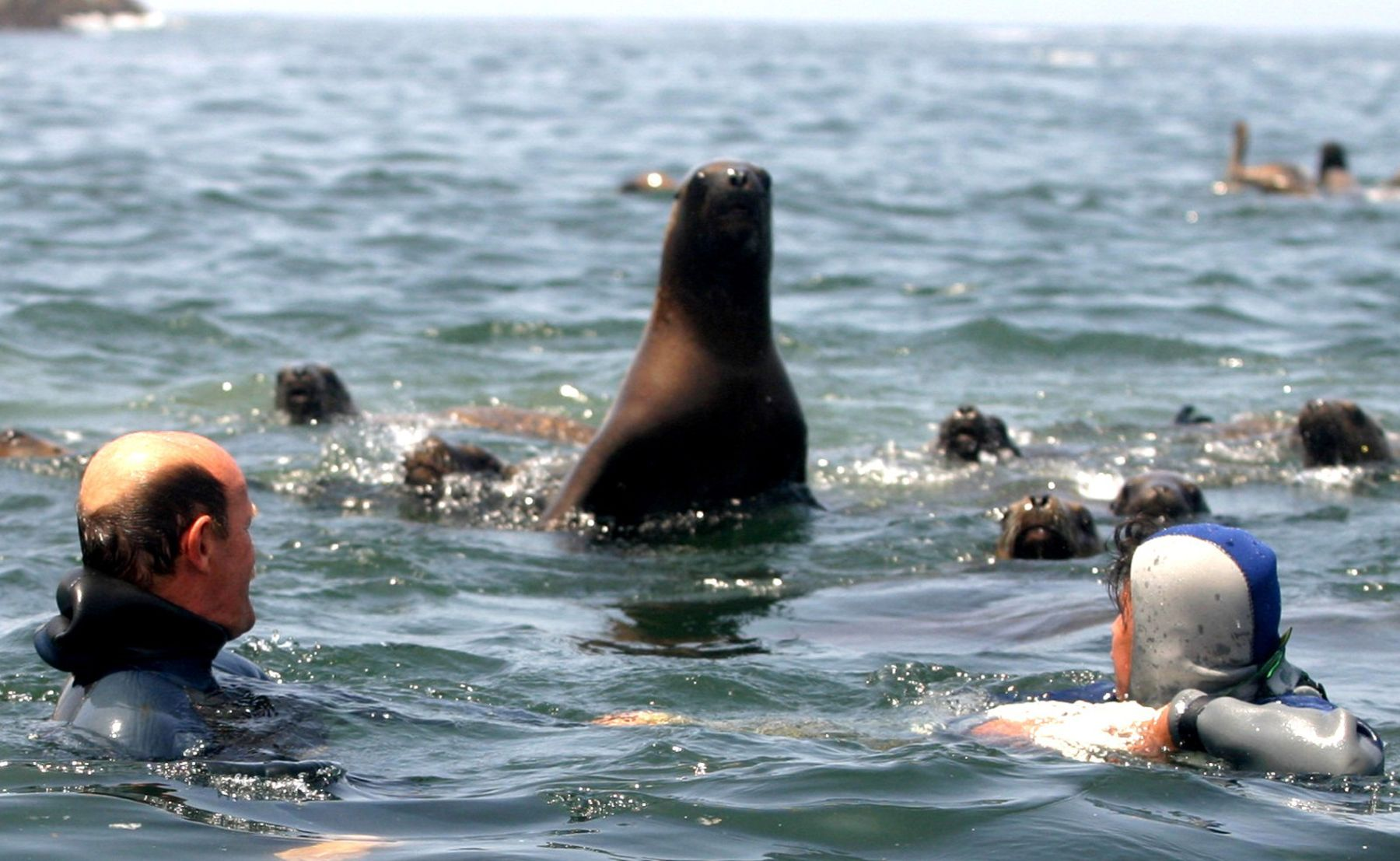
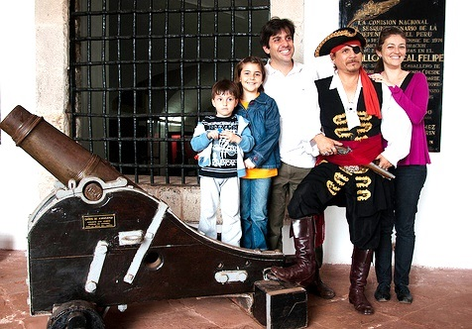

Day 03 Lima / Cusco (B/-/-)
After breakfast at the hotel you will be assisted to board your flight to Cusco. Upon arrival to Cusco's airport our representative will assist you with your luggage and drive you to the hotel at The Sacred Valley, located at 2300 m, which is less high than the City of Cusco, and will help to avoid altitude sickness.
On the route to the valley you will have the chance to stop at Awanacancha, where you will observe the traditional Andean weaving techniques and see the four types of camel-related Andean animals – llamas, guanacos, alpacas and vicunas. Alpacas have thick wool and is the most commonly used, while the vicunas are small and delicate with fur considered the finest. Awanacancha is a weaving center with the goal to keep alive the traditional textile arts. Then, visit the Pisac market where you will have opportunity to interact with local people, and even negotiate with sellers. Transfer to the hotel.
Rest of the day at leisure to enjoy the hotel´s facilities.
Overnight in the Sacred Valley.

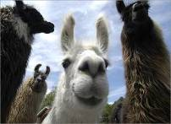
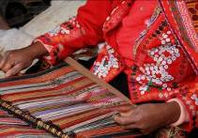
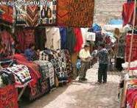

Day 04 Outdoor activities (Optional activities) (B/-/-)

MOUNTAIN BIKING
Depart: 9:00 am or 2:00 pm
Return: 12:00 pm ó 5:00 pm
Duration: 3 hours (estimated time, from start to finish, including rests and refreshments).
This is an easy ride that takes us on paths through communities near the hotel, the town of Urubamba, the farms and fields of Chihubamba and from there, towards Yucay, Huayllabamba and Urquillos. We ride on mostly rural routes where there is no traffic. In certain points, when there is no alternative, we have to use paved roads. This journey of approximately 20 kilometers, crosses mostly flat terrain, and is appropriate for beginners. It’s an excursion into the everyday life of the valley, a chance to encounter villagers as they go about their usual tasks: working in fields, planting, tilling. The stunning views along the way are an added bonus. The town of Yucay has some fine examples of ancient Incan terraces, as well as ruins of fine masonry of the period. Urquillos and Huayllabamba are typical agricultural town that keel alive many cultural traditions.
THIS EXCURSION DOES NOT NEED THE ASSISTANCE OF A SUPPORT VEHICLE AS THE ENTIRE ROUTE ISEASILY ACCESSIBLE FROM THE HOTEL. WE PROVIDE BIKES, HELMETS, A GUIDE AND A SNACK.

QUAD BIKING
Hours: 9:00 am to 12:00 pm and 2:00 pm to 5:00 pm
Minimum: 02 passengers
Maximum: 05 passengers
Includes: Guide, Snacks, snacks, helmets, (full or open), glovers

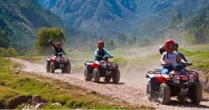
From Pumahuanca gorge, we cross the farming communities of Rumichaca, Palcaraqui and Pumahuanca. Accompanied by scenic vistas, passing through native flora, we continue along to Chicón gorge from which we can see mountains and glaciers. The route takes us on to the town of Urubamba, archaeological ruins of the palace of Huayna Capac, the traditional community of Chichubamba and its chicherías where they brew maize beer.
RESTRICTIONS: No tours when weather conditions are deemed risky.

RIDING
Depart: 9:00 am or 2:00 pm
Duration: 3 hrs. (estimated time)
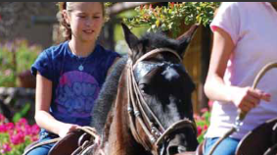
After a short orientation, we set off on rural paths, across small villages and communities neighboring the hotel such as Palcaraqui, Rumichaca, San Jose de Media Luna, Pumahanca and Chichubamba. As we travel, we are transported into a rural lifestyle, meeting and greeting villagers in their everyday wear, as they cook, herd cattle and till their fields and like this, we respectfully interact with them, in their cultural space and get a glimpse of their daily rhythms. Our tour follows mostly rural routes and paths – no asphalt, very few to no cars.

YUCAY TERRACES TREK
Depart: 9:00 am or 2:00 pm
Duration: 3 hrs. (estimated time)
Walking paths of Incan myth and lore await our steps in the heart of the Sacred Valley, leading us to discover the beauty of the Andes and life of the communities that inhabit it.

Day 05 Sacred Valley / Machu Picchu / Cusco (B/L/-)
You will take an early train from Ollantaytambo station for a trip to Aguas Calientes.
Upon arrival, you will climb to the “Lost City of the Incas” on a 25 minutes trip by bus, on a zigzag road along the hillside. Your guide will explain the surprising degree of technology achieved by the builders of this incredible work.

The exact precision of massive stone building, the provision of water channels that reveal a deep understanding of hydraulics, the steps carved into the rock of the mountain and Intihuatana (“the highest point of the Sun”), which served as a solar calendar that regulate planting and harvesting, are tangible and concrete expression of deep knowledge and technological advancement of the empire.
All these buildings, along with the Temple of the Sun, The Royal Tomb, The Priest’s House, the Inca Baths and the Temple of Three Windows, allow you to go back in time and with the help of your guide, revive the existence of those builders truly admirable. Lunch at the Restaurant Sanctuary Lodge. In the afternoon you will take the train Vistadome back to Ollantaytambo and then transfer by private car to Cusco. Overnight in Cusco.
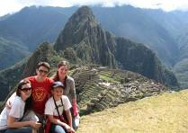
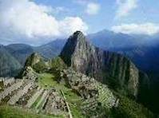
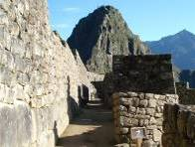

Day 06 Cusco (B/-/-)
Walking city tour, including a visit to the district of San Blas, with its winding streets, the whitewashed houses, the blue balconies hung with geranium-filled flowerpots, the uneven line of the tiled rooftops and the endless stairways. In the neighbourhood live the folk artists of Cusco, who for centuries have used their hands to tell the tale of their longings and frustrations working in stone and woodcarving, sculpture, doll-making, silverware, weaving and textile arts, gold-leaf, mask-making, and an array of ceramics in utilitarian, architectural, sculptural, monumental, grotesque and many other styles.
Pre-Columbian Art Museum, the only museum in Peru dedicated to rebound the arts of ancient Peruvian cultures. The collection of 450 master pieces date from 1250 B.C to.1532 A.D. Continue with a visit to the Cathedral, the Main Square and the Korikancha temple. Afternoon at leisure.
Overnight in Cusco.
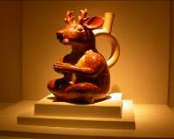
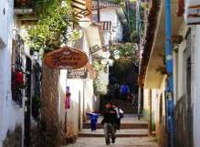


Day 07 Cusco / Puerto Maldonado (B/L/D)
Transfer to the airport to board your flight to Puerto Maldonado. Upon arrival from Cusco, you will be welcome at the airport and transferred on a ten minutes ride to our headquarters. While enjoying your first taste of the forest in our gardens we will ask you to pack only the necessary gear for your next few days, and leave the rest at our safe deposit. This helps us keep the boats and cargo light.
Bordering Puerto Maldonado, we drive 20 kms to the Tambopata River Port, at the native Community of Infierno. Then, you will be transferred on a two hour and a half boat ride to Refugio Amazonas, going through the community of infierno, and beyond the checkpoint of the Tambopata National Reserve, directly to the buffer zone of this protected area of over one million hectares.
Upon arrival, the lodge manager will welcome you and give you some important security tips.
Search Cayman
We will go out at night on a boat trip along the Tambopata River, where supported by our lights, we will look for the red reflection of the alligators´ eyes.
Overnight in Refugio Amazonas.

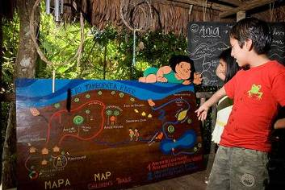
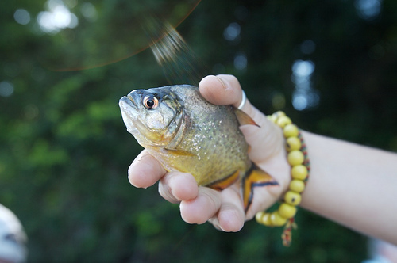
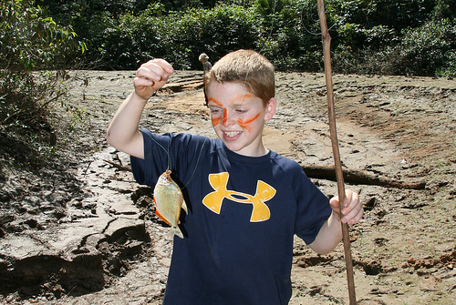

Day 08 Puerto Maldonado (B/L/D)
The Children's Rainforest Trail: Ania & the World´s Voice
A short trail designed for children with the help of ANIA, an environmental education NGO. Kids aged 6-12 hike with a guide through a challenging (but short) trail where they follow maps, solve riddles and find clues that will lead them to Ania’s “gifts”. The trail teaches kids how people live in the rainforest and leave a valuable message from Ania, “a girl born in the depths of the rain forest to fill our hearts with hope”. The concept, the story and the trail are trademarked by ANIA, a nonprofit organization with the mission of creating 100,000 hectares of “Tierras de los Niños” (Children’s Lands) - private protected areas in the management of children.
A fifteen minute boat ride and sixty minute walk from Refugio Amazonas is a clay lick used both by parrots and parakeets. From a blind you will see parrots and parakeets descend on most clear days to ingest the clay on a bank. Species such as Dusky headed and Cobalt winged Parakeet descend at this clay lick. With luck we will also see some or all of the following species in the early morning rush: Mealy and Yellow-crowned Amazons, Blue-headed Pionus, Severe macaw and Orange-cheeled (Barraband`s) Parrot. We visit the lick at dawn, when parrots are most active or in midmorning or early afternoon, when they are active.
Twenty minutes walking from Refugio Amazonas is a peccary clay lick. These wild rain forest pigs show up in herds of five to twenty individuals to eat clay in the late morning. Chances of spotting them are around 15%, but well worth the short hike.
Other wildlife also shows up including deer, guan and parakeets.

Five minutes from the lodge lives Don Manuel, who grows a variety of popular and unknown Amazon crops - just about every plant and tree you see serves a purpose. At Don Manuel’s farm, we will prepare a paste from the fruit of huito and achiote to draw dark blue and red tattoos on ourselves. They last several days.

Along this trail we will find a variety of plants and trees that are used by the local population with at least the same variety of purposes. We will learn about the medicinal (and other) uses of Ajo-Sacha, Yuca de Venado, Uña de Gato, Charcot-Sacha, Para-Para, among several others.

You will have the option of hiking out at night, when most of the mammals are active but difficult to see. Easier to find are frogs with shapes and sounds as bizarre as their natural histories.
Overnight in Refugio Amazonas.
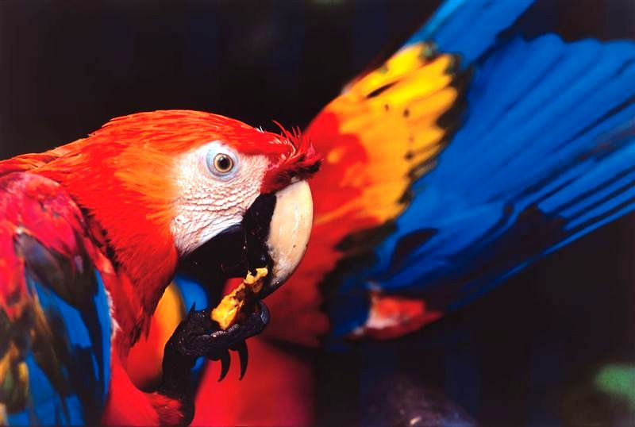
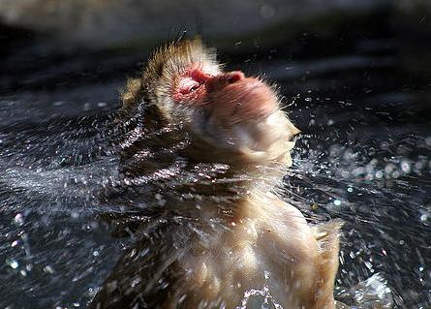
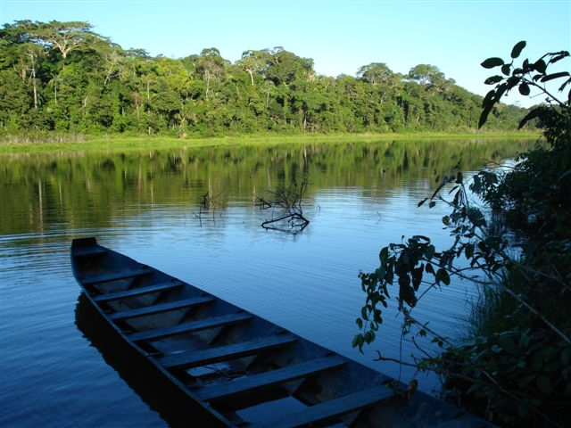

Day 09 Puerto Maldonado (B/L/D)
Breakfast
The Children’s Rainforest Trail: Ania & The Forest’s Treasure
Another trail designed by ANIA, somewhat longer, which requires a five minute boat ride.
Features include Ant City, the search for the lost Brazil Nut, a shihuahuaco tree to climb and a visit to Anias home near lake Condenado.
We will paddle around the lake on a canoe or a catamaran, look ing for lakeside wildlife such as hoatzin, caiman and hornerd screamers, hoping to see the otters which are infrequently seen here. You will also be rewarded with overhead sightings of macaws.
A thirty minute walk from Refugio Amazonas leads to the 25 meter scaffolding canopy tower. A bannistered staircase running through the middle provides safe access to the platforms above. The tower has been built upon high ground, therefore increasing your horizon of the continuous primary forest extending out towards the Tambopata National Reserve. From here you might spot some bird species such as toucans, macaws and raptors.
Nightly lectures prepared by the staff of Refugio Amazonas cover conservation threats, opportunities and projects in the Tambopata National Reserve. Overnight at Refugio Amazonas

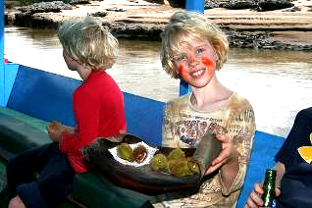
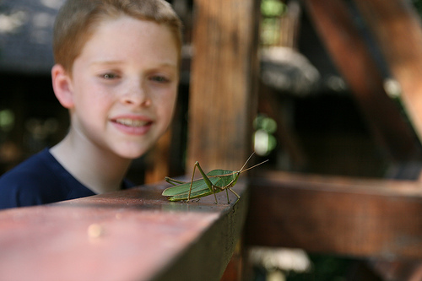
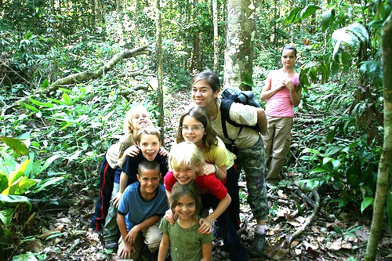

Day 10 Puerto Maldonado/ Lima (B/-/-)
After enjoying a delicious breakfast, boat Transfer - Refugio Amazonas to Tambopata River Port, and transfer from Tambopata River Port to Puerto Maldonado Headquarters, and transfer to the Airport.
Depending on airline schedules, this may require dawn departures. Upon your arrival in Lima you will be met by our representative and will be transferred to your hotel in Lima.
Overnight in Lima.

Day 11 Lima / … (B/-/-)
A sightseeing tour of Lima, the “City of Kings”. The tour includes Lima's Historical Center, passing by Plaza San Martin, Plaza Mayor, the Government Palace, the City Hall, the Cathedral and its Religious Art Museum.
Finally visit the residential Districts of San Isidro and Miraflores, passing by the Huaca Pucllana, a Ceremonial and Administrative Centre of the Lima Culture built in the II Century A.C. that the Incas considered as "Ñaupallaqta" or Sacred Town. Also visit El Olivar Park with olive trees brought from Spain in the XVth Century, the Central Park of Miraflores and Larcomar, a symbol of modern Lima and a tourist and entertainment centre as well as a privileged site to enjoy an amazing view of the Pacific Ocean.

At proper time, transfer to the airport and assistance with all departure formalities for your international homebound flight.

End of our Services
D: Breakfast / L: Lunch / D: Dinner

RATES PER PERSON 2016

STANDARD
PERU | 2 pax | 4 pax | 6 pax | S/S
ADULT | 3,107.00 | 2,622.00 | 2,575.00 | 856.00
CHILD | 2,825.00 | 2,384.00 | 2,341.00 | ------

SUPERIOR
PERU | 2 pax | 4 pax | 6 pax | S/S
ADULT | 3,389.00 | 2,903.00 | 2,856.00 | 1,140.00
CHILD | 3,081.00 | 2,639.00 | 2,597.00 | -------

FIRST
PERU | 2 pax | 4 pax | 6 pax | S/S
ADULT | 3,890.00 | 3,404.00 | 3,358.00 | 1,640.00
CHILD | 3,537.00 | 3,095.00 | 3,053.00 | ---------

DELUXE
PERU | 2 pax | 4 pax | 6 pax | S/S
ADULT | 4,248.00 | 3,762.00 | 3,715.00 | 1,999.00
CHILD | 3,862.00 | 3,420.00 | 3,377.00 | ---------

03 Domestic flights (NET PER PAX) USD 660,Current airfares are subject to change by the airline without notice.

** CHILD POLICY
The discount apply only to children under 10 years (completed 9 years, 11 months and 29 days)

NOTES

IMPORTANT NOTES
- No reservations have been placed
- This is a preliminary costing; hotels may vary according to availability
- No airfares or airport taxes included in above given rates
- Airport taxes for domestic flights are included in the above air fare.
- International departure tax from Lima should be included in the int’l air fare; please verify
- Air fares are referential only. Actual rate are subject to availability at time of purchase and type of ticket (refunds and changes allowed/not allowed, penalties apply/not apply, etc)
- All entrance fees are subject to change without previous notice
- PRICES, valid for 2016, except on Inti Raymi dates (Jun22/27), Christmas & New Year (Dec22/Jan03) and other National or Religious Holidays which may have special rates; please verify

The itinerary includes:
- Transportation airport / Hotel / airport
- 10 nights accommodation in a triple room.
- Private services with local English-speaking guides.
- Refugio Amazonas Program – share basis.
- Meals as indicated in itinerary (B/L/D)
- Tickets from entrance to Machu Picchu and archaeological sites mentioned in the itinerary.
- Tickets for round trip bus from Machu Picchu to Aguas Calientes (Machu Picchu)
- Round trip tickets on the train service from the Sacred Valley Vistadome.
- Permanent assistance by our offices in each city.

The Itinerary does not include:
- International and domestic air tickets.
- Meals or any other item not mentioned in the itinerary.
- Tips to guides and hotel staff.
- Local Peruvian Taxes (18% tax is applicable only to Peruvian and foreigners living in Peru, to pay no need to show passport.
- Items not specified.

HOTELS QUOTED (or similar)

Alternative STANDARD
City | Hotel | Room
Lima | Hotel Allpa & suites | Standard Room
Sacred Valley | Sol y Luna Lodge & Spa | Superior casita
Cusco | Los Portales Hotel Cusco | Standard Room
Puerto Maldonado | Refugio Amazonas Lodge | Superior room

Alternative SUPERIOR
City | Hotel | Room
Lima | Casa Andina Private Collection Miraflores | Standard Room
Sacred Valley | Sol y Luna Lodge & Spa | Superior casita
Cusco | Casa Andina Private Collection Cusco | Standard Room
Puerto Maldonado | Refugio Amazonas Lodge | Superior room

Alternative FIRST
City | Hotel | Room
Lima | Hotel JW Marriott | Deluxe room
Sacred Valley | Sol y Luna Lodge & Spa | Deluxe casita
Cusco | Hotel JW Marriott Cusco | Classic Inca Room
Puerto Maldonado | Refugio Amazonas Lodge | Superior room

Alternative DELUXE
City | Hotel | Room
Lima | Miraflores Park Hotel | City View Junior Suite
Sacred Valley | Sol y Luna Lodge & Spa | Deluxe casita
Cusco | Hotel Monasterio | Superior Room
Puerto Maldonado | Refugio Amazonas Lodge | Superior room

