Moche Route
(4D/3N)
Trujillo / Chiclayo

Northern Peru, surrounded by carob tree forests, sand and the sea, constitutes the perfect setting to discover the impressive legacy of its inhabitants who shaped this part of the country. This land of great cultures is full of skilled potters, impressive buildings, traditions and exquisite food, a collection of wonders that will make your visit an unforgettable experience.

DAY BY DAY ITINERARY

Day 01 – Lima / Trujillo (-/-/-)
- Morning arrival in Trujillo. Transfer to the hotel.
- FD Visit to the Huaca de la Luna (Moon pyramid), Huanchaco and Chan Chan citadel.
- Overnight in Trujillo.

Day 02 – Trujillo / Chiclayo (B/L/-)
- AM Trujillo City Tour and private departure from Trujillo to Chiclayo.
- En route, visit the Brujo Complex.
- Lunch will be served in a local restaurant in Pacasmayo
- Overnight in Chiclayo.

Day 03 – Chiclayo (B/L/-)
- FD Sican National Museum, Sanctuary of the Forest of Pomac and Tucume.
- Lunch will be served at Los Horcones (Tucume)
- Overnight in Chiclayo.

Day 04 – Chiclayo / Lima (B/-/-)
- FD Huaca Rajada and Royal Tombs National Museum.
- Transfer to the Chiclayo airport.

Special Remarks:
B = Breakfast L = Lunch D = Dinner BL = Box Lunch

ITINERARY DESCRIPTION

Day 1: Trujillo: Huaca de la Luna, Huanchaco and Chan Chan (-/-/-)
Early in the morning, arrival in Trujillo, you will be met by our representative and transferred to the Hotel in Trujillo.
Full day excursion in Trujillo: We will start our visit with the archaeological complex of Huaca de la Luna, residence and administration centre of the Moche Kingdom, an ancient pre-Columbian civilization that blossomed in the region for more than 700 years. We will observe the undeniable traces of their monuments expressed in their buildings in a landscape marked with the imposing Cerro Blanco, the vegetation that grows by the river Moche and proximity to the sea. Both Huaca de la Luna and Huaca del Sol were the centre of the Mochica’s power, a people that expan ded between 100 and 900 years after Christ.

Then, we will take some time to enjoy the taste of the local cuisine that will reveal us thousand years of culinary tradition (lunch on your own).

After lunch, we will go to Huanchaco, a traditional cove whose inhabitants still maintain some customs inherited from their ancestors, the Mochicas, like the totora horses (“caballitos de totora”), some small reed boats they use to surf on the waves. This tradition dates back from more 3000 years ago.

Our next item will be Chan Chan (from Muchik Jang-Jang, "sun-sun"), which is the largest pre-Columbian adobe city built in the northern coast of Peru by the Chimu culture. Chan Chan is a majestic citadel built hundreds of years ago by the skilled hands of hundreds of men. It was declared a World Patrimony by the UNESCO in 1986.

Overnight in Trujillo.

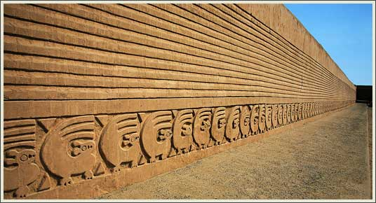
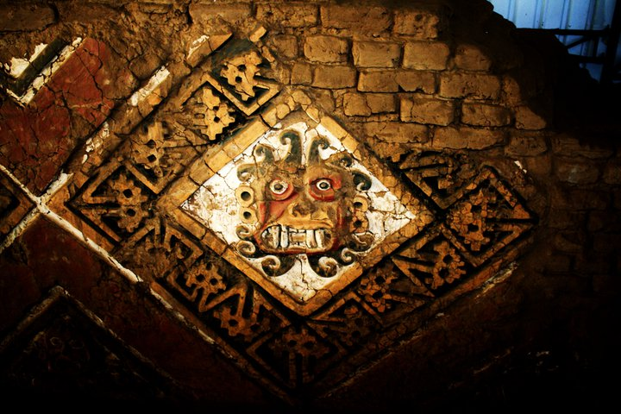
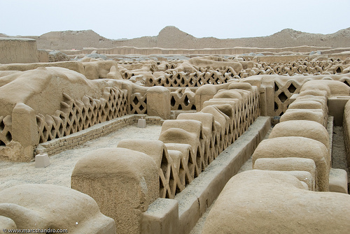

Day 2: Trujillo / Chiclayo (B/L/-)
We will start with a city tour of one of the most beautiful colonial town of northern Peru: Trujillo, founded in 1534. We will walk through its streets full of mansions and architectonic masterpieces expressed in the diverse style of construction: the neoclassical and rococo styles among others.

After, we will continue our visit with the archaeological complex El Brujo was one of the most important religious and political centers of the Moche culture (100 - 750 AD) as well as some of the most beautiful pyramids they built in the Chicama Valley. Offering visitors one of the best exhibitions of mural art of this culture, as most of its walls and walls are decorated with high relief representations using different colors. (Half Day)
Lunch in Pacasmayo City.

Transfer to Chiclayo and overnight stay.
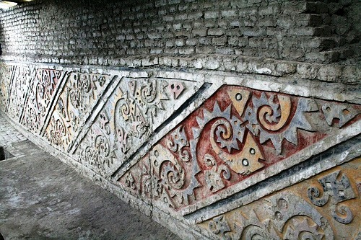
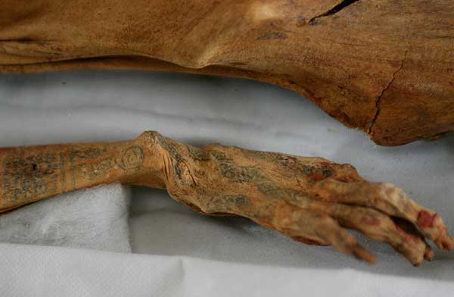
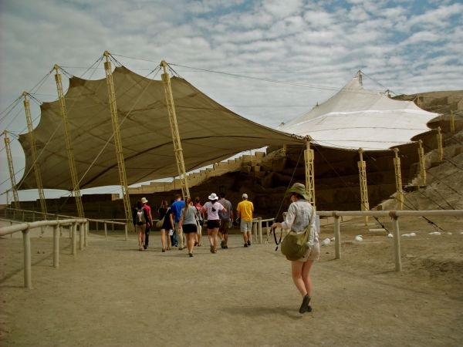

Day 3: Chiclayo (B/L/-)
At the appropriate time we will began our journey with the Sican National Museum, a place that will allow us to open the door to the knowledge of the lifestyle of the ancient people who made of the dry forest a strategic point for developing one of the most important cultures of northern Peru: Sicán, also known as Lambayeque.

The next point to know will be the Historical Sanctuary of the Forest of Pomac that in the light of the archaeological and wildlife research conducted during the past years, can only confirm the mystical and sacred source of dry forest. It stands imposing and vigorous, being the oldest and best preserved equatorial dry forest of 5,887.38 ha.

The Forest of Pomac not only conserve species of endemic flowers and wildlife but also the highest concentration of Temples-Mausoleum of the Sicán Cultural Core of Lambayeque, Hispanic culture to which we owe the world identification of the sacred gold of the ancient Peru; such as ceremonial knives called "Tumi" and the magnificent funerary masks, masks of Winged Eyes.

Precisely on this particular place, we will start our visit knowing “the millenary tree”, of hundreds of years, being an icon of veneration for the local populations, who are the guardians of Myths and legends created around this particular tree.

We will continue the visit with the Point of view of the Salinas, a place that will allow us to appreciate a panoramic view of the ecological character of the forest, and also to understand its integration to a whole cultural system, biological, and ancestral in Lambayeque. From there we will have a closer approximation to the interpretation of the archaeological importance having been the cradle Pomac Forest of the most important pre-Hispanic cultures of northern Peru: Lambayeque culture, also called Sicán.

Then through a walk we will go to the Community of Pomac III, which people will receive us with the kindness which characterize them and will be proud to show us the fruits the generous Forest brings them.

During this visit we will appreciate The Peruvian Native Cotton (Gossypium barbadense) established as a legacy the ancient Peruvian people left to the world; as it was these through different cultures they used, developed and improved the use of this natural colored fiber for 5000 years to the present. One of its particularities is its natural range of colors which in the ancient times reached up to 11 shades of color giving the garments and costumes wore by the ancient inhabitants and officers of Lambayeque. We will know from the Cotton from the farmers themselves who will explain in the field the process of the sow, the rigorous care and harvest of this input that contributed significantly in the development of the civilizations of the Peruvian coast.
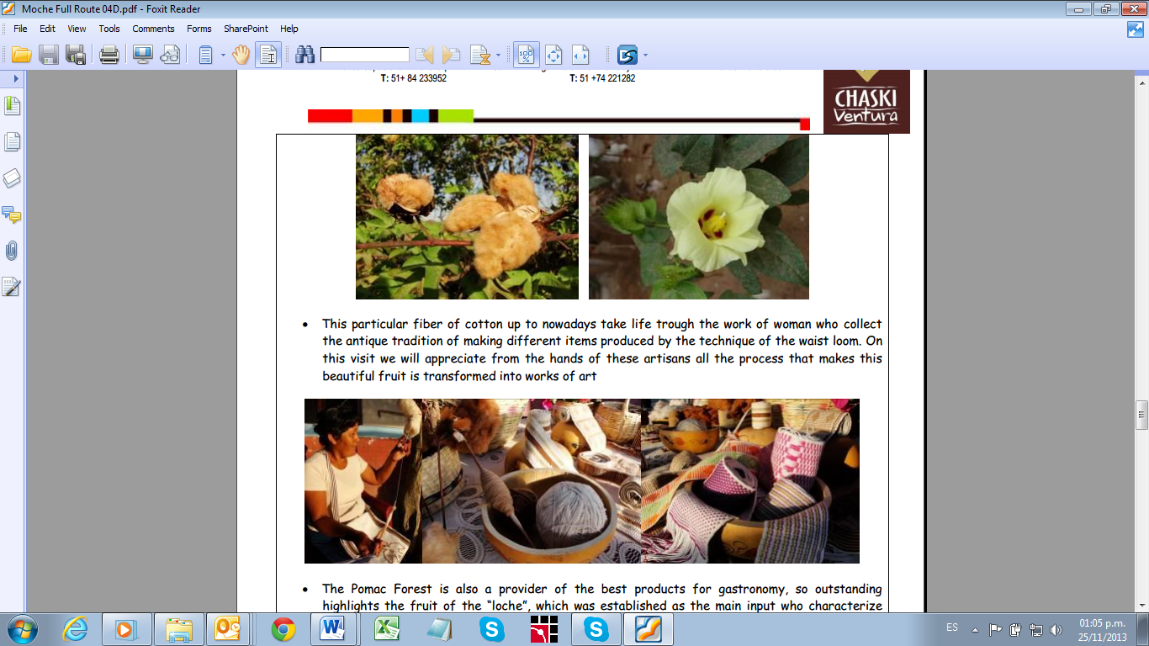
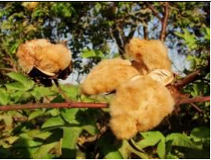

This particular fiber of cotton up to nowadays take life trough the work of woman who collect the antique tradition of making different items produced by the technique of the waist loom. On this visit we will appreciate from the hands of these artisans all the process that makes this beautiful fruit is transformed into works of art.

The Pomac Forest is also a provider of the best products for gastronomy, so outstanding highlights the fruit of the “loche”, which was established a s the main input who characterize the lambayecana food, which, has permitted to underline it as one of the best kitchens of Peru.

Particularly the area of the Forest of Pomac is recognized to be the lands where they cultivate the best “loche” of Peru. As a proof of its particular contribution to the food, we will taste a typical example of the regional gastronomy, prepared by the hands of the community people who keep the secret of the time that haunted the old masters of pre-Hispanic Peru and as at nowadays remains a national and world recognition.

After, we will visit Tucume and the Valley of the Pyramids: Pyramids and 26 religious groups spread on 220 hectares. Tucume is the biggest Archaeological Opencast Complex in the world, in the middle of an arid desert with a beautiful dry forest.

Return to hotel and overnight in Chiclayo.

Day 3: Chiclayo / Lima (B/-/-)
In the morning, we will visit Huaca Rajada, the place where the Lord of Sipán was discovered and we will learn about the Moche culture.
Actually, the Lord of Sipan was a member of the Moche dynasty and the archaeologists tried to find out who exactly he was. According to recent excavations, it seems this man was the fourth character in the hierarchy. We will visit the fair new Site Museum of Huaca Rajada that exhibits his remains.
Our next point will be Lambayeque, where a delicious meal will be awaiting us.
After lunch, we will visit the National Museum Tumbas Reales, whose design was inspired by the Mochica truncated pyramids. The Museum is listed as the most modern in Latin America and one of the ten best in the world. The Royal Tombs Museum shelters real gems of Mochica art and keeps the remains of the old dignitary of Sipan.

Finally, transfer to the Chiclayo airport to get your flight back to Lima.

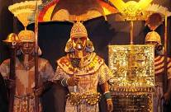
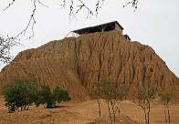
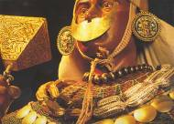

END OF OUR SERVICES

B= Breakfast L= Lunch D= Dinner BL = Box Lunch

RATES PER PERSON - 2016

Comissionable rates in USD  (land services) | 02 pax | 04 pax | 05/09 pax | Single Supp
Program in DWB room | 998.50 | 879.60 | 823.50 | 208.30
Airfare Lima/Trujillo & Chiclayo/Lima* | 450.00 | 450.00 | 450.00 | 450.00

* Current NET airfares are subject to change by the airline without notice.

NOTES

IMPORTANT NOTES
- No reservations have been placed
- This is a preliminary costing; hotels may vary according to availability
- No airfares or airport taxes included in above given rates
- Airfare Lima/Trujillo - Chiclayo/Lima US$ 450.00 net per person, subject to change.
- Airport taxes for domestic flights are included in the above air fare
- International departure tax from Lima should be included in the int’l air fare; please verify
* Airfares are referential only. Actual rate are subject to availability at time of purchase and type of ticket (refunds and changes allowed/not allowed, penalties apply/not apply, etc)

INCLUSIONS
- Private transfers with local English speaking transferman and guides, except where otherwise specified.
- Private services with local English speaking guides as indicated in the itinerary, except where is indicated as shared.
- All entrance fees to the sites mentioned in the itinerary
- Meals: As indicated in the itinerary (B/L/D)
- 03 nights’ hotel accommodation
- All tips (except hotel staff & guides); additional tips are optional and voluntary.
- Permanent assistance during the trip

EXCLUSIONS
- International air fares or domestic air fares
- Meals or any other item not described in the itinerary
- Early check-in, late check-out, services and non-mentioned meals in the itinerary
- Personal expenses
- Drinks during meals, hotel extras and personal spending
- Tips for hotel staff & guides
- Local VAT taxes (18% applicable only to Peruvian and foreign residents of Peru; in order to be exempted you will need to show your passport)

HOTEL INFORMATION

City | Hotels quoted | Room category
Trujillo | Casa Andina Private Collection 4* Sup | Superior room
Chiclayo | Casa Andina Select Chiclayo 4* | Superior room

METROPOLITAN TOURING INFORMATION

 | ECUADOR | PERU | Argentina/Chile | COLOMBIA
City | Quito | Lima | Cordoba | Bogotá
Address | 45-74 De las Palmeras & De las Orquídeas Av. | 180, Del Pinar Av., Torre Pinar IV, Of. 1001, Chacarilla, Surco | 33, Derqui St. – 2nd floor, Of. B  (X5000GXA) | 85-61, Carrera 15 St. Of. 401
Fax | (+593) 2 3341250 | (+51 1) 7186051 | (+54-351) 5684156
Telephone | (+593) 22 988200 | (+51 1) 7155515 | (+54-351) 568 0088 | (+57 1) 6180244
Emergency Contact | (+593) 9 9215719 | (+51-1) 989258180 | (+54-351)9 153503180  (+54-351)9 153503187

