Nature Lovers with Amazon Discovery
(11D/10N)
Lima / Cusco / Sacred Valley / Machu Picchu / Iquitos / Pacaya Samiria Reserve

A truly unique and unforgettable combination specially designed for nature lovers.
Explore exhilarating UNESCO Natural Heritage sites and a New Wonder of the World as Machu Picchu…all in one journey.

DAY BY DAY ITINERARY

Day 01 - …../ Lima (-/-/-)
- Assistance at the airport in private service with English speaking transferman
- Overnight in Lima

Day 02- Lima / Cusco / Sacred Valley (B/L/-)
- Transfer Hotel – Lima airport in private service with English speaking transferman
- Transfer Cusco airport – Hotel in the Sacred Valley in private service with English speaking guide
- En route visit to Awanacancha, Pisaq ruins and Pisaq market in private service with English speaking guide
- Private Garden Lunch in the Sacred Valley
- Overnight in the Sacred Valley.

Day 03 – Sacred Valley (B/L/-)
- FD Chinchero, Maras saltpans, Moray Terraces and Ollantaytambo fortess in private service with English speaking guide
- Lunch at local restaurant
- Overnight in the Sacred Valley

Day 04 – Sacred Valley / Machu Picchu (B/L/D)
- FD Machu Picchu by Vistadome train in private service with English speaking guide
- Buffet lunch at Machu Picchu Sanctuary Lodge
- Dinner at the hotel
- Overnight in Machu Picchu town

Day 05 – Machu Picchu / Cusco (B/-/-)
- Morning at leisure without guide
- PM: Return via Vistadome train to Cusco.
- Transfer to the hotel in private service with English speaking transferman
- Overnight in Cusco
Day 06 – Cusco (B/-/-)
- AM: Cusco Walking city tour including San Blas, The Cathedral, Korirancha and MAP Museum in private service with English speaking guide
- PM: Afternoon at leisure.
- Overnight in Cusco.

Day 07 – Cusco / Lima / Iquitos (B/-/D)
- AM: Transfer to the airport in private service with English speaking transferman
- Assistance at Lima´s airport for your connecting flight to Iquitos.
- 04d/03nts program at Amazon Discovery Cruise (Fixed departures)
- Overnight onboard.

Day 08 – Iquitos (B/L/D)
- 04d/03nts program at Amazon Discovery Cruise (Fixed departures)
- Overnight on board.

Day 09 – Iquitos (B/L/D)
- 04d/03nts program at Amazon Discovery Cruise (Fixed departures)
- Overnight on board.

Day 10 – Iquitos / Lima (B/L/-)
- Transfer to the airport in Iquitos.
- Arrival in Lima and assistance for your international flight connection.

Day 11 – Lima / … (B/-/-)
- AM: City tour Colonial and Modern Lima in private service with English speaking guide
- At proper time, transfer to the airport for your international departure

ITINERARY DESCRIPTION

DAY 1: … / Lima (-/-/-)
Upon arrival in Lima International Airport, you will be met by our representative and transferred to Costa del Sol Ramada Hotel located at the airport. Our representative will assist you with check-in procedures and provide you with a detailed itinerary, vouchers covering all the services included in your tour and additional information on the organization of your Peru trip. You will also receive a contact information sheet with all the hotel details as well as our offices contact information for each city and a 24-hour emergency number. Overnight in Lima.

DAY 2 : Lima / Cusco / Sacred Valley (B/L/-)
Early in the morning transfer to Lima Airport to board your flight to Cusco (1 hour aprox.) Upon arrival to the capital of the Inca’s Empire transfer with assistance to the hotel in Sacred Valley of the Incas. On the route to the valley you will take a chance to stop at Awanacancha to observe traditional Andean weaving and to see the four types of camel-related Andean animals – llamas, guanacos, alpacas and vicunas. Alpacas have thick wool and is the most commonly used while the vicunas are small and delicate with fur considered the finest. Awanacancha is a weaving center with the goal to keep alive the traditional textile arts. Here you can meet these four types of camelids, learn about the harvesting of the different wools and the natural dying techniques and have a chance to see native weavers from different areas showing their different weaving styles.

Visit the town of Pisac, where the Incas built an observatory t o study astronomy as well as an impressive network of cultivated terrace. After this, you will have the opportunity to bargain with vendors at the local handicraft market.

Garden Lunch at Belmond Hotel Rio Sagrado.
Hidden away from the outside world, El Jardin restaurant is the perfect spot to enjoy a delicious lunch surrounded by the great outdoors. Select a table in the warm sunlight or the cool leafy shade. Relax to the sounds of birdsong and gently flowing water. Using the best locally-sourced ingredients, our garden lunches and homemade breads are not to be missed.

Return to the hotel and overnight in the Sacred Valley.


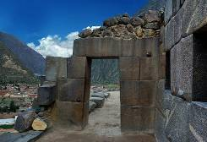
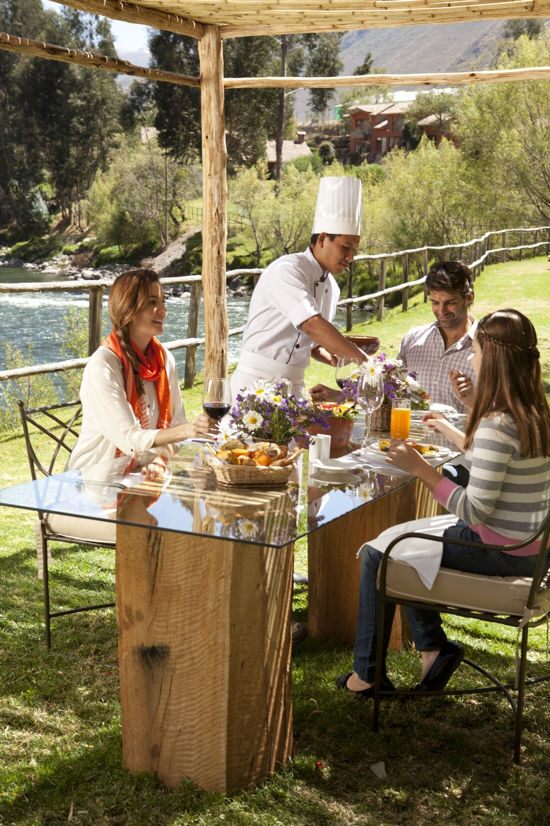

DAY 3 : Sacred Valley (B/L/-)
Start your day with the Visit of Chinchero Village. An attractive church built during the Colony is the highlight of this village and on the inside hang lovely paintings from the Cusco School. Yet, it is on Sundays that the action really starts to happen when area merchants and farmers assemble at the flea market to buy and sell, using the age old method of bartering for goods. Likewise, you can visit impressive archeological remains in the area.
Continue to Maras and Moray; two still relatively unknown sites for the mainstream traveler, which we definitely recommend visiting during your stay in Cusco. The salt mines of Maras are an arrangement of terraces, where salt is gathered in small pools, which are filled by hot spring waters containing an astonishing percentage of salt.

These springs have been exploited since Inca times. It proves to be an unforgettable experience when you see the sun reflected on the hundreds of white salt pools. Moray is something very different. Four natural depressions in the landscape were used by the Incas to build terraces that served them as a botanical laboratory to improve their harvest. The circular-shaped terraces still remain intact. After enjoying a delightful lunch at a local restaurant in the Sacred Valley, you will visit the Inca fortress of Ollantaytambo. The site was built just as the Spaniards arrived and evidence of how it was constructed is still visible. After seeing the magnificent past of the spot stroll through the quaint streets of the present town.

Overnight in the Sacred Valley.
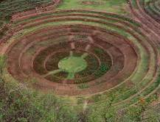
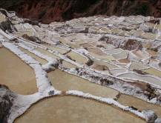
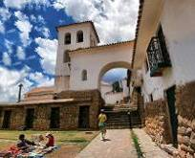

DAY 4 : Sacred Valley / Machu Picchu (B/L/D)
Your private guide will meet you at your hotel early this morning. You will be driven to the train station to board the Vistadome train, for a dramatic train ride to Machu Picchu (6180 feet), the great mountain-top city abandoned by the Inca Empire, reclaimed by the jungle and lost to humanity until its rediscovery in 1911. The legendary 'Lost City of Machu Picchu' is without a doubt the one of the world's most impressive archaeological sites. Built by the Incas on the summit of "Machu Picchu" (Old Peak), overlooking the deep canyon of the Urubamba river in a semi-tropical area 120 Km. (75 miles) from the city of Cusco at 7,000 feet above sea level. It sits on a mountain site of extraordinary beauty, in the middle of a tropical mountain forest; Machu Picchu was probably the most amazing urban creation of the Inca Empire at its height, with its giant walls, terraces and ramps, which appear as though they have been cut naturally in the continuous rock escarpments.
Machu Picchu is also one of the Inca's best kept secrets, since they did not left written records and Spanish chronicles make no mention of the citadel, it remains a mystery. Upon arrival to the ruins, a guided tour of the lost citadel.
Lunch included at Machupicchu Sanctuary Lodge´s Tinkuy Restaurant. Dinner included at the hotel.
Overnight in Machupicchu.
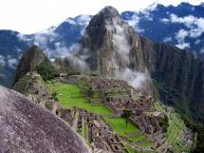
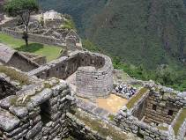
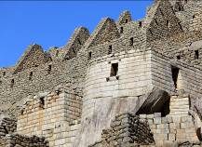

DAY 5 : Machu Picchu / Cusco (B/-/-)
Check out at 10am. Morning at leisure without guide. (2nd entrance fee NOT included)
Excellent opportunity to wake up early and enjoy with a beautiful sunrise. Then, you will have time visit the Citadel of Machu Picchu for the second time.
In the afternoon, back to Cusco by train, and transfer to your hotel.
Overnight in Cusco.

DAY 6: Cusco / Lima (B/-/-)
Walking city tour, including a visit to the district of San Blas, with its winding streets, the whitewashed houses, the blue balconies hung with geranium-filled flowerpots, the uneven line of the tiled rooftops and the endless stairways. In the neighborhood live the folk artists of Cusco, who for centuries have used their hands to tell the tale of their longings and frustrations working in stone and woodcarving, sculpture, doll-making, silverware, weaving and textile arts, gold-leaf, mask-making, and an array of ceramics in utilitarian, architectural, sculptural, monumental, grotesque and many other styles for example Edilberto Merida, renowned sculptor. He looked to religion for his primary inspiration, but he moved away from traditional religious images, by making grotesque images with exaggerated features. It is a form of sculpture that has come to be known as "mud of protest." His style is one of expressionism and has thus been referred to as Expresionismo Indio. Then visit the Pre-Columbian Art Museum, the only museum in Peru dedicated to rebound the arts of ancient Peruvian cultures. The collection of 450 master pieces date from 1250 B.C to.1532 A.D.
Continue with a visit to the Cathedral, the Main Square, the Korikancha temple.

PM: Transfer to the Cusco airport. Arrival in Lima and transfer to the hotel.
Overnight in Lima.
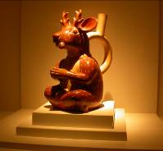
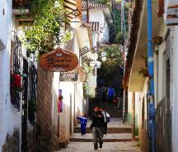


DAY 7: Lima / Iquitos (B/-/D)
Transfer to the airport for your flight to Iquitos.
Iquitos is a bustling river city and the largest in the Peruvian Rainforest. The Metropolitan area has 600,000 people living in its four districts.
During the 20th century the city attracted many Europeans immigrants; they contributed to a period of great wealth and social and commercial development. The rubber boom and the associated need for a large workforce had a significant negative effect on the indigenous population. Slavery and gross human rights abuses were widespread, and in some areas 90% of the Indian population was wiped out.

Transfer by coach to Embarkation port at the Itaya River just front of Iquitos City. Embark ship. After a short orientation and Happy Hour, enjoy your first night’s dinner onboard.
Overnight on board.

DAY 8: Iquitos (B/L/D)
Am: Tahuayo River
This morning we will have the chance to search for the most elusive and exotic fresh water pink river dolphin, medium sized, long snout and little or no dorsal fin you will see that they are really pink, This is a favorite feeding spot for these dolphins. Opportunity to jump into the dark waters and enjoy a refreshing swim in this pristine area.

Pm: Yarapa River and creeks.
Another tributary of the Amazon River, along Yarapa River, you will explore its shores and small creeks in search of rare and unusual Amazonian wildlife. Small monkeys, birds, and iguanas are just some of the creatures on our list. Tropical flowers and plants grow wild along the riverbanks, allowing you to witness the marvelous dynamics of the Amazon Rainforest.
Overnight on board.

DAY 9: (Tuesday) Iquitos (B/L/D)
Cano Piranha or Marayali/Tamishiyacu Creek/San Francisco Village
Am: Amazon Headwaters, skiff exploration at Cano Piranha or Marayali, San Francisco Village.

This morning you awake in the historic place of the Peruvian Amazon where the Ucayali & Marañon Rivers merge and give birth to the mighty Amazon River. After exploring the area, visit the community named San Francisco where you can stroll around the small village, seeing the local people’s houses and how simple their daily life is. You will be warmly greeted by lots of happy and smiling children and an opportunity to visit the school (pending school in session). The local teacher will also be there to answer any questions you have. Meet the local townspeople in the arts and craft market, led by the village women and children.

Pm: Tamishiyacu creek
This tributary of the Amazon River has small clusters “ribereños” people (those who live symbiotically with the rivers) who make their living with small scale agricultural and charcoal commerce. Visit a local shamanic healing clinic and meet with a native shaman who will introduce you into the mythical world of hallucinogenic and medicinal plants in this region of the Peruvian Amazon Rainforest.

DAY 10: Another destination or back home (B/L/-)
We will have a panoramic city tour, remember that Iquitos is the farthest inland port that serves ocean vessels in the world. We will pass thru the remains of wonderful houses that hosted “Rubber Barons” in the beginning of the 20th century.
After disembarkation, we will visit the Manatee Rescue Center, a fantastic project that is committed to save orphaned manatees and reinsert them in the wild. You´ll learn about them and why they are so endangered in this part of the Amazon.

END OF OUR SERVICES
B= Breakfast L= Lunch D= Dinner

RATES PER PERSON 2016

Commissionable rates per pax sharing double/twin room (USD) | 01 pax | 02 pax | 04 pax | SGL SUP
Standard Category | 4,695.50 | 4,157.00 | 4,210.00 | 1,564.00
Superior Category | 5,240.00 | 4,701.00 | 4,755.00 | 2,176.00
Deluxe Category | 6,479.00 | 5,940.00 | 5,994.00 | 3,375.00
Airfare Lima/Cusco/Lima & Lima/Iquitos/Lima (*) |  | USD | 840.00
(*) Current NET airfares are subject to change by the airline without notice.

NOTES

IMPORTANT NOTES
- This itinerary starts on Mondays only.
- No reservations have been placed
- This is a preliminary costing; hotels may vary according to availability
- No airfares or airport taxes included in above given rates
- Airfare Lima/Cusco/Lima and Lima/Iquitos/Lima US$ 860.00 net per person, Air fares are referential only. Actual rate are subject to availability at time of purchase and type of ticket (refunds and changes allowed/not allowed, penalties apply/not apply, etc)
- Domestic airport taxes are included in the above air fare
- International departure tax from Lima should be included in the int’l air fare; please verify
- All entrance fees are subject to change without previous notice
- Prices valid for 2016, except on Inti Raymi dates (Jun20/27), Christmas & New Year (Dec22/Jan03) and other National or Religious Holidays when special rates may apply; please verify

The itinerary includes:
- Transportation airport / Hotel / airport
- 10 nights’ accommodation in a double room.
- M/V Amazon Discovery Cruise (Fauna Cabin) Package includes accommodations, all meals, Amazon sightseeing, naturalists and lecture services, shared excursions aboard the skiffs and any other activity included in the package.
- Private land services with local English-speaking guides.
- Jungle excursions will be provided in shared basis.
- Meals as indicated in itinerary (B/L/D)
- Tickets from entrance to Machu Picchu and archaeological sites mentioned in the itinerary.
- Tickets for round trip bus from Machu Picchu to Aguas Calientes (Machu Picchu)
- Round trip tickets on the train service from the Sacred Valley Vistadome.
- Permanent assistance by our offices in each city.

The Itinerary does not include:
- International and domestic air tickets.
- Meals or any other item not mentioned in the itinerary.
- Tips to guides and hotel staff.
- Local Peruvian Taxes (18% tax is applicable only to Peruvian, foreigners living in Peru, or tourist staying more than 60 days in Peru).

HOTEL INFORMATION

Alternative Standard
City | Hotels quoted (or similar) | Room category
Lima | Hotel Jose Antonio | Standard room
Sacred Valley | Sonesta Posada del Inca Yucay | Standard room
Machu Picchu | El Mapi Hotel | Superior room
Cusco | Hotel Jose Antonio | Standard room
Lima | Hotel Jose Antonio | Standard room
Iquitos | Haimark Amazon Discovery Cruise | Fauna cabin

Alternative Superior
City | Hotels quoted (or similar) | Room category
Lima | Casa Andina Private Collection Miraflores | Standard room
Sacred Valley | Hotel Aranwa Sacred Valley | Deluxe Room
Machu Picchu | Inkaterra Machu Picchu Pueblo | Superior Deluxe Room
Cusco | Aranwa Cusco Boutique Hotel | Classic Room
Lima | Casa Andina Private Collection Miraflores | Standard room
Iquitos | Haimark Amazon Discovery Cruise | Fauna cabin

Alternative Deluxe
City | Hotels quoted (or similar) | Room category
Lima | Belmond - Miraflores Park Hotel | Ocean View Junior Suite
Sacred Valley | Belmond - Rio Sagrado Hotel | Deluxe Terrace room
Machu Picchu | Belmond - Machu Picchu Sanctuary Lodge | Superior room
Cusco | Belmond - Hotel Monasterio | Superior room
Lima | Belmond - Miraflores Park Hotel | Ocean View Junior Suite
Iquitos | Haimark Amazon Discovery Cruise | Fauna cabin

Fixed Departures 2016

2016
3-night Cruise
February 14
February 17
March 12
April 14
April 17
May 14
May 17
July 13
July 16
September 17
September 20
October 23
October 26
November 16
November 19

AMAZON DISCOVERY: TERMS & CONDITIONS

Any and all information contained herein is subject to change at any time.

Itinerary arrival and departure times are always subject to change without notice. Haimark S.A., Ltd. (the operator of the Amazon Discovery) reserves the right to cancel, alter, advance, postpone or substitute any scheduled sailing or itinerary, substitute another vessel for the scheduled ship, or substitute or cancel scheduled ports of call, which, in its sole judgment and discretion, is justified for any reason, and to do so without liability for any loss whatsoever to guests as a result of said change(s). Additionally, it reserves the right to cancel reservations and bookings in the event of a full-ship charter, whether or not a deposit or full payment has been received, and in such event, the operator‘s only liability will be to refund to the guest the amount it has received.

Haimark S.A., Ltd. makes arrangements for transportation, other than cruise passage, only as a booking agent. Haimark S.A., Ltd.’s responsibility does not extend beyond the vessel. In arranging for the transportation of guests to and from the ship, Haimark S.A., Ltd. does so with independent contractors. Haimark S.A., Ltd. is not responsible for incidents such as airline cancellations, re-routings or any disruption of scheduled services or accommodation, or lost luggage.

All fares are subject to change at anytime without notice and do not guarantee availability.

Travel documents will not be dispatched until full and final payment and passenger contact information has been received and cleared.

Contact information shall mean a passenger’s:
- full name
- passport number
- address
- telephone number (land and mobile)
- electronic mail address
- emergency contact information and
- any other information as requested by Haimark S.A., Ltd.
- It must be possible to reach each passenger’s emergency contact at any time of day, therefore contact information must be provided to do so. Such information should include the name, address, electronic mail address (if available) and phone number (including a cell phone number if available) of a parent, guardian, spouse, domestic partner, or other person to contact in the event of an emergency.

No passenger will be allowed to embark unless Haimark S.A., Ltd. has received all information.

CRUISE TARIFF

Cruise fares cover certain shipboard services including: accommodations, shore excursions, onboard meals and entertainment, complimentary beverages aboard ship where noted in the respective cruise program brochure.

All fares are quoted in US dollars, are per guest and based on double occupancy. Not included in your cruise tariff are: airfare, hotel accommodations, optional shore excursions, meals ashore (unless otherwise noted), beverages not highlighted as included, fuel surcharges, laundry (unless otherwise noted), purchases from the ship boutique or any item or service of a personal nature such as medical care, massages, and spa treatments.

DEPOSIT/FINAL PAYMENT
To reserve your cruise, a $850. per person deposit of the cruise fare is required at the time of booking.

Final payment is due no later than 120 days prior to departure. Final documentation will be issued after receipt of final payment and approximately 30 days prior to sailing.

All reservations are subject to cancellation if payments are not received by the due date, and are guaranteed only when paid in full 120 days prior to sailing.

Reservations made within 120 days of sailing require full payment within seven days of booking or sooner.

CANCELLATIONS/REFUNDS

Should you find it necessary to cancel your reservation submit your cancellation in writing via E-mail to the account executive with whom your original reservation was placed and confirmed.

If your cancellation request is received more than 120 days prior to your initial sailing date, a $500 non-refundable administrative fee will be charged per booking. This administrative fee cannot be converted to a future cruise credit.

Cruise cancellation requests received within 120 days of the initial sailing date will be subject to the following charges, regardless of suite resale:
- 120 – 91 days prior to the initial sailing date: 50% of the total cruise fare per person
- 90 – 0 days prior to the initial sailing date or nonappearance at the time of sailing: 100% of the total cruise fare per person.

Cruise tickets must be returned before refunds (if owed) can be processed.

HEALTH AND MEDICAL REQUIREMENTS

All guests are required to report in writing at the time their reservation is made:

- Any physical or mental condition that may require medical or professional treatment or attention during the voyage

- Any condition that may render the guest unfit for travel, or that may require special care or assistance

- Any condition that may pose a risk or danger to the guest or anyone else onboard the ship

- Any condition that may require oxygen for medical reasons

- Any intention or need to use a wheelchair cart, other mobility device

By booking passage and by boarding the ship, the guest represents and warrants that he/she is physically and otherwise fit to travel, and that the guest will comply at all times with applicable rules and regulations of the ship and orders and instructions of the ship’s officers.

Haimark S.A., Ltd. reserves the right without liability to require a guest to disembark and/or to refuse to board and transport a guest who, in the judgment of Haimark S.A., Ltd. or the ship’s Captain, is unfit to travel or may require care beyond that which Haimark S.A., Ltd. is reasonably able to provide.

Haimark S.A., Ltd. strongly recommends that guests are able to navigate the stairs on-board without assistance. Should guests require assistance, they must travel with someone who is able to assist them both ashore and onboard. Haimark S.A., Ltd. is unable to offer special assistance. Please note that wheel- on and/or wheel-off access is not available at ports-of-call.
ABOUT CHILDREN
7 years old minimum on all departures.

BAGGAGE

You may bring aboard the ship a reasonable amount of clothing and personal effects without charge. Airlines are strict with baggage limitations. Guests are encouraged to contact individual airlines for weight limitations.

All baggage must be securely packed, and properly and clearly labeled. Liquid, fragile, perishable and other articles not suitably packed are transported at your own risk. Haimark S.A., Ltd. is not responsible for loss or damage to baggage or any other personal item during air travel or land extension programs.

Baggage and personal belongings will be taken off the ship upon guest disembarkation. Under no circumstances will baggage be stored onboard without the owner of such baggage being on the vessel. Haimark S.A., Ltd. is not responsible for baggage stored in shore side facilities.

Under no circumstances may dangerous items (including but not limited to: explosives, firearms, combustible or illegal substances) be taken aboard the ship. We recommend that you hand-carry travel documents (passport, visa, cruise tickets), medications and valuables. These items are the full responsibility of the guest at all times. Haimark S.A., Ltd. shall not be responsible for the loss of, or damage to, such personal items.

LOST PROPERTY

Haimark S.A., Ltd. may levy a charge for the return of personal items left onboard or lost and subsequently found.

TRAVEL DOCUMENTS

All travel documents (air and cruise tickets, passport and medical insurance information) are the guest’s responsibility. It is also the guest’s responsibility to obtain any necessary visas and public health documents for all applicable ports and to comply with all customs requirements.

TAXES, GOVERNMENT FEES/ QUASIGOVERNMENT FEES AND FUEL SUPPLEMENTS

Haimark S.A., Ltd. reserves the right to charge a per person fuel supplement in the event that the price of fuel increases up to and including the day of embarkation. Haimark S.A., Ltd. may collect any taxes, government fees/ quasigovernment fees and fuel supplement (the “Surcharges”) at the time of booking, prior to sailing or on board the vessel, even if the cruise fare has been paid in full. Surcharges will be invoiced accordingly.

All fares, and itineraries are subject to change without notice. Additional restrictions may apply. Haimark S.A., Ltd. reserves the right to correct any errors or omissions.

