Peru & Bolivia
13d/12nts
Private services

Travel along highland countries, cradle of the Inca culture where ethnography and ecology are preserved in their original state and might be seen through their colorful living cultures.

DAY BY DAY ITINERARY

Day 1 – Lima (-/-/-)
- Arrival to Lima, transfer airport - hotel in private service with English speaking transferman
- Overnight in Lima

Day 2 – Lima / Cusco (B/-/-)
- Transfer hotel - Lima airport in private service with English speaking transferman
- Arrival in Cusco and transfer to the hotel in private service with English speaking transerman
- PM: City tour and 04 nearby ruins in private service with English speaking guide
- Overnight in Cusco

Day 3 – Cusco / Sacred Valley / Cusco (B/L/-)
- FD Sacred Valley: Visit Pisac Market and Ollantaytambo fortress in private service with English speaking transferman
- Lunch at local restaurant
- Overnight in Cusco

Day 4 – Cusco / Machupicchu / Cusco (B/L/-)
- Transfer to the train station in private service with English speaking guide
- Vistadome train ticket to Machupicchu (RT)
- FD excursion to Machupicchu in private service with English speaking guide
- Lunch at local restaurant in town included
- Transfer train station / Hotel in private service with English speaking guide
- Overnight in Cusco

Day 5 – Cusco / La Paz (B/L/-)
- Transfer to Cusco airport in private service with English speaking transferman
- Arrival in La Paz and transfer to the hotel in private service with English speaking transferman
- Lunch at local restaurant included
- PM: City tour and Moon Valley excursion in private service with English speaking guide
- Overnight in La Paz

Day 6 – La Paz / Uyuni / Tunupa Volcano / Colchani (B/BL/D)
- Transfer to the airport in private service with English speaking transferman
- Arrival in Uyuni and transfer to the hotel
- FD Excursion to the Salt falts in private service with English speaking guide
- Box Lunch included
- Dinner at the hotel included
- Overnight at a salt Hotel

Important: Please note itinerary might change during the rainy season (Nov. - Apr. approx.)

Day 7 – Colchani / Galaxy Caves/ Salt Flat / Colchani (B/BL/D)
- Guided Visit the Galaxy Caves, the Devil’s cave and the Incahuasi Island in private service with English speaking guide
- Box Lunch included
- Dinner at the hotel included
- Overnight at a salt Hotel

Important: Please note itinerary might change during the rainy season (Nov. - Apr. approx.)

Day 8 – Colchani / Uyuni / La Paz (B/BX/-)
- Transfer to the airport in private service with English speaking transferman
- Arrival to La Paz and transfer to the hotel in private service with English speaking transferman
- PM: HD Excursion to Tiawanaco Archaeological Complex in private service with English speaking guide
- Box lunch included
- Overnight in La Paz

Day 9 – La Paz / Sun Island (B/L/D)
- Land transfer from La Paz to Huatajata port in group service with English speaking guide
- Catamaran cruise to Sun Island in group service with English speaking guide
- Lunch on board the Catamaran
- PM Visit the Challapampa Village & enjoy a Cross Cultural Integration with the Native Community
- Candle light dinner and onvernight on board the Catamarn

Day 10 – Sun Island / Inti Wata Complex / Copacabana / Puno (B/L/-)
- Visit the Pilkokaina Palace and Inti Wata Complex with the Inca Staircase & Sacred fountain in group service with English speaking guide
- Buffet Lunch on board the Catamaran
- Continue to Copacabana and visit the Sanctuary in group service with English speaking guide
- Overland transfer to Puno in group service with English speaking guide
- Transfer to your hotel
- Overnight in Puno

Day 11 – Puno (B/L/-)
- FD excursion to Uros floating island and Taquile in private service with English speaking guide
- Lunch included at local house in Taquile
- Overnight in Puno

Day 12 – Puno / Juliaca / Lima (B/-/-)
- Transfer Hotel – Juliaca airport in private service with English speaking guide
- On the way visit the Sillustani Tombs.
- Arrival in Lima and transfer to the hotel in private service with English speaking transferman
- Overnight in Lima

Day 13 – Lima / … (B/-/-)
- AM: HD City tour and Larco Herrera Museum in private service with English speaking guide
- At proper tiem transfer and assistance with all departure formalities for your International homebound flight in private service with English speaking transferman

Special Remarks:
B = Breakfast L = Lunch D = Dinner BL = Box Lunch

ITINERARY DESCRIPTION

Day 1 – Lima -/-/-
Transfer Lima Airport / Hotel (private)
Upon arrival into Lima International Airport, you will be met by our representative and private driver and will be transferred to your hotel. Our representative will assist you with check-in procedures and provide you with a detailed itinerary, vouchers covering all the services included in your tour and additional information on the organization of your Peru trip. You will also receive a contact information sheet with all the hotel details as well as our offices contact information for each city and a 24-hour emergency number.

Day 2 – Lima / Cusco B/-/-
Transfer Hotel / Lima Airport (private)
At the appropriate time, our representative will meet you at the hotel lobby and transfer you to the Lima Airport to board your flight to Cusco. Our representative will assist you with check-in procedures and all departure formalities.

Transfer Cusco Airport / Hotel (private)
Upon arrival into Cusco Airport, you will be met by our representative and private driver and will be transferred to your hotel. Our representative will assist you with check-in procedures.

Remain of the morning at leisure to rest in order to avoid altitude sickness.

PM: Half day Cusco City tour & main surrounding ruins (private)
Enjoy a guided sightseeing tour of the city of Cusco, the Imperial City and archaeological capital of South America, where you will be able to admire the finest examples of Inca history and architecture. Visit the city's most important historical monuments that reveal the influence of different cultures: the Plaza de Armas, the Cathedral dating from Spanish viceroyalty times, built with great slabs of red granite renaissance style in contrast with the baroque style silverwork of its interior and, the Santo Domingo church built upon the foundations of the Inca temple Koricancha, dedicated to worship the Sun God.

Continue to Cusco City’s main surrounding ruins: the Sacsayhuaman Fortress - a ceremonial compound and magnificent example of Inca military power that boasts a panoramic view of the city, the Qenqo Amphitheater - a ritualistic site with subterranean galleries that form an underground maze, Puca Pucara or red fortress and, the Inca Baths of Tambomachay.

After the tour you will be transferred to your hotel and overnight in Cusco.
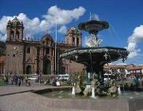
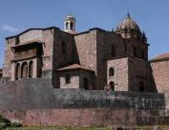
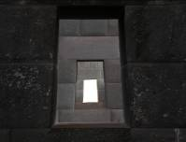

Day 3 – Cusco / Sacred Valley / Cusco B/L/-
Full day Pisac market & Ollantaytambo Fortress (private)
Today you will head to the town of Pisac, famous for its ruins but even more so for its market. Originally held only on Sundays, the Pisac Market was the place of reunion for all artisans of the region to get together and exchange or buy and sell their products.

During the XXth century, due to the increase of tourism in the area it became increasingly popular to the point that now it is held daily. It is a favorite destination for visitors from all over the world who don’t want to miss the opportunity of enjoying the colorful ambience in this marketplace. This is an excellent chance to share the peasants’ customs closely with plenty of time to explore and even barter all the goods and crafts typical of the areas around Cusco. Leisurely roam through the textiles and souvenir sections of the market.

Continue through the Sacred Valley for a visit to the Inca fortress and citadel of Ollantaytambo. This site was built just as the Spaniards arrived and evidence of how it was constructed is still visible. This fortress was believed to be constructed in order to guard the entrance to this part of the valley and protect it from possible invasions of tribes from the jungle lowlands. Later it served as a temporary capital for Manco Inca, leader of the Inca resistance in 1537 during the Spanish conquest of Perú, who fortified the town to stop the advance, as Cusco had fallen under Spanish domination.

Ollantaytambo also features the vestiges of the town built by orders of Inca Pachacutec and thought to be not only a strategic military place to control the Sacred Valley of the Incas, but also for agricultural and religious purposes. Additionally, this place is a ceremonial center dedicated to the purification and worship of water with 150 steps built with perfectly carved stones, very similar to those of Tipon. The archaeological site includes a series of superimposed terraces and stunning finely carved stone blocks located on the upper terrace or Temple of the Sun. The main settlement has an orthogonal layout with four streets crossed by other seven parallel streets and at the center the Incas built a large plaza about the size of four blocks.

The town of Ollantaytambo is referred to as a "Live Inca Town" because inhabitants still live according to customs and traditions inherited from their ancestors. Take a journey in time through its straight streets with perfectly laid stones that feature a canal for water to run through the town.

After the tour you will be transferred to your hotel.

Overnight in Cusco
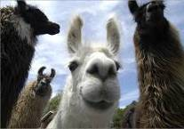
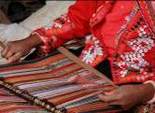
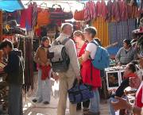

Day 4 – Cusco / Machu Picchu / Cusco B/L/-
Full day excursion to Machu Picchu via roundtrip train (private)
Morning transfer to the train station for an amazing train journey to the famous Inca Citadel of Machu Picchu, the great mountain-top city abandoned by the Inca Empire, reclaimed by the jungle and lost to humanity until its rediscovery in 1911.

Along the way you will enjoy the changing landscape as you travel from Andean highlands to the beginnings of the jungle (“eyebrow of the jungle”), before finally arriving at the town of Aguas Calientes.

From here, board the bus that will take you on a 20 minute ride up to the citadel of Machu Picchu, or Lost City of the Incas, which sits upon the summit bearing the same name, and is one of the most representative and recognized examples of Incan architecture. A guided tour of the Citadel includes the Main Plaza, the Circular Tower, the Sacred Sun Dial, the Royal Quarters, the Temple of the Three Windows and various burial grounds.

The legendary 'Lost City' is without a doubt one of the world's most impressive archaeological sites. Built by the Incas on the summit of "Machu Picchu" (old peak), overlooking the deep canyon of the Urubamba river in a semi-tropical area 120 Kms (75 miles) from the city of Cusco at 3,400 m.a.s.l (11,155 f.a.s.l).

It sits on a mountain site of extraordinary beauty, in the middle of a tropical mountain forest; Machu Picchu was probably the most amazing urban creation of the Inca Empire at its height, with its giant walls, terraces and ramps, which appear as though they have been cut naturally in the continuous rock escarpments.

Machu Picchu is also one of the Inca's best kept secrets, since they did not leave written records and Spanish chronicles make no mention of the citadel, it remains a mystery.

In the afternoon, return to Cusco by train and upon arrival at the train station you will be met by our representative and driver for your transfer to the hotel.

Overnight in Cusco.
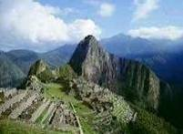
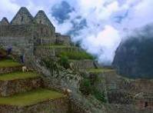
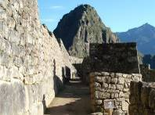

Day 5 – Cusco / La Paz (daily flights except Saturday) B/L/-
Transfer Hotel / Lima Airport (private)
At the appropriate time, our representative will meet you at the hotel lobby and transfer you to the Cusco Airport to board your next flight to La Paz. Our representative will assist you with check-in procedures and all departure formalities.

Upon your arrival to La Paz's airport you will be met by our transferman who will assist you with your luggage and drive you to the hotel for your check-in.
Lunch included in a local restaurant.

PM: HD City tour & Moon Valley (private)
Pick up passengers from the hotel to visit the famous Witch Doctor's Market, San Francisco Colonial Church and the typical handicrafts of the Sagarnaga Street.The tour continues to Plaza Murillo where the Cathedral, the Government Palace and the National Congress buildings are located. Then, visit the famous colonial street Jaen where interesting museums are clustered together, followed by a visit to the replica of the semi-subterranean temple of the Tiwanaku Culture. To change scenery the tour continues to the residential areas of Obrajes, Calacoto and La Florida. The tour ends with a visit to the unique Moon Valley, where passengers will have the opportunity to walk around, and visit a ceramic workshop with a demonstration of the art of pottery.

Overnight in La Paz.

Day 6 - La Paz / Uyuni / Tunupa Volcano / Colchani B/BL/D
Early this morning our representative will escort you to La Paz airport to board your flight to Uyuni (45 min).

Arrive to Uyuni and departure to visit the Colchani Town, the crafts and piles of salt, the Ojos del Salar and then we will cross the Salt Flat to The Tunupa Volcano, visit the surrounding, the Chantani Village, the Coquesa Mummies and the Pukara in Ayque. Box lunch on route

Dinner at the hotel and overnight at a Luna Salada hotel.

Note: Hot water and heating services in Uyuni, Salt Flats and Lagoons area are not permanent (this includes the Tayka and Salt hotels
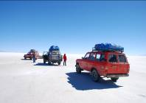
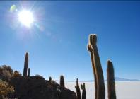


Day 7 – Colchani / Galaxy Caves / Salt Flats / Colchani B/L/D
Breakfast and pick up from the hotel to visit the Galaxy Cave, you will cross the Uyuni Salt Flat, visiting the Galaxy Cave, the Devil`s Cave and the Incahuasi Island. Lunch. At the end of the afternoon, we will enjoy the sunset, expecting until the sun disappears in the white desert, giving a must-see sight.
Return to the hotel.

Dinner and overnight stay at Luna Salada Salt Hotel.

Note: Hot water and heating services in Uyuni, Salt Flats and Lagoons area are not permanent (this includes the Tayka and Salt hotels

Day 8 – Colchani / Uyuni / La Paz B/BL/-
Pick up from your hotel to the airport for flight to La Paz.
Transfer from the airport to the hotel in La Paz.
La Paz Airport is located at 25 minutes from any downtown hotel.

PM: HD Visit to Tiwanaku archaeological complex (private=
Passengers are picked up from the airport to visit the epic city of Tiwanaku, the capital of an ancient civilization. Located 72 km away form the city of La Paz and near the south-eastern shores of Lake Titikaka. During its greatest times, the capital of Tiwanaku was the largest in the world and considered to be the Cradle of all American Civilizations. This pre-Inca ruins started endless archeological debates, the most recent radiocarbon 14 tests show that this edifications date back to 1580 B.C.
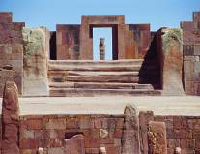
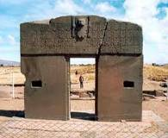
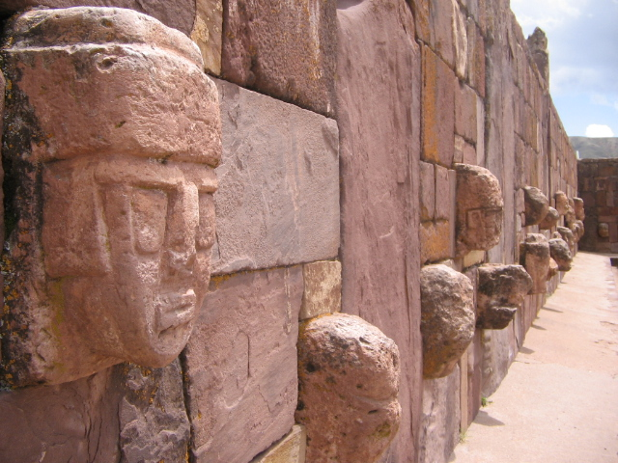

In this ancient breath taking city we will visit the Kalasasaya (Sun) temple, Semisubterranean (Earth) Temple, Akapana Pyramid and the legendary Sun Gate, the tour also takes us to the museum filled with ceramic objects and tools from previous civilizations prior to the Incas.

Return to the hotel and overnight in La Paz.

Day 9 – La Paz / Sun Island (North side) B/L/D
Early transfer to Titicaca Lake. Board the Catamaran Cruise Ship and sailing to Sun Island, the legendary birthplace of the Inca Empire. Buffet Lunch on board. Visit Challapampa Village and enjoy of the participative tourism, visitors have the opportunity to interact with one of the most unspoiled indigenous Titicaca villages through an innovative program organized with the local community visiting their own museum, chapel, school, a typical house, sailing in their vessels to an Inca holy temple, andean ritual and walking through Inca trails.

Romantic candle light dinner and overnight on board the Catamaran in lake view cabins with private facilities.

Day 10 – Sun Island / Inti Wata Complex Copacabana / Puno B/L/-
Catamaran Cruise Ship sails across the lake enjoying breakfast and the overwhelming panorama visiting the Pilkokaina Inca Palace. Continue to the Inti Wata Cultural Complex including the Ekako Underground Museum, the traditional medicine and the Titikaka Reed Shipbuilders display centers, the Pachamama agricultural Inca terraces, a handicraft center, the Intica lounge and at the Manco Kapac look out the largest variety of Andean camelids.Snack in the Complex. Visit the Inca Garden, steps and the Inca fountain Also, the Inti Wata Complex at Sun Island includes a unique sailing experience aboard a huge Titikaka Traditional vessel.

Buffet lunch on board while sailing to Copacabana. Visit the Sanctuary and land transfer to Puno.
Overnight in Puno.

Day 11 – Puno B/L/-
Full day excursion to the Uros & Taquile Islands with lunch (shared, via regular boat)
Early in the morning, you will have an unforgettable motorboat excursion on the waters of Lake Titicaca to the unique "Floating Islands" of the Uros.

These ancient inhabitants of the lake known as the Water Tribe have built their own islands by periodically adding new layers of a vegetable fiber of the Papyrus family called "Totora" (scientific Scirpus totora), which is unique to the area.
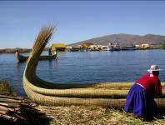
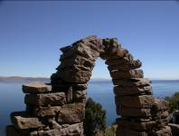
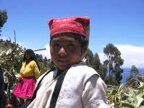

We continue our motorboat trip to Taquile Island, inhabited by Quechua-speaking natives who have developed efficient and unique social systems, as well as fine hand weaving techniques, passed down through the generations.

Upon arrival at the Town of Taquile you will have lunch at one of the local homes served by the owners, designated by the local authorities as they are a very well organized town so all their inhabitants may have equal opportunities with their visitors.

After lunch, take a walk through the various hills and archaeological sites of this 6 km long Island.

Return to your hotel in Puno after the visit and overnight in Puno.

Day 12 – Puno / Juliaca / Lima B/-/-
Transfer Hotel / Juliaca Airport (private)
At the appropriate time, our representative will meet you at the hotel lobby and transfer you to the Juliaca Airport to board your flight back to Lima. Our representative will assist you with check-in procedures and all departure formalities.

En route excursion to the Sillustani tombs (private)
Enjoy a guided excursion to the Sillustani tombs, a pre-Incan burial ground on the shores of Lake Umayo where you will be able to see the archaeological vestiges of these structures known as chullpas (tombs), ancient and impressive circular tower-like stone structures built above ground by the Colla tribe some 3000 years ago, before the Inca period.

Some of them are more than 12 meters high and housed the remains of compelty family groups, although most likely limited to bury nobility; the chullpas known as Lagarto and Intiwatana are the most prominent but there are over 90 tombs of different sizes and shapes, with some left unfinished.

Later the site was inhabited by the Incas, who made their own version of these towers reason why there are two types: the rough pre-Inca towers and the larger smooth ones built by the Incas. The biggest tower took about 50 years to build and consists of rocks of 2 to 6 tons.

After the tour you will be transferred to the Juliaca Airport.

Transfer Lima Airport / Hotel (private)
Upon arrival into Lima Airport, you will be met by our representative and private driver and will be transferred to your hotel. Our representative will assist you with check-in procedures.

Overnight in Lima.

Day 13 – Lima / …. B/-/-
Half day Lima City tour & Larco Museum (private)
Enjoy a half day guided sightseeing tour to the most attractive and important sites in Lima, the "City of Kings". Visit Lima's Historical Center, passing by Plaza San Martin, Plaza Mayor, the Government Palace, the City Hall, the Cathedral and its Religious Art Museum (closed on Sunday and Saturday pm; Santo Domingo Convent is provided instead on these days) as well as San Francisco Monastery and its famous underground crypts known as the Catacombs.

Continue your visit through the residential Districts of San Isidro and Miraflores, passing by the Huaca Pucllana, a Ceremonial and Administrative Centre of the Lima Culture built in the II Century A.C. that the Incas considered as "Ñaupallaqta" or Sacred Town. Also visit El Olivar Park with olive trees brought from Spain in the XVth Century, the Central Park of Miraflores and El Parque del Amor, or Peruvian Love Park.

The Love Park, located on the cliffs of Miraflores overlooking the Pacific Ocean, is a beautiful natural lookout, where you can see the waves of the Pacific rolling in towards the coast below and the Morro Solar in Chorrillos at a distance, with the coast extending further along the bay until the port of Callao. This is also the perfect spot for a romantic view of the setting sun in the late afternoon, right in front of you.

Your visit continues with a stop at the Larco Museum, for an excellent overview of Peru's ancient past as it holds the best private collection of pre-Columbian art in the country.

You will have the chance to tour through this old Hacienda House in the Pueblo Libre district, which was built upon a pre-Incan sacred site (huaca), housing the private collection of a great Peruvian scholar: Don Rafael Larco Hoyle.

The museum chronologically exhibits hundreds of ceramic, textile, metal and precious stone pieces and also inside you will find the vault which safeguards precious pieces of gold and silver with semiprecious stones.

The Larco Museum is one of the few museums in the world that allows such intimate access to its deposits, in this case around 45,000 pieces. Another attraction of the museum and of great interest to visitors is the exhibition of erotic pre-Colombian art. After the visit you will be driven to your hotel.

After the visit you will be driven to your hotel.
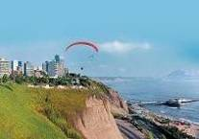
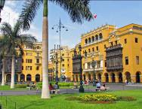
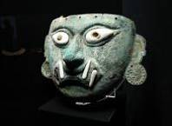

Transfer Hotel / Lima Airport (private)
At the appropriate time, our representative will meet you at the hotel lobby and transfer you to the Lima Airport to board your next flight. Our representative will assist you with check-in procedures and all departure formalities.

END OF OUR SERVICES

B= Breakfast L= Lunch D= Dinner BL = Box Lunch

GROSS RATES

Commissionable rates per pax sharing double/twin room (USD) | 02 pax | 03 pax | 04 pax | SGL SUP
Standard Category | 4,016.00 | 3,418.50 | 3,134.50 | 628.50
Standard Superior Category | 4,143.50 | 3,545.50 | 3,261.70 | 784.60
Superior Category | 4,410.70 | 3,813.00 | 3,529.20 | 1,052.10

Flight tickets (NET rates):
Lima/Cusco – Juliaca/Lima = Usd 450 aprox (Daily flights)
Lima / La Paz = Usd 320.00 aprox (Daily flights*)
La Paz / Uyuni / La Paz = 400.00 aprox (Daily flights*)

Actual airfares and frequency are subject to changes by the airline.

NOTES

- No reservations have been placed
- This is a preliminary costing; hotels may vary according to availability
- No airfares or airport taxes included in above given rates
- Air fares are referential only. Actual rate are subject to availability at time of purchase and type of ticket (refunds and changes allowed/not allowed, penalties apply/not apply, etc)
- All entrance fees are subject to change without previous notice
- Bolivia:
  - Saturdays and Sundays in the afternoon and Mondays all day the museums, Casa de la Moneda & Casa de Libertad are closed
  - Uyuni tours are for people that love adventure.
- Itinerary subject to change according to our operations department, weather conditions, change of the Schedule of the flights.
- Commisionable rates, valid for 2016, except on Inti Raymi (Jun 20/27), Christmas & New Year (Dec22/Jan03) and other National or Religious Holidays when special rates would apply; please verify

IMPORTANT
- During the rainy season (NOV – APR sometimes is more) the salt flat is full of water, paxs will visit only what is possible to and itinerary might change for these days
- In order to handle clients a correct information, we kindly request you to advice them that hotels in the area of the “Uyuni Salt Flats” are rustic and sometimes services are very basic, due to the far-off location with distribution centers, although we always give the best possible accommodation. On the other hand, roads at the Uyuni Salt Flats are not paved and during raining season, the journeys can take longer. Please also remember that hotel classification in Bolivia is local standards, which do not always match international levels.
- A Visa might be required to enter to Bolivia, please check in advance.
- Please note that ending 2010, the Government had to abrogate a decree suspending the fuel subsidy. If imposed again, we will be forced to adjust our rates accordingly.

INCLUSIONS
- Peru: Private services with local English or Spanish speaking guide
- Bolivia: Excursions and transfers on private basis, EXCEPT for the catamaran package from La Paz to Puno which is on shared basis.
- Meals: As indicated in the itinerary
- Train tickets (Vistadome coach)
- Bus tickets to and from the Machu Picchu ruins
- Entrance fees for the mentionated places to be visited.
- 12 Nights hotel accommodations.
- Excursions and transfers on private basis, EXCEPT for the Catamaran package from La Paz to Puno which is on shared basis as described above.

EXCLUSIONS
- International and domestic airfares (actual price subject to changes by the airline).
- Bolivia: International airport taxes.
- Bolivia: National airport taxes.
- All relevant visa fees.
- Meals or any other item not described in the itinerary.
- Personal expenses.
- Tips to guides and hotels’ staff.

HOTEL INFORMATION

Standard | City | Hotel name & web link
 | Lima | Allpa Hotel - Standard room
 | Cusco | San Agustin Internacional - Superior room
 | Puno | La Hacienda Puno Standard room
 | La Paz | Hotel Europa – Standard room
 | Uyuni | Luna Salada – Standard room
 | Titicaca Lake | Catamaran

STD Sup | City | Hotel name & web link
 | Lima | Hotel Jose Antonio Lima - Standard room
 | Cusco | Hotel Jose Antonio Cusco - Standard room
 | Puno | Hotel Jose Antonio Puno – Standard room
 | La Paz | Hotel Europa – Standard room
 | Uyuni | Luna Salada – Standard room
 | Titicaca Lake | Catamaran

Superior | City | Hotel name & web link
 | Lima | Hotel Casa Andina Private Collection - Superior room
 | Cusco | Casa Andina Private Collection Cusco – Superior room
 | Puno | Casa Andina Private Collection Puno – Superior room
 | La Paz | Hotel Europa – Standard room
 | Uyuni | Luna Salada – Standard room
 | Titicaca Lake | Catamaran

METROPOLITAN TOURING INFORMATION

 | ECUADOR | PERU | Argentina/Chile | COLOMBIA
City | Quito | Lima | Cordoba | Bogotá
Address | 45-74 De las Palmeras & De las Orquídeas Av. | 180, Del Pinar Av., Torre Pinar IV, Of. 1001, Chacarilla, Surco | 33, Derqui St. – 2nd floor, Of. B  (X5000GXA) | 85-61, Carrera 15 St. Of. 401
Fax | (+593) 2 3341250 | (+51 1) 7186051 | (+54-351) 5684156
Telephone | (+593) 22 988200 | (+51 1) 7155515 | (+54-351) 568 0088 | (+57 1) 6180244
Emergency Contact | (+593) 9 9215719 | (+51-1) 989258180 | (+54-351)9 153503180  (+54-351)9 153503187

