**South America Wonders**

**Machu Picchu & Iguazu Falls**

(11D/10N)

*Metropolitan Touring offers a unique program, combining two of the most exciting and intense destinations in South America. In Peru, embrace the sensations of a country filled with archaeological richness and colorful millennial traditions; while the Iguassu Falls offer a beautiful scenery made up of exuberant vegetation, great rivers, a red-colored land and the untouched jungle covered by extraordinary flora and fauna.*

*The Iguassu Falls, on the border between Brazil and Argentina, and the majestic Inca citadel of Machu Picchu are both unique and imposing wonders that will exceed your senses. Don't miss the chance of exploring both wonders in just one extraordinary trip!*

**DAY BY DAY ITINERARY**

**Day 01 Lima (-/-/-)**

* **Assistance at the airport. (English Speaking transferman)**
* **Overnight in Lima**

**Day 02 Lima (B/-/-)**

* **City tour Colonial and modern Lima. (English Speaking Guide)**
* **PM. At leisure.**
* **Overnight in Lima**

**Day 03 Lima / Cusco (B/-/-)**

* **Transfer Hotel – Lima airport (English Speaking transferman)**
* **Arrival in Cusco. Transfer airport – Hotel (English Speaking transferman)**
* **PM City tour and nearby ruins (English Speaking Guide)**
* **Overnight in Cusco**

**Day 04 Cusco / Machu Picchu (B/L/-)**

* **FD Machu Picchu excursion by Vistadome train (English speaking Guide)**
* **Buffet lunch at Machu Picchu Sanctuary Lodge**
* **Overnight in Machu Picchu Town**

**Day 05 Machu Picchu / Cusco (B/-/-)**

* **Morning at leisure without guide (Second entrance fees to Machu Picchu are not included)**
* **PM: Return via Vistadome train to Cusco**
* **Transfer to the hotel (English Speaking Guide)**
* **Overnight in Cusco**

**Day 06 Cusco / Lima / Iguazu (B/-/-)**

* **Transfer to the airport (English Speaking transferman)**
* Assistance on Lima airport **(English Speaking transferman)**
* Transfer airport in Foz do Iguaçu – hotel in Puerto Iguazu.
  + Shared basis on 3* accommodation
  + Private basis with guide on 4* and 5* accommdation.
* Overnight in Iguazú.

**Day 07 Iguazu (B/-/-)**

* FD tour to Argentinean Falls.
  + *Shared basis on 3* and 4* accommodation*
  + *Private basis with guide on 5* accommdation.*
  + *Entrance fees not included*
* Overnight in Iguazú

**Day 08 – Iguazu/Buenos Aires (B/-/-)**

* HD tour to Brazilian Falls.
  + *Shared basis on 3* and 4* accommodation*
  + *Private basis with guide on 5* accommdation.*
  + *Entrance fees not included*
* Transfer hotel – Puerto Iguazu Airport.
  + *Shared basis on 3* accommodation*
  + *Private basis with guide on 4* and 5* accommdation.*
* Transfer airport – hotel on private service with English speaking guide.
* Overnight in Buenos Aires

**Day 09 – Buenos Aires (B/-/-)**

* HD City Tour.
  + *Shared basis on 3* and 4* accommodation*
  + *Private basis with guide on 5* accommdation.*
* Overnight in Buenos Aires.

**Day 10 - Buenos Aires (B/-/-)**

* Day at leisure.
* Overnight in Buenos Aires.

**Day 11 - Buenos Aires - … (B/-/-)**

* Transfer out Hotel – Airport on private service with English speaking guide.

**Special Remarks:**

**B** = Breakfast **L** = Lunch **D** = Dinner **BL** = Box Lunch

**ITINERARY DESCRIPTION**

**Day 01: Lima (-/-/-)**

**Transfer Lima Airport / Hotel (private)**

Upon arrival into Lima International Airport, you will be met by our representative and private driver and will be transferred to your hotel. Our representative will assist you with check-in procedures and provide you with a detailed itinerary, vouchers covering all the services included in your tour and additional information on the organization of your Peru trip. You will also receive a contact information sheet with all the hotel details as well as our offices contact information for each city and a 24-hour emergency number.

Overnight in Lima.

**Day 02: Lima (B/-/-)**

**AM: Half day Colonial & Modern Lima City tour (private)**

Today we will go on a guided sightseeing tour to the most attractive and important sites in Lima, the "City of Kings". Visit Lima's Historical Center, passing by Plaza San Martin, Plaza Mayor, the Government Palace, the City Hall, the Cathedral and its Religious Art Museum (closed on Sunday and Saturday pm; Santo Domingo Convent is provided instead on these days) as well as San Francisco Monastery and its famous underground crypts known as the Catacombs.

Continue your visit through the residential Districts of San Isidro and Miraflores, passing by the Huaca Pucllana, a Ceremonial and Administrative Centre of the Lima Culture built in the II Century A.C. that the Incas considered as "Ñaupallaqta" or Sacred Town. Also visit El Olivar Park with olive trees brought from Spain in the 15th Century, the Central Park of Miraflores and El Parque del Amor, or Love Park.

The Love Park, located on the cliffs of Miraflores overlooking the Pacific Ocean, is a beautiful natural lookout, where you can see the waves of the Pacific rolling in towards the coast below and the Morro Solar in Chorrillos at a distance, with the coast extending further along the bay until the port of Callao. This is also the perfect spot for a romantic view of the setting sun in the late afternoon, right in front of you. After the visit you will be transferred to your hotel.

Afternoon at leisure and overnight in Lima.

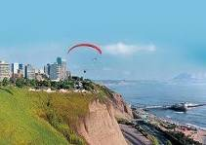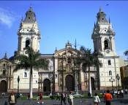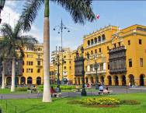

**Day 03: Lima / Cusco (B/-/-)**

**Transfer Hotel / Lima Airport (private)**

At the appropriate time, our representative will meet you at the hotel lobby and transfer you to the Lima Airport to board your next flight. Our representative will assist you with check-in procedures and all departure formalities.

**Transfer Cusco Airport / Hotel (private)**

Upon arrival into Cusco Airport, you will be met by our representative and private driver and will be transferred to your hotel. Our representative will assist you with check-in procedures.

Remain of the morning at leisure for your complete acclimatization to the altitude.

**PM: Half day Cusco** **City tour & main surrounding ruins (private)**

Enjoy a guided sightseeing tour of the city of Cusco, the Imperial City and archaeological capital of South America, where you will be able to admire the finest examples of Inca history and architecture. Visit the city's most important historical monuments that reveal the influence of different cultures: the Plaza de Armas, the Cathedral dating from Spanish viceroyalty times, built with great slabs of red granite renaissance style in contrast with the baroque style silverwork of its interior and, the Santo Domingo church built upon the foundations of the Inca temple Koricancha, dedicated to worship the Sun God.

Continue to Cusco City’s main surrounding ruins: the Sacsayhuaman Fortress - a ceremonial compound and magnificent example of Inca military power that boasts a panoramic view of the city, the Qenqo Amphitheater - a ritualistic site with subterranean galleries that form an underground maze, Puca Pucara or red fortress and, the Inca Baths of Tambomachay.

After the tour you will be transferred to your hotel.

Overnight in Cusco.

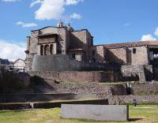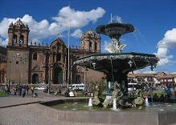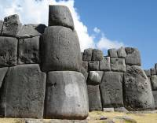

**Day 04: Cusco / Machu Picchu (B/L/-)**

**Full day excursion to Machu Picchu via roundtrip train (private)**

Morning transfer to the train station for an amazing train journey to the famous Inca Citadel of Machu Picchu, the great mountain-top city abandoned by the Inca Empire, reclaimed by the jungle and lost to humanity until its rediscovery in 1911.

Along the way you will enjoy the changing landscape as you travel from Andean highlands to the beginnings of the jungle (“eyebrow of the jungle”), before finally arriving at the town of Aguas Calientes.

From here, board the bus that will take you on a 20 minute ride up to the citadel of Machu Picchu, or Lost City of the Incas, which sits upon the summit bearing the same name, and is one of the most representative and recognized examples of Incan architecture. A guided tour of the Citadel includes the Main Plaza, the Circular Tower, the Sacred Sun Dial, the Royal Quarters, the Temple of the Three Windows and various burial grounds.

The legendary 'Lost City' is without a doubt one of the world's most impressive archaeological sites. Built by the Incas on the summit of "Machu Picchu" (old peak), overlooking the deep canyon of the Urubamba river in a semi-tropical area 120 Kms (75 miles) from the city of Cusco at 3,400 m.a.s.l (11,155 f.a.s.l).

It sits on a mountain site of extraordinary beauty, in the middle of a tropical mountain forest; Machu Picchu was probably the most amazing urban creation of the Inca Empire at its height, with its giant walls, terraces and ramps, which appear as though they have been cut naturally in the continuous rock escarpments.

Machu Picchu is also one of the Inca's best kept secrets, since they did not leave written records and Spanish chronicles make no mention of the citadel, it remains a mystery.

Remain of the day at leisure on your own in Aguas Calientes.

Overnight in Aguas Calientes

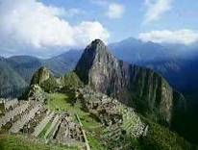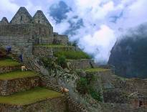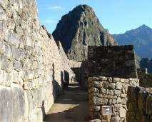

**Day 05: Machu Picchu / Cusco (B/-/-)**

Morning at leisure without guide (Second entrance fees are not included)

Excellent opportunity to wake up early and enjoy a beautiful sunrise as well as stroll around the Town of Aguas Calientes and visit its Hot Springs Thermal waters. Then, you will have time to perform some of the following activities (not included in the overall price): visit the Citadel of Machu Picchu for a second time, or for more active and adventurous people, we suggest to climb up the Huayna Picchu from where you can appreciate the immensity of Machu Picchu, even more amazing being so high and distant (no guide services included this day).

In the afternoon, return to Cusco by train and upon arrival at the train station you will be met by our representative and driver for your transfer to the hotel.

Overnight in Cusco

**Day 06: Cusco / Lima / Iguazu (B/-/-)**

**Transfer Hotel / Cusco Airport (private)**

At the appropriate time, our representative will meet you at the hotel lobby and transfer you to the Cusco Airport to board your next flight.

**Lima Airport assistance (private)**

Upon arrival into Lima International Airport, you will be met by our representative who will assist you with check-in procedures for your next flight.

Upon arrival Iguazu airport you will be assisted by one of our representatives who will take you to the hotel and help you with the check-in procedures.

Overnight in Iguazu

**Day 07: Iguazu (B/-/-)**

Breakfast will be served at the hotel.

Then, depart on a guided tour to the Cataratas Argentinas (Argentinean Falls). The UNESCO organization declared this place World Heritage in the year 1984. Paseo Inferior (Lower Circuit) : this circular 1.200-metre-walk will let you have a great view of the majority of the rapids and falls by giving you front and a upward bound views with various distances ranging from ample landscape bird eye views of Garganta del Diablo (Devil’s throat) and many Brazilian rapids up to spectacular close ups.

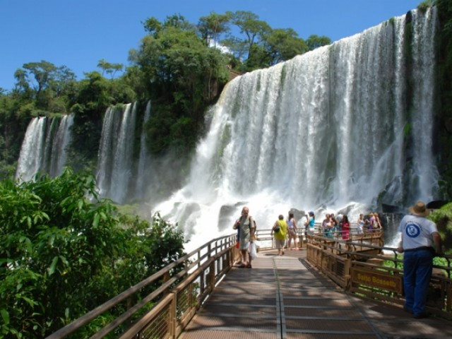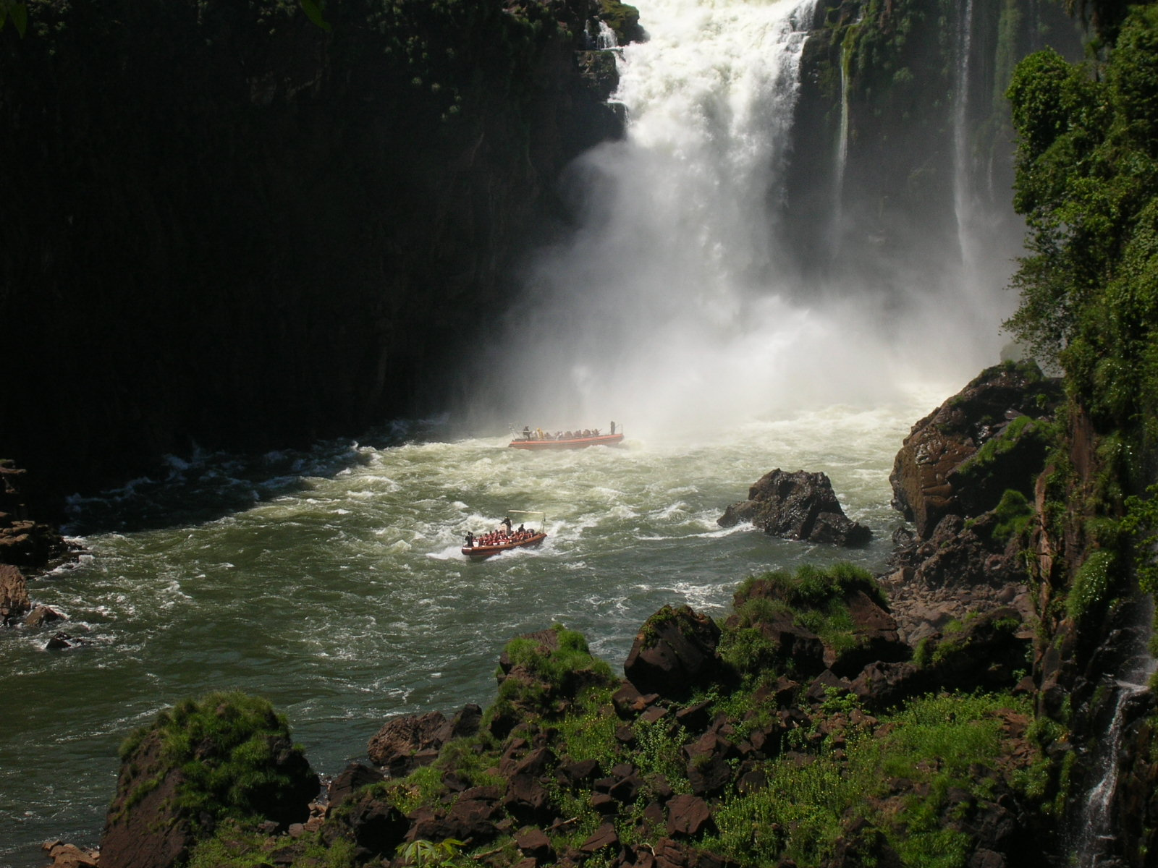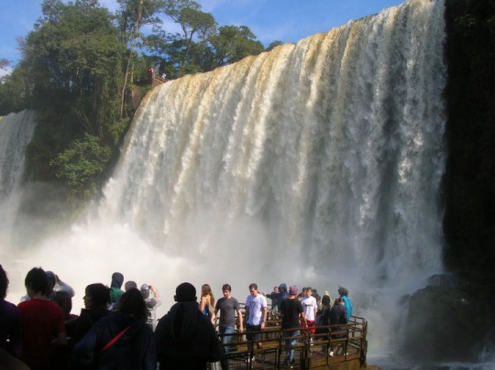

Should you want, you will be able to enjoy the Salto Bossetti (Bossetti Fall) side showers. The amount of time necessary for this stroll is approximately 2 hours. This walk has a little high difficulty level due to the amount of steps it bears. Paseo Superior (Higher Circuit): it is a 1.300 metre-round-trip circuit. The elevated catwalks will raise your adrenaline levels while taking you over the fall lines of several of the main white waters all the way to feel the vertigo at the very edge of them. This delivers a unique complete breathtaking scenery outlook from a high point of view. The length of this second stroll is 1 hour. This is the less effort demanding walk of the three traditional ones. It has no steps. Garganta del Diablo: to access this site you will have to take the Tren Ecológico de la Selva (Ecological Jungle Train), and you must get off at the stop having the same name, Garganta del Diablo. From there you will start a stroll by the very safe new catwalk which is a long and winding path that goes around the islands for 1.100 metres all the way to the large balconies located on the edge in front of Garganta del Diablo. The amount of time necessary for this promenade is approximately 2 hours and it has no steps.

Overnight in Iguazu.

**Day 08 – Iguazu / Buenos Aires (B/-/-)**

Breakfast will be served at the hotel.

Today you will take the tour to Cataratas Brasileras. (Brazilian Falls) Situated on the western side of the Paraná State in Brazil, this park limits with Argentinean territory. It has a 185 thousand ha which connect by the Río Iguazú (Iguazú River) to the 67 thousand ha that belong to the Argentinean Parque Nacional Iguazú which turns this vast area into one the largest natural reserves in South America. It was declared World Heritage in the year 1986 by the UNESCO. The circuit starts at the Centro de Visitantes (visitors centre) designed to be the access gateway to the park. It operates as an embarking and disembarking centre for visitors. In order to be able to complete the catwalk circuits you must take a fabulous means of transportation which is the modern

coach system with panoramic units for the people to move safely within the park. The length of the catwalks is 1.200 metres from where you will get a stunning view of the 275 Saltos (waterfalls) which are called Cataratas del Iguazú. On the Brazilian side the four main rapids are: Floriano, Deodoro, Benjamín Constant and Salto Unión or Garganta del Diablo.

Then, you will be transferred to the airport to take your flight to Buenos Aires. Upon arrival, you will be assisted by one of our representatives who will take you to the hotel and help you with the check-in procedures.

Overnight in Buenos Aires.

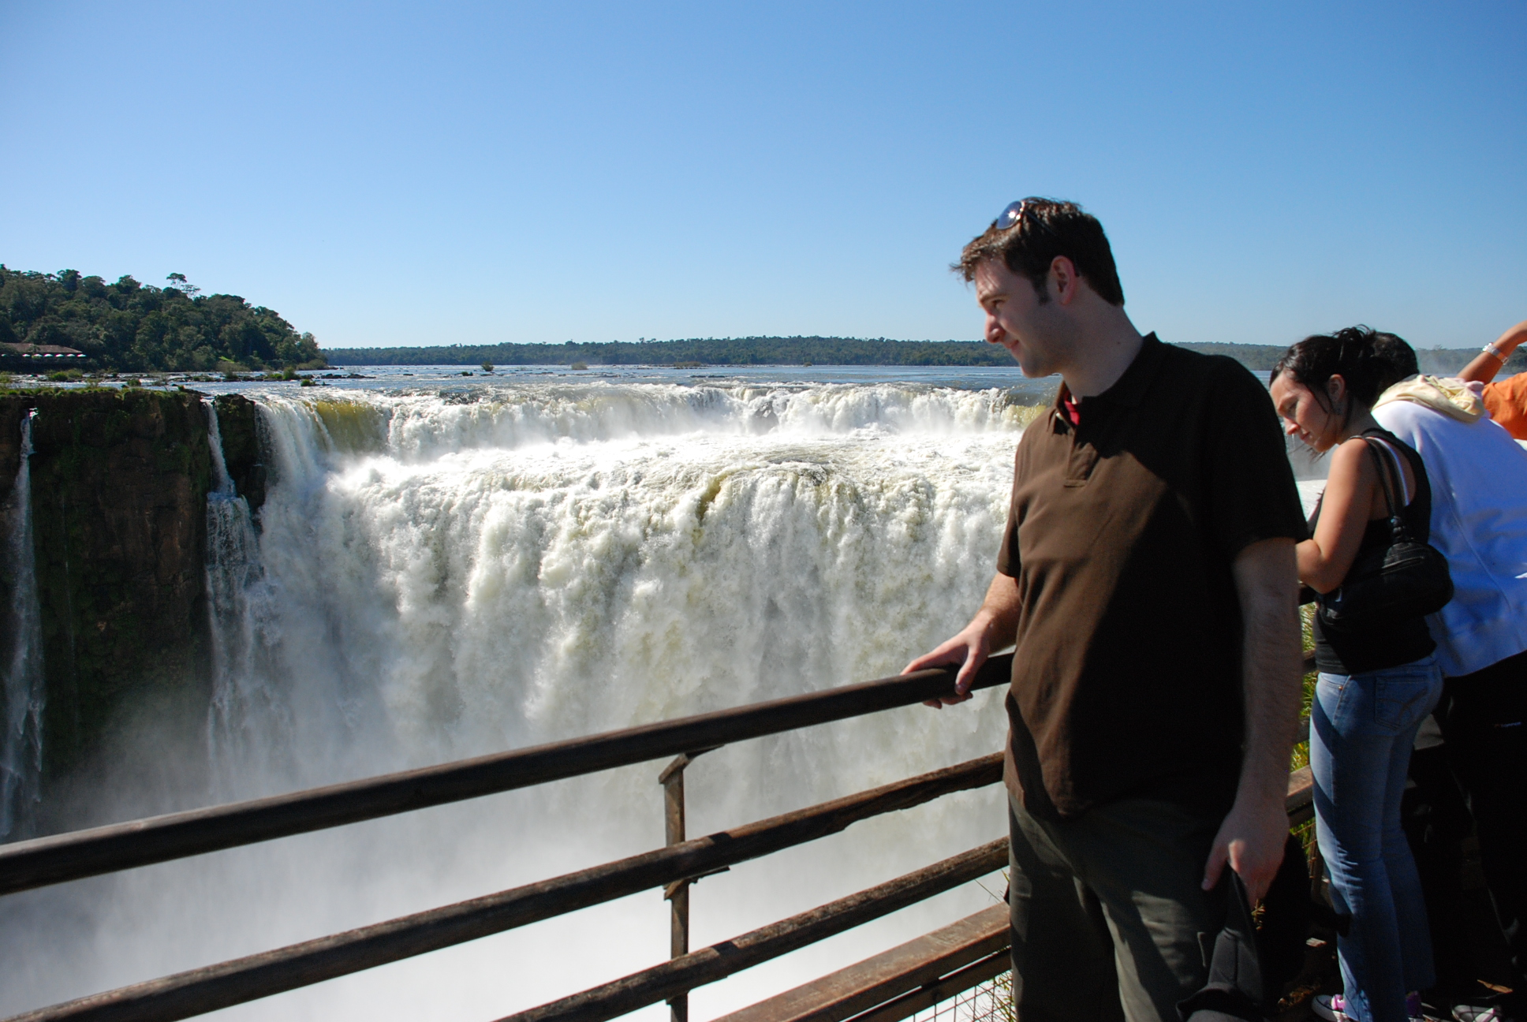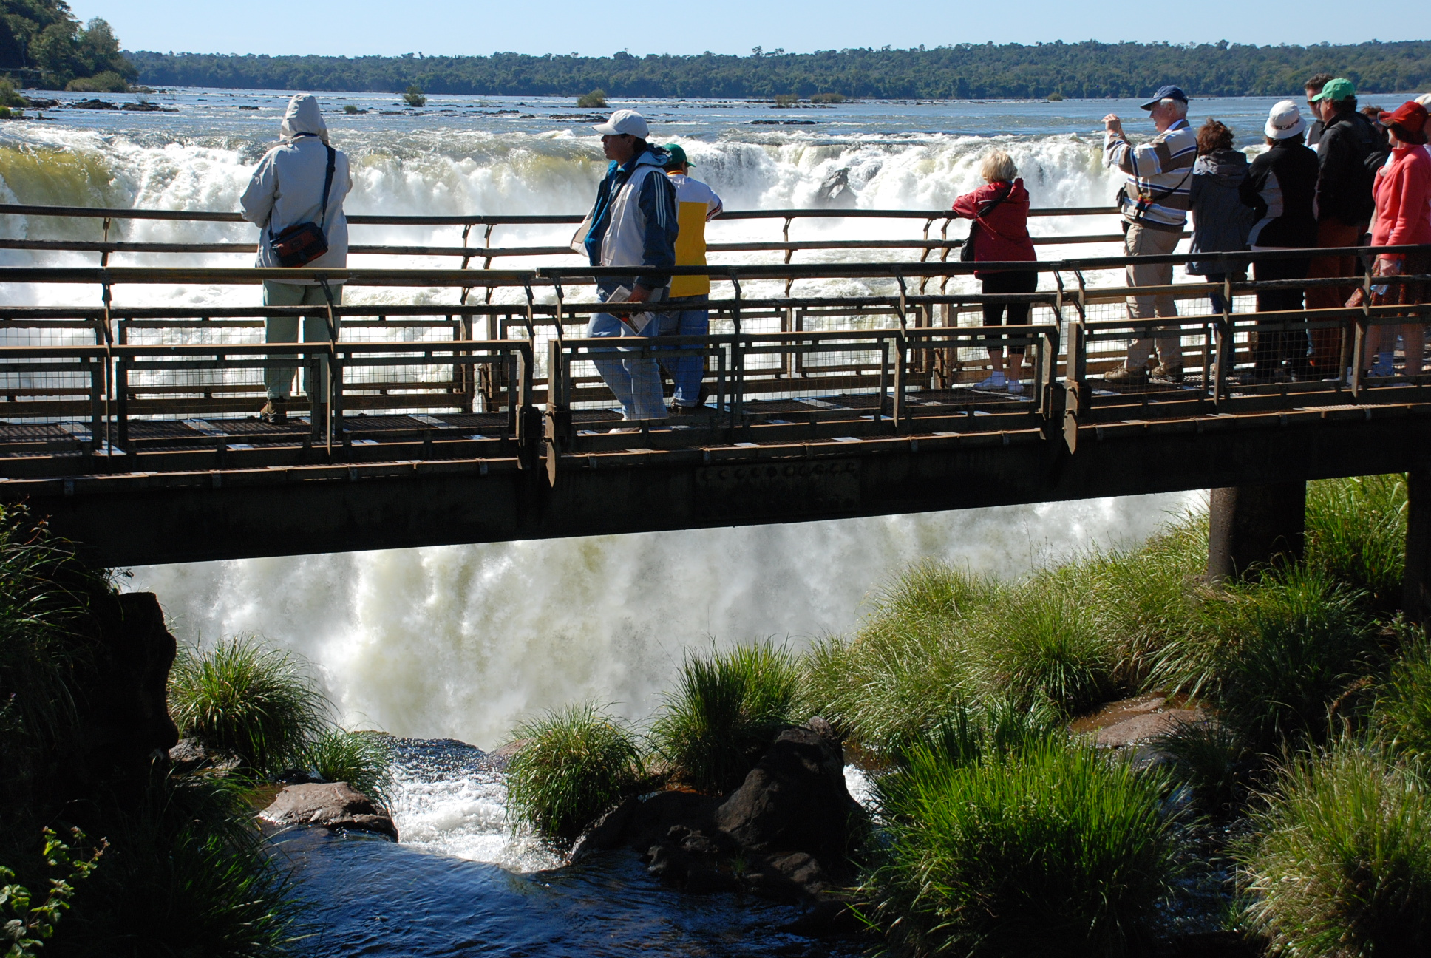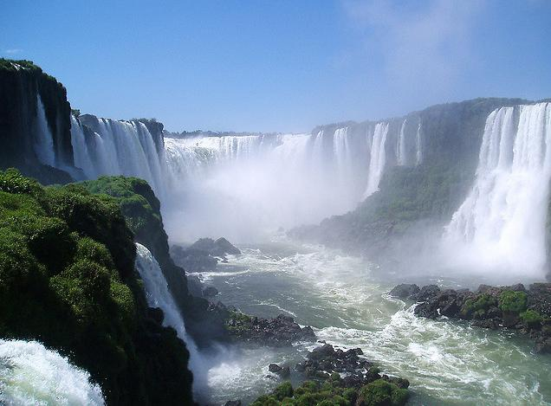

**Day 09 – Buenos Aires (B/-/-)**

Breakfast will be served at the hotel.

Then, depart on a guided tour to the most important places in Buenos Aires. The tour includes the Metropolitan Cathedral, Government House and the area of Plaza de Mayo. You will be at the heart of the Tango activity where this sensuous dance is performed in the street for passersby to enjoy in the traditional neighborhood of San Telmo, where this typical dance dwells. Then you will visit La Boca and stop at this colorful suburb of the city adopted years ago as his home by the first Italian immigrants. Today is home for important artists.

Then, a visit to Palermo is scheduled, a residential neighborhood with parks and elegant buildings. Finally, you will visit the sophisticated Recoleta, one of the most exclusive neighborhoods in which among other attractions, you can take a look at the famous cemetery alongside fine restaurants and cafes.

Overnight in Buenos Aires.

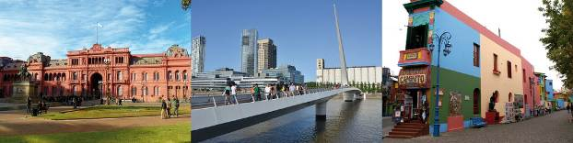

**Day 10 - Buenos Aires (B/-/-)**

Breakfast will be served at the hotel.

Day at leisure.

***Optional:*** At sunset, we suggest you to assist to a Dinner Tango Show to enjoy the glamour, beauty and sophistication of the best music in Argentina. (Not included).

Overnight in Buenos Aires.

**Day 11 - Buenos Aires - … (B/-/-)**

Breakfast will be served at the hotel. At the set time, you will be transferred to the international airport to take your flight to return home.

**End of our services**

**B: Breakfast L: Lunch D: Dinner**

**COMMISSIONABLE RATES 2016 (land services) Price per pax in DWB room**

From 05 Jan to 30 Sep

|  |  |  |  |  |  |  |  |  |
| --- | --- | --- | --- | --- | --- | --- | --- | --- |
| **Southamerican Wonders** | | **2 pax** | | **3-4pax** | | **5-9pax** | | **S/S** |
| **Program Alt. Standard** | Usd 2,064.30 | | Usd 1,779.90 | | Usd 1,808.30 | | Usd 583.00 | |
| **Program Alt. Superior** | Usd 2,706.70 | | Usd 2,389.70 | | Usd 2,386.00 | | Usd 1,183.00 | |
| **Program Alt. First** | Usd 3,136.50 | | Usd 2,819.50 | | Usd 2,815.90 | | Usd 1,579.20 | |
| **Program Alt. Deluxe** | Usd 4,021.00 | | Usd 3,610.80 | | Usd 3,531.80 | | Usd 2,251.00 | |

From 01 Oct to 20 Dec

|  |  |  |  |  |
| --- | --- | --- | --- | --- |
| **Southamerican Wonders** | **2 pax** | **3-4pax** | **5-9pax** | **S/S** |
| **Program Alt. Standard** | Usd 2,140.90 | Usd 1,853.90 | Usd 1,880.10 | Usd 613.00 |
| **Program Alt. Superior** | Usd 2,812.60 | Usd 2,489.80 | Usd 2,482.70 | Usd 1,247.10 |
| **Program Alt. First** | Usd 3,242.50 | Usd 2,919.60 | Usd 2,912.60 | Usd 1,643.30 |
| **Program Alt. Deluxe** | Usd 4,170.30 | Usd 3,744.90 | Usd 3,655.00 | Usd 2,335.00 |

|  |  |
| --- | --- |
| **Flight tickets (NET price per person)** |  |
| **Lima / Cusco / Lima** | Usd 450.00 * |
| **Iguazu/ Buenos Aires** | Usd 280.00 * |

* Current airfares are subject to change by the airline without notice.

# IMPORTANT NOTES

* No reservations have been placed
* This is a preliminary costing; hotels may vary according to availability
* No airfares or airport taxes included in above given rates
* International departure tax from Lima should be included in the int’l air fare; please verify
* Air fares are referential only.  Actual rate are subject to availability at time of purchase and type of ticket (refunds and changes allowed/not allowed, penalties apply/not apply, etc)
* All entrance fees are subject to change without previous notice
* Rates valid for 2016 except on Holly Week dates (April/ 24-31), Inti Raymy (June 22/27), Christmas & New Year (Dic 17-04 Jan) and other National or Religious Holidays which may have special rates; please verify.

# INCLUDED

* Private services with local English speaking guides as indicated in the itinerary except where otherwise specified
* All entrance fees to the sites mentioned in the itinerary
* Meals: As indicated in the itinerary
* 01 Roundtrip train ticket to Machu Picchu via Vistadome coach per person
* 01 Entrance ticket to Machu Picchu per person
* 01 Bus ticket to and from the Machu Picchu ruins per person
* 02 nights accommodation in Lima.
* 02 nights accommodation in Cusco.
* 01 night accommodation in Aguas Calientes.
* 02 nights accommodation in Iguazú.
* 03 nights accommodation in Buenos Aires.
* FD Argentinean Falls tour.
* HD Brazilian Falls Tour.
* HD Buenos Aires city tour.
* Permanent assistance during the trip.

# NOT INCLUDED

**EXCLUSIONS**

* International air fares or domestic air fares
* Early check-in, late check-out, services and non-mentioned meals in the itinerary
* Personal expenses
* Drinks during meals, hotel extras and personal spending
* Local VAT taxes (18% applicable only to Peruvian and foreign residents of Peru; in order to be exempted you will need to show your passport)
* Tips.

# HOTELS QUOTED

**Alternative Standard**

|  |  |  |
| --- | --- | --- |
| **Nights** | **City** | **Hotel** |
| 2nts | Lima | [Allpa Hotel & Suites](http://allpahotel.com/es/rooms.php)- Standard Room |
| 2nts | Cusco | [San Agustin Internacional](http://www.hotelessanagustin.com.pe/hotels/cusco/internacional/) - Standard Room |
| 1nt | Machu Picchu | [El Mapi Hotel](http://www.elmapihotel.com/)- Superior Deluxe Room |
| 2nts | Iguazu | [Jardin del Iguazu](http://www.jardindeiguazu.com.ar/) – Standard room |
| 3nts | Buenos Aires | [Merit San Telmo](http://merit-san-telmo.hotels-in-buenos-aires.com/en/) – Standard room |

**Alternative Superior**

|  |  |  |
| --- | --- | --- |
| **Nights** | **City** | **Hotel** |
| 1nts | Lima | [Dazzler Lima](https://www.dazzlerhoteles.com/en/hotels/peru/hotels-in-lima/dazzler-lima/) – Classic Room |
| 2nts | Cusco | [Casa Andina Private Collection Cusco](http://www.casa-andina.com/peru/hotels/cusco-hotels/private-collection-cusco/hotel.php) – Superior Room |
| 1nt | Machu Picchu | [Sumaq Machu Picchu Hotel](http://www.machupicchuhotels-sumaq.com/) - Superior room |
| 2nts | Iguazu | [Amerian Portal del Iguazu](http://portaldeliguazu.com/) – Standard room |
| 3nts | Buenos Aires | [Esplendor Plaza Francia](https://www.esplendorhoteles.com/en/hotels/argentina/hotels-in-buenos-aires-city/esplendor-plaza-francia/) – Concept room |

**Alternative First Class**

|  |  |  |
| --- | --- | --- |
| **Nights** | **City** | **Hotel** |
| 1nts | Lima | [Hilton Lima Hotel](http://www3.hilton.com/en/hotels/peru/hilton-lima-miraflores-LIMMFHH/about/index.html) - Standard room |
| 2nt | Cusco | [Hotel JW Marriott Cusco](http://www.marriott.com/hotels/travel/cuzmc-jw-marriott-hotel-cusco/)– Classic Inca room |
| 1nt | Machu Picchu | [Sumaq Machu Picchu Hotel](http://www.machupicchuhotels-sumaq.com/) – Superior Deluxe room |
| 2nts | Iguazu | [Amerian Portal del Iguazu](http://portaldeliguazu.com/) – Standard room |
| 3nts | Buenos Aires | [Esplendor Plaza Francia](https://www.esplendorhoteles.com/en/hotels/argentina/hotels-in-buenos-aires-city/esplendor-plaza-francia/) – Concept room |

**Alternative Luxury Class**

|  |  |  |
| --- | --- | --- |
| **Nights** | **City** | **Hotel** |
| 1nts | Lima | [Miraflores Park Hotel](http://www.miraflorespark.com.pe/web/olim_es/miraflores.jsp?langredirect=true) – Junior Suite Ocean view |
| 2nt | Cusco | [Hotel Monasterio](http://www.monasteriohotel.com/web/ocus_es/hotel_monasterio.jsp?langredirect=true) – Deluxe room |
| 1nt | Machu Picchu | [Inkaterra Machu Picchu Pueblo](http://www.inkaterra.com/en/machu-picchu) - Superior Deluxe room |
| 2nts | Iguazu | [Loi Suites Iguazu](http://www.loisuites.com.ar) – Studio room |
| 3nts | Buenos Aires | [Buenos Aires Grand](http://www.buenosairesgrand.com/the-hotel-en.html) – Deluxe Junior |

# METROPOLITAN TOURING CONTACT INFORMATION

|  |  |  |  |  |
| --- | --- | --- | --- | --- |
|  | **ECUADOR** | **PERU** | **Argentina / Chile** | **COLOMBIA** |
| **City** | **Quito** | **Lima** | **Cordoba** | **Bogotá** |
| **Address** | 45-74 De las Palmeras & De las Orquídeas Av. | 180, Del Pinar Av., Torre Pinar IV, Of. 1001, Chacarilla, Surco | 33, Derqui St. – 2nd floor, Of. B  (X5000GXA) | 85-61, Carrera 15 St. Of. 401 |
| **Fax** | (+593) 2 3341250 | (+51 1) 7186051 | (+54-351) 5684156 |  |
| **Telephone** | (+593)  22 988200 | (+51 1) 7155515 | (+54-351) 568 0088 | (+57 1) 6180244 |
| **Emergency Contact** | (+593) 9  9215719 | (+51-1) 989258180 | (+54-351)9 153503180  (+54-351)9 153503187 |  |