Undiscovered Treasures
(6D/5N)
Chiclayo / Kuelap / Trujillo

When you think of visiting Peru, you mostly concentrate on the Inca sites. However, Peru is also home to extraordinary Pre-Inca Cultures, developed in the Northern region of Peru. Chiclayo and Trujillo, cities full of magic and history where many cultures settled, and Kuelap, a city emerging from the clouds guarded by gigantic defense wall, are waiting for you to discover the mysticism of these ancient cultures currently in research.

DAY BY DAY ITINERARY

Day 01 – Lima / Chiclayo (-/L/-)
- Early arrival in Chiclayo. Transfer to the hotel.
- FD Sipan Archaeological Complex, Royal Tombs Museum and Tucume Pyramids.
- Lunch included on a local restaurant.
- Overnight in Chiclayo.

Day 02 – Chiclayo / Chachapoyas (B/BL/D)
- Departure by private transportation from Chiclayo to Chachapoyas.
- Box lunch included.
- Dinner at the hotel.
- Overnight in Chachapoyas.

Day 03 – Chachapoyas / Karajilla / Chachapoyas (B/BL/D)
- FD Karajilla´s cliff tombs and Quiocta Caverns
- Box lunch included
- Dinner at the hotel
- Overnight in Chachapoyas

Day 04 – Chachapoyas / Kuelap / Chachapoyas (B/BL/D)
- FD Kuelap archaeological citadel.
- Box lunch included
- Dinner at the hotel
- Overnight in Chachapoyas

Day 05 – Chachapoyas / Chiclayo (B/BL/-)
- Departure by private transportation from Chiclayo to Chachapoyas.
- Box lunch included.
- Overnight in Chiclayo.

Day 06 – Chiclayo / Trujillo / Lima (B/L/-)
- Departure by private transportation from Chiclayo to Trujillo.
- On route, visit the Brujo Complex and CAO Museum.
- Visit Sun and the Moon pyramids
- Transfer to the Trujillo airport

Special Remarks:
B = Breakfast L = Lunch D = Dinner BL = Box Lunch

ITINERARY DESCRIPTION

Day 1: Chiclayo : Sipan, Tucume and Tumbas Reales Museum (-/L/-)
Very early in the morning, arrival in Chiclayo, you will be met by our representative and transferred to the Casa Andina Select Chiclayo.
Full day excursion in Chiclayo. Visit Sipan Archaeological Complex, one of the most important archaeological discoveries in the in the last few years. Because of its importance have been compared with Tomb of Tutankamon of Egypt. Between 1987 y 1988 Dr. Walter Alva was the director of the excavations and study of the archaeological site where the remains of an important personage “ The Lord of Sipan“ of the high society Moche was found.
Continue with Royal Tombs of Sipan Museum. This important museum is located in Lambayeque at 11 Kilometers at the north side of Chiclayo. The tomb found in 1987 was the richest ever found in the western hemisphere and by 1990 was the richest series of tombs found anywhere in the world for a century. The new purpose –built 3 storey pyramid – like Museum is also an attraction in its own right. This museum conserve all the archaeological material found in Sipan.
The exhibition also shows a reconstruction of the Lord of Sipan tomb with his values jewels of gold , silver , copper and some additional tombs of warriors .
This museum is the result of years of effort of an archaeologist’s team leaded by Walter Alva.
Lunch included on a typical restaurant in town.
Finally, visit Tucume Pyramids. This important archaeological site is formed by 26 pre-Inca pyramids and is located at 33 kilometers at the north side of Chiclayo. This place was the kingdom of Naylamp, god of the Chimus. There is a site museum with pieces founded in the archaeological site.
Visitors walking amongst the pyramids can find pottery fragments.
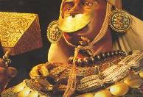
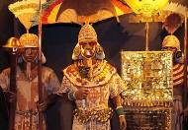
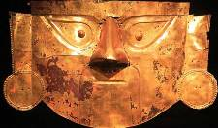

Day 2: Chiclayo / Kuelap (B/BL/D)
Departure by private transportation from Chiclayo to Chachapoyas following the Pan-American Highway, taking then the Trans-Andean route.The trip goes through one of the driest deserts of the planet, then climbs the Andes, descends to the Marañón River and finally ascends via the great Utcumbamba canyon. Box lunch included.

Day 3: Chachapoyas - Cliff tombs of Karajía (B/BL/D)
The sanctuary is located 48km north-east of the city of Chachapoyas after 2 hours by car and a short 20 minutes hike. The sarcophaguses of Karajia are 2 meters high, being empty inside and outside they are made of a mixing of clay, straw and pebble, and lay over a structure made of wood.
A chamber with the shape of a pear pro tected the mummy which was sitting down, and wrapped in deer skin. One of the figures has been destroyed by falling rocks, and one damaged. The others are intact. The heads have angular, stylized faces, made of clay, while the bodies of the figures were made on site of wattle and clay, which was then covered in brightly painted designs. On top of the heads sit skulls, but whose skulls they were we cannot even guess at, because these figures have been left undisturbed, not studied by archaeologists, and thankfully not destroyed by looters. How the ancient Chachapoyans reached this place to create this burial site for their elites is still a mystery.
You will enjoy a box lunch and later we will visit the Quiocta Caverns, another tourist nature attraction which is located in Lamud district, province of Luya, among the typical vegetation, at 20 minutes distance are the amazing calcareous needles with different shapes and sizes known as stalactites and stalagmites. Return to Chachapoyas.

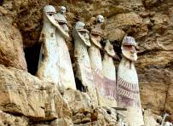
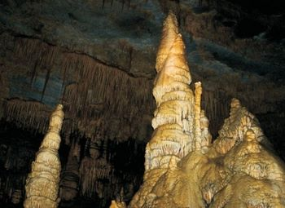
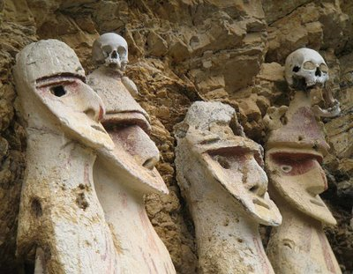

Day 4: Chachapoyas – Kuelap: The Cloud People´s Ancient City (B/BL/D)
It is a majestic Chachapoya architectural work located in the upper part of the Utcubamba River Vally, nearby the hamlet of Kuelap. The fortress of Kuelap was buit and inhabited by the Chachapoyas between 1000 and 1400 aD.
Called The Fortess and buit on top a hight mountain, its Perus mountainous jungle´s most important archaeological complex which presents itself to visitors, like an unconquerable place, surrounded by cliffs and precipes, on three of its four sides.
The walls and hundreds of circular houses are covered by the cloud forest, being at 3000 meters above sea level, always surprise the visitors that see it for the first time. We will explore lots of ceremonial constructions and aqueducts. Although Kuélap was discovered 60 years before Machu Picchu, it is not recognized worldwide. However, recent discoveries nearby areas that are related with Kuélap and with its history, had captured the attention of archaeologists, of international magazines and film companies. Box Lunch included. Return to Chachapoyas.

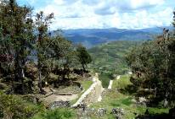
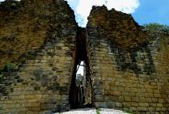
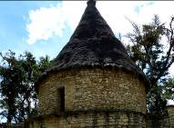

Day 5: Chachapoyas / Chiclayo (B/BL/-)
After an early breakfast we return to Chiclayo by road. We will make a pleasant stop at a suitable spot along the way to eat our box lunch. We arrive in Chiclayo in the late afternoon and transfer to the hotel.

Day 6: Chiclayo / Trujillo (B/L/-)
This drive to the South along the Panamerican Highway takes 3.5 hours and travels through deserts and irrigated valleys. On route, visit "Huaca Cao Viejo", an archaeological site dating back to the Moche culture (100 BC-650 AD). It is a badly damaged, stepped pyramid with a central court that was probably used primarily for religious ceremonies.
This pyramid is undoubtedly the most impressive Moche site in the Chicama Valley and is nowadays more often referred to as "EL BRUJO" ("The Sorcerer").
The oldest figures appear to be intricate geometric patterns with snake-like characteristics painted in red and yellow, which can be seen on the left-hand side of the third level of the frontal (northeast) facade.
RECENT NEWS FROM EL BRUJO
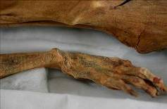
Mummy of Tattooed Woman Discovered in El Brujo
A well-preserved tattooed mummy of a young woman has been discovered deep inside a mud-brick pyramid in El Brujo by archaeologists under the direction of scientist Regulo Franco.
The 1,500-year-old mummy may shed new light on the mysterious Moche culture. The incredible mix of ornamental and military artifacts has experts speculating about this woman’s identity and her role in the Moche society.
For more information you can read the full article at national geographic:
http://www7.nationalgeographic.com/ngm/0606/feature2/index.html
Arrival to Trujillo and visit the Sun and the Moon pyramids. Built of millions of adobe bricks, they are the largest pre-Columbian structures in South America. Interesting coloured freezes have been discovered and can be seen at the Moon Pyramid.
Large-scale human sacrifice at Huaca de la Luna became evident when archaeologists uncovered the remains of at least 34 sacrificed adult male individuals in the soft clay of the southeastern court at the foot of the mountain. They had been bound and, judging by the type of wounds that had been inflicted, were probably captured in battle.

The sacrifice represents a single ritual event linked by archaeologist Steve Bourget to a season of torrential rains caused by an extreme case of the maritime El Niño phenomenon, which strikes the coast of South America at irregular intervals and which may have caused the final abandonment of this site.

Transfer to the Trujillo Airport to board your flight to your next destination and assistance with your luggage, airport tax payment and airline check-in procedures.

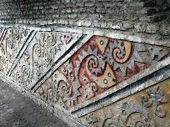
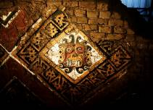
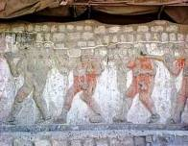

END OF OUR SERVICES

B= Breakfast L= Lunch D= Dinner BL = Box Lunch

RATES PER PERSON

Commissionable rates in USD  (land services) | 02 pax | 04 pax | 05/09 pax | Single Sup.
Program in DWB room | 2,238.50 | 1,863.50 | 1,679.50 | 177.10
Airfare Lima/Chiclayo & Trujillo/Lima* | 450.00 | 450.00 | 450.00 | 450.00

* Current NET airfares are subject to change by the airline without notice.

NOTES

IMPORTANT NOTES
- Rates valid from April to November 2016 (dry season)
- No reservations have been placed
- This is a preliminary costing; hotels may vary according to availability
- No airfares or airport taxes included in above given rates
- Airfare Lima/Chiclayo - Trujillo/Lima US$ 450.00 net per person, subject to change.
- Airport taxes for domestic flights are included in the above air fare
- International departure tax from Lima should be included in the int’l air fare; please verify
* Airfares are referential only. Actual rate are subject to availability at time of purchase and type of ticket (refunds and changes allowed/not allowed, penalties apply/not apply, etc)

INCLUSIONS
- Private transfers with local English speaking transferman and guides, except where otherwise specified.
- Private services with local English speaking guides as indicated in the itinerary, except where is indicated as shared.
- All entrance fees to the sites mentioned in the itinerary
- Meals: As indicated in the itinerary (B/L/D)
- 05 nights’ hotel accommodation
- All tips (except hotel staff & guides); additional tips are optional and voluntary.
- Permanent assistance during the trip

EXCLUSIONS
- International air fares or domestic air fares
- Meals or any other item not described in the itinerary
- Early check-in, late check-out, services and non-mentioned meals in the itinerary
- Personal expenses
- Drinks during meals, hotel extras and personal spending
- Tips for hotel staff & guides
- Local VAT taxes (18% applicable only to Peruvian and foreign residents of Peru; in order to be exempted you will need to show your passport)

HOTEL INFORMATION

City | Hotels quoted (or similar) | Room category
Chiclayo | Casa Andina Select Chiclayo 4* | Standard room
Chachapoyas | La Xalca Hotel 3* | Standard room

METROPOLITAN TOURING INFORMATION

 | ECUADOR | PERU | Argentina/Chile | COLOMBIA
City | Quito | Lima | Cordoba | Bogotá
Address | 45-74 De las Palmeras & De las Orquídeas Av. | 180, Del Pinar Av., Torre Pinar IV, Of. 1001, Chacarilla, Surco | 33, Derqui St. – 2nd floor, Of. B  (X5000GXA) | 85-61, Carrera 15 St. Of. 401
Fax | (+593) 2 3341250 | (+51 1) 7186051 | (+54-351) 5684156
Telephone | (+593) 22 988200 | (+51 1) 7155515 | (+54-351) 568 0088 | (+57 1) 6180244
Emergency Contact | (+593) 9 9215719 | (+51-1) 989258180 | (+54-351)9 153503180  (+54-351)9 153503187

