11 DAY PROGRAM COLOMBIA & PERU

Traveling date: | 2016 |  | Issuing date: | July 2016
Country/s: | Colombia & Peru |  | Validity: | 2016

DAY BY DAY ITINERARY

Day 01 – [Thur] - … / Bogotá (-/-/-)
- Transfer El Dorado Airport / Hotel (private service English speaking guide)
- Overnight in Bogotá

Day 02 – [Fri] – Bogotá (B/L/-)
- Full day tour visiting: Paloquemado Market, Monserrate Hill & City tour (private service English speaking guide)
- Lunch included
- Overnight in Bogotá

Day 03 – [Sat] – Bogotá / Cartagena (B/-/-)
- Transfer Hotel / Bogota Airport (private service English speaking guide)
- Transfer Cartagena Airport / Hotel (private service English speaking guide)
- Overnight in Cartagena

Day 04 – [Sun] – Cartagena (B/-/-)
- Morning Monuments Tours: La Popa, San Felipe Fortress & San Pedro Claver Church (private service English speaking guide)
- Late afternoon, 2 hours walking tour inside the historic center (private service English speaking guide)
- Overnight in Cartagena

Day 05 – [Mon] – Cartagena (B/L/-)
- Full day visit to Rosario Islands including lunch & transfers (private transfers, shared boat)
- Overnight in Cartagena

Day 06 – [Tue] – Cartagena / Bogotá (B/-/-)
- Transfer Hotel / Cartagena Airport (private service English speaking guide)
- Shuttle service El Dorado Airport / Hotel Movich Buro26 (shared service)
- Overnight in Bogotá

Day 07 – [Wed] - … / Bogota / Cusco / Sacred Valley (B/-/-)
- Shuttle service Hotel Movich Buro26 / El Dorado Airport (shared service)
- Transfer Cusco Airport / Sacred Valley including Awanacancha Textile Center & Pisac Market en route (private English speaking guide)
- Box lunch en route
- Overnight in the Sacred Valley

Day 08 – [Thu] - Sacred Valley (B/L/-)
- FD Maras Saltpans, Moray Terraces & Ollantaytambo Fortress (private English speaking guide)
- Bufet lunch at local restaurant
- Overnight in the Sacred Valley

Day 09 – [Fri] - Cusco / Machu Picchu (B/L/D)
- FD tour to Machu Picchu via roundtrip Vistadome train (private English speaking guide)
- Buffet lunch at Tinkuy Restaurant at Machu Picchu Sanctuary Lodge
- Overnight in Aguas Calientes

Day 10 – [Sat] - Machu Picchu / Cusco (B/-/-)
- AM: At leisure (no re-entry ticket, no bus ticket, no guide)
  - Optional: 2nd entrance fee Machu Picchu + 2nd RT bus ticket (no guide)
  - Optional: 2nd entrance fee Machu Picchu + Huayna Picchu + 2nd RT bus ticket (no guide)
- PM: Return to Cusco, then transfer to hotel (private English speaking transferman)
- Overnight in Cusco

Day 11 – [Sun] - Cusco / Bogota / … (B/-/-)
- AM: Walking City tour Cusco (private English speaking guide)
- PM: Transfer hotel / Cusco Airport (private English speaking transferman)

Special Remarks:
B = Breakfast L = Lunch D = Dinner BL = Box Lunch

ITINERARY DESCRIPTION

Day 01 – [Thur] - … / Bogota (-/-/-)
Transfer Bogota International Airport / Hotel (private Spanish-speaking driver and English/Spanish-speaking guide)
Upon arrival at the International Airport El Dorado, you will be met by our representative and will be taken to your hotel. Our guide will assist you at the hotel with the registration procedures (check-in) and give you a detailed itinerary of all the services included in your trip. You will also receive information about our office contact details including our 24-hour emergency phone number.

Bogotá is Colombia’s capital city with approximately 8 million people; it is a cosmopolitan center of sophistication and has become an epicenter of business, politics and entertainment. The city has been transforming itself into a surprising tourist destination and welcoming city. Bogotá has a thriving nightlife, superb al fresco dining and bar culture as well as international shopping. Its privileged location and international airport makes it highly accessible and functional as a main gateway to destinations throughout the country. Overnight in Bogota

NOTE: Our transfer fee includes transportation of one bag per person of up to 23kg (50 lbs.) plus one carry on. If you plan to travel with additional luggage, please let us know in advance in order to assign a different vehicle capacity for the transfer. Please keep in mind that additional costs may be charged.

Day 02 – [Fri] – Bogota (B/L/-)
Bogota City tour including Monserrate Hill, Paloquemao & lunch (private Spanish-speaking driver and English/Spanish-speaking guide; 8-hour duration)
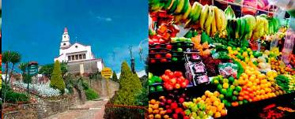
The tour starts with an early morning visit to the Paloquemao’s Market. This is one of the largest and most important markets in the country. Paloquemao presents the perfect mix of the old and new Bogotá and offers a great insight into the life and customs of the people from Bogotá. You will find a large variety of flowers, exotic fruits, vegetables, meat, seafood, cheese, medicinal herbs as well as typical food. Everything is fresh and arrives daily to Bogotá from all regions of Colombia. You will have the opportunity to live a unique cultural experience, tasting some exotic fruits and enjoying a small snack during the visit.

Afterwards visit the famous and well-preserved historical colonial quarter of La Candelaria. Steeped in history, this area is a must for photographers with its splendid colonial architecture; you will want to take the opportunity to capture the sights and sounds of this fascinating part of Bogotá. Walk through the streets permeating with the heady atmosphere of the past, as revealed by the library of Luis Angel Arango and down to the prominent Plaza de Bolivar, the heart of Bogotá, where locals and visitors mingle amongst the magnificent and foreboding structures. You will want to discover the history of this old part of the city by visiting the Cathedral, the Congress Palace, the Cardinal’s Palace, the colonial churches of El Sagrario and San Agustin, the Independence House, the Palace of Justice and the City Hall that are all located in this impressive square.

Continuing to the east, on top of the forested mountains, you will find “Cerro de Monserrate”. This mountain has a white catholic church located at the top and has been a site of worship since 1657. On a clear day, you will have the opportunity to enjoy a spectacular view of the city. You also might see snowcap of “Nevado del Tolima” on the far west side.

The tour then follows with a visit to the “Museo del Oro”, the most important gold museum in the world and a ‘must see’ when traveling to Bogotá. This museum displays one of the largest collections of pre-Columbian gold. Galleries on three levels display exquisitely crafted pieces dating back nearly 2.500 years. Visit the vault-like room on the top floor where the most treasured pieces are displayed, as well as the Offering Room, where passengers enter a black circular area that is gradually illuminated with indigenous music playing in the background; the light begins to dawn, and finally a remarkable display of gold offering collection is discovered.

The tour ends with a visit to the “Museo de Botero”, housed in a renovated colonial mansion. The works on display are all donated by Fernando Botero, Colombia’s most famous contemporary artist. Around 120 pieces of his own work are displayed at the museum including his famous sculptures, paintings and drawings.

His work is well known for the ‘proportionally exaggerated’ fat figures. In addition to his work, his personal collection by Picasso, Renoir, Dalí, Degas, Chagall, Matisse, Monet and Giacometti are also exhibited.

Lunch is included during the tour at a local restaurant with a set menu. Overnight in Bogota

NOTE: The Gold Museum is closed on Mondays and Botero Museum is closed on Tuesdays. It is important to remember, when visiting churches, monasteries, and shrines, women should not wear shorts or miniskirts and men should not wear shorts.

Day 03 – [Sat] – Bogota / Cartagena (B/-/-)
Transfer Hotel / Bogota Airport (private Spanish-speaking driver & English/Spanish-speaking guide)
Our guide will meet you at the lobby of the hotel and will take you to the International Airport El Dorado or Puente Aéreo (depending on your flight). We will assist you at the airport during the check-in at the airline counter to help you connect to your next destination.

NOTE: Our transfer fee includes transportation of one bag per person of up to 23kg (50 lbs.) plus one carry on. If you plan to travel with additional luggage, please let us know in advance in order to assign a different vehicle capacity for the transfer. Please keep in mind that additional costs may be charged.

Transfer Cartagena Airport / Hotel (private Spanish-speaking driver and English/Spanish-speaking guide)
Upon arrival at the Rafael Núñez Airport, you will be met by our representative and will be taken to your hotel. Our guide will assist you at the hotel with the registration procedures (check-in).

With its breathtaking colonial architecture, horse-drawn carriages and narrow cobbled streets, the city of Cartagena de Indias is one of the most exciting destinations in Colombia. This Caribbean colonial jewel was the first Spanish colony on the South American mainland and one of the main ports for the Spanish fleet which turned the city into an important center of trade in the 16th century. It is a city full of history which has been an inspiration for artists, writers, historians and musicians. This vibrant and colorful city throughout the years has enchanted tourists with its fairy-tale charms that invite people to linger and explore the city for days. Overnight in Cartagena

NOTE: Our transfer fee includes transportation of one bag per person of up to 23kg (50 lbs.) plus one carry on. If you plan to travel with additional luggage, please let us know in advance in order to assign a different vehicle capacity for the transfer. Please keep in mind that additional costs may be charged.

Day 04 – [Sun] – Cartagena (B/-/-)
AM: City tour + Monuments of Cartagena (Historic Center) [private service Spanish-speaking driver and English/Spanish-speaking guide, 4-hour duration]
The tour begins with a visit to the “Convento de la Popa”, where the city’s highest point is located and you can enjoy the best view of the beautiful city of Cartagena. This convent was built in the 17th century by the Augustinian Monks. Initially it was just a small wooden chapel, but later it was replaced by a strong construction which still remains.

Continue with a visit to the “Castillo de San Felipe”. This castle was built by the Spaniards in the 1600s and it is the greatest and strongest fortress ever built in a Spanish colony. Located at the top of San Lázaro hill, its purpose was to protect and guard the city’s landward side from any attack or invasion. This fortress provides a complex system of tunnels connected with strategic points to distribute provisions and facilitate a possible evacuation. Additionally, the tunnel’s architecture was built so that any noise would echo along them, in order to make internal communications easier and hear even the slightest sound of the enemies approaching.

Afterwards, a walk through “Las Bóvedas” is included. These 23 vaults were built in the 18th century and they are considered the last major colonial construction made within the city walls for military purposes. The vaults were used as storerooms for munitions and provisions by the Spaniards, and later on, they became jail cells. Nowadays, they are used as crafts markets where you can find handicrafts, antiques, galleries, jewelry, clothing and souvenirs, among other things.
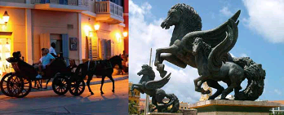

At the end of the tour you will visit the “Iglesia y Convento San Pedro de Claver”; this convent was founded in the early 17th century by San Ignacio de Loyola. The name of the church was given in honor to San Pedro Claver, a Jesuit priest who spent his life ministering to the enslaved people brought from Africa. This baroque church has an imposing stone facade and inside there are fine stained-glass windows and a high altar made of Italian marble. You will also find a beautiful cloister surrounded with trees, a museum and the place where San Pedro Claver lived and died.

NOTE: It is important to remember, when visiting churches, monasteries, and shrines, women should not wear shorts or miniskirts and men should not wear shorts.

PM: Cartagena Walking tour (private English/Spanish-speaking guide; 2-hour duration)
Discover Cartagena’s rich history and beautiful colonial architecture where you will admire the old houses, stunning balconies and different little squares. You will know more about the culture of Cartagena and its interesting architecture as you walk through the different cobbled streets and plazas; each street has a different story to tell. You will also see this city alive, with its students, vendors, and all the people that live there.

Passengers will pass by the main square called “Plaza de Bolívar”. In this beautiful plaza you will find many trees and a statue of the most important leader of South America’s Independence movement, the liberator Simón Bolívar. Initially it was used for military parades; however, after 1610 it was called “Plaza de la Inquisición”, because the Inquisition Palace was located on the west side of the plaza. Then you will pass by the “Plaza de la Proclamación”, where the town gathered to support the declaration of independence on November of 1811.

The tour then continues to the “Plaza de San Pedro de Claver”, a small plaza named after the saint that fought to help the slaves that came from Africa and were sold in the city. Next, you will visit the “Plaza de la Aduana”, the largest and oldest square where the important governmental and administrative buildings were located in the colonial times.

Afterwards, visit the “Plaza de los Coches”. A triangular plaza surrounded by the old city wall, houses with Spanish colonial architecture and buildings with colonial arches at ground level. This arcade walkway is known as “El Portal de los Dulces”, a whole street full of stands that sell typical Colombian sweets. There you will also find the main entrance to the inner walled city, which was originally called “Boca del Puente”. This gateway was complemented years later with a Republican-style clock tower, which is known as a symbol of Cartagena.

At the end of the tour, you will visit the “Plaza Santo Domingo”. This plaza is full of life and entertainment and it is a perfect place for social interaction and relaxation while enjoying the open air restaurants that are located there. You will also see the church of Santo Domingo, a beautiful colonial church with a stunning facade.

Day 05 – [Mon] – Cartagena (B/L/-)
Full day Rosario Islands – Majagua (private transfer hotel-port-hotel with Spanish-speaking driver & English/Spanish-speaking guide; shared motorboat transfer from the port to Isla Grande and vice versa, this service is provided by the Hotel San Pedro de Majagua)
It is time to step outside the walls of Cartagena and experience the beauty of one of the many islands located in Islas del Rosario: Isla Grande.

The Rosario Islands are located about 30 miles away from the city. An archipelago formed by coral reefs with small white sand beaches, and clear Caribbean waters that invite you to appreciate the diverse marine life. These small islands have been protected by the authorities since 1977, when they were declared a National Park. The park’s coral reefs, mangrove habitats and lagoons support more than 1,300 different species in nearly 500 square miles.
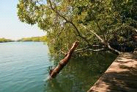
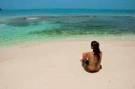

The day starts at your hotel where you will be picked up and transferred to the port. The boat usually departs at 9:00 am. You will head out from the port into open water for a 60-minute ride approximately to the island. Upon arrival you will disembark and have time to explore the island or just to relax.

You can sit on the small beach and rest, enjoy a walk around the island, sign up for a diving course in the coral reefs, swim or relax with a massage session. The hotel has a beach front bar and snacks can be purchased throughout the day. You will be arriving back to Cartagena between 4:00 and 4:30 pm.

Lunch is included with a set menu. Overnight in Cartagena

NOTE: The day use fee at San Pedro de Majagua includes shared motorboat transfer, towel service (one per person), a welcome fruit punch and typical lunch with: fish, fried plantain, coconut rice and one soft drink.

All extra activities like snorkeling, kayaking, diving course, ecological walks, bicycle rides, massages, etc. must be paid in cash at the island.

This service does not include guide assistance, only the hotel staff is available on the island.

Departure time from the island is scheduled between 02:30 and 03:30 p.m. depending on the tide, waves and weather condition.

Approximate time to enjoy at the island: 5 hours.

On occasion participants can expect to get sprayed or splashed by water due to wind and wave conditions during the boat ride.

Please note that pregnant women and pets are not allowed on the boat.

Day 06 – [Tue] – Cartagena / Bogota (B/-/-)
Transfer Hotel / Cartagena Airport (private Spanish-speaking driver & English/Spanish-speaking guide)
Our guide will meet you at the lobby of the hotel and will take you to the Rafael Núñez Airport. We will assist you at the airport during the check-in at the airline counter to help you connect to your next destination.

NOTE: Our transfer fee includes transportation of one bag per person of up to 23kg (50 lbs.) plus one carry on. If you plan to travel with additional luggage, please let us know in advance in order to assign a different vehicle capacity for the transfer. Please keep in mind that additional costs may be charged.

**TRANSFER FROM THE AIRPORT TO THE MOVICH BURÓ HOTEL AND VICE VERSA WILL BE PROVIDED BY THE HOTEL AIRPORT SHUTTLE**

Day 07 – [Wed] - Bogota / Cusco (B/-/-)
Transfer Airport / Sacred Valley Hotel including Awanacancha Textile Center & Pisac Market (private)
Upon your arrival in Cusco, you will be met by our representative who will assist you with your luggage and drive you to your hotel in the Sacred Valley. Our representative will assist you with check-in procedures and provide you with a detailed itinerary and vouchers covering all the services included in your tour, as well as additional information on the organization of your Peru trip. You will also receive a contact information sheet with all the hotel details as well as our offices contact information for each city and a 24-hour emergency number.

En route towards the Valley, you will have the chance to visit Awanacancha, an Andean textile center whose key objective is to maintain the wealth of the Inca’s textile art and keep their traditions alive. Awanacancha means “the palace of weaving” and as its name announces, it is all about textile production. Here you will learn about the dyeing techniques and instruments used for hundreds of years in the weaving of these famous textiles.

Continue through the Sacred Valley, heading to the town of Pisac to visit the Pisac Market, which was the place of reunion for all artisans of the region to get together and exchange or buy and sell their products. Originally held only on Sundays, but due to the increase of tourism in the area during the XXth Century it became increasingly popular to the point that now it is held daily.

It is a favorite destination for visitors from all over the world who don’t want to miss the opportunity of enjoying the colorful ambience in this marketplace. This is an excellent chance to share the peasants’ customs closely with plenty of time to explore and even barter all the goods and crafts typical of the areas around Cusco. Leisurely roam through the textiles and souvenir sections of the market.

After the tour you will continue to the Sacred Valley. Overnight in the Sacred Valley
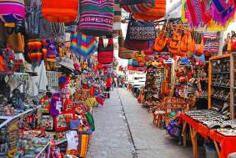
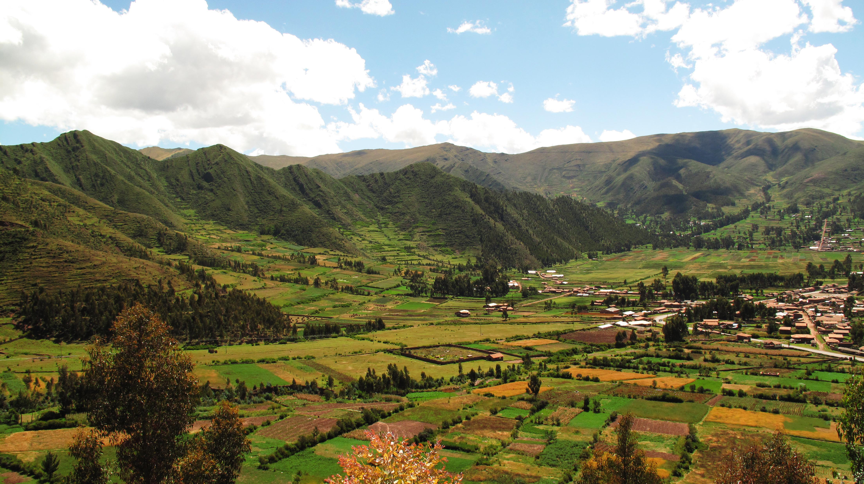
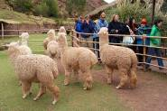

Day 08 – [Thu] - Sacred Valley (B/L/-)
Full day Maras Saltpans, Moray Terraces & Ollantaytambo (private)
Enjoy a journey through the Sacred Valley of the Incas, to the salt fields of Maras and its seemingly never-ending terraces, where salt extracted from springs is stored. Although these waters have been used for centuries, even before the time of the Incas, Maras was founded by the Spanish in 1556. It supplied salt to the southern highlands during the viceroyalty, so it was an important town. The use of Maras Salt dates back thousands of years and is inherited from generation to generation and managed communally.

It is produced naturally in about 5,000 pools of approximately 5 square meters each forming different levels of terraces, nourished by salty water from a creek that permeates the pools and then evaporated by the intense sun, forming thick crystals.

They are extracted once a month, as soon as they have reached a height of 10 cm. It is impressive to see the variety of colors created by the reflection of the sun’s rays in this field of salt deposits, and to learn about the Incas striking ability to generate resources.

Continue your excursion to admire the Moray terraces, believed to be a former gigantic agricultural laboratory, an astronomical observatory or a place of worship, or maybe all three. It is thought that Moray was used for plant adaptation to new climatic environments thanks to its circular terraces in immense cone-shaped depressions of 47 to 84 m that resemble giant fingerprints or contour lines. These create a series of microclimates at the different heights of the terraces, which enabled the Incas to experimentally improve a great variety of crops. Today, it is an evidence of the high level of agricultural knowledge they reached.

Lunch will be served at a local restaurant where you will enjoy a varied buffet lunch in an incredible setting.

Then, you will head to the Inca fortress and citadel of Ollantaytambo. This site was built just as the Spaniards arrived and evidence of how it was constructed is still visible.

This fortress was believed to be constructed in order to guard the entrance to this part of the valley and protect it from possible invasions of tribes from the jungle lowlands. Later it served as a temporary capital for Manco Inca, leader of the Inca resistance in 1537 during the Spanish conquest of Perú, who fortified the town to stop the advance, as Cusco had fallen under Spanish domination.

Ollantaytambo also features the vestiges of the town built by orders of Inca Pachacutec and thought to be not only a strategic military place to control the Sacred Valley of the Incas, but also for agricultural and religious purposes. Additionally, this place is a ceremonial center dedicated to the purification and worship of water with 150 steps built with perfectly carved stones. The archaeological site includes a series of superimposed terraces and stunning finely carved stone blocks located on the upper terrace or Temple of the Sun. The main settlement has an orthogonal layout with four streets crossed by other seven parallel streets and at the center the Incas built a large plaza about the size of four blocks.

The town of Ollantaytambo is referred to as a "Live Inca Town" because inhabitants still live according to customs and traditions inherited from their ancestors. Take a journey in time through its straight streets with perfectly laid stones that feature a canal for water to run through the town.

After the tour you will be transferred to your hotel. Overnight in the Sacred Valley
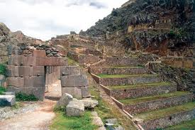
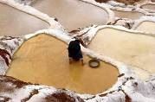
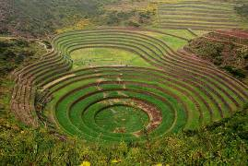

Day 09 – [Fri] - Cusco / Machu Picchu (B/L/-)
Full day excursion to Machu Picchu via roundtrip Vistadome train (private)
Morning transfer to the train station for an amazing train journey to the famous Inca Citadel of Machu Picchu, the great mountain-top city abandoned by the Inca Empire, reclaimed by the jungle and lost to humanity until its rediscovery in 1911.

Along the way you will enjoy the changing landscape as you travel from Andean highlands to the beginnings of the jungle (“eyebrow of the jungle”), before finally arriving at the town of Aguas Calientes.

From here, board the bus that will take you on a 20 minute ride up to the citadel of Machu Picchu, or Lost City of the Incas, which sits upon the summit bearing the same name, and is one of the most representative and recognized examples of Incan architecture. A guided tour of the Citadel includes the Main Plaza, the Circular Tower, the Sacred Sun Dial, the Royal Quarters, the Temple of the Three Windows and various burial grounds.

The legendary 'Lost City' is without a doubt one of the world's most impressive archaeological sites. Built by the Incas on the summit of "Machu Picchu" (old peak), overlooking the deep canyon of the Urubamba river in a semi-tropical area 120 Kms (75 miles) from the city of Cusco at 3,400 m.a.s.l (11,155 f.a.s.l).

It sits on a mountain site of extraordinary beauty, in the middle of a tropical mountain forest; Machu Picchu was probably the most amazing urban creation of the Inca Empire at its height, with its giant walls, terraces and ramps, which appear as though they have been cut naturally in the continuous rock escarpments.

Machu Picchu is also one of the Inca's best kept secrets, since they did not leave written records and Spanish chronicles make no mention of the citadel, it remains a mystery.

Buffet lunch at the Machu Picchu Sanctuary Lodge is included. Return to Aguas Calientes town. Overnight in Aguas Calientes
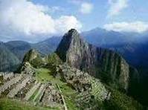
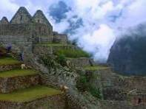
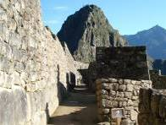

Day 10 – [Sat] - Machu Picchu / Cusco (B/-/-)
AM: At leisure
Excellent opportunity to wake up early and enjoy a beautiful sunrise as well as stroll around the Town of Aguas Calientes and visit its Hot Springs Thermal waters. Then, you will have time to perform some of the following activities (not included in the overall price): visit the Citadel of Machu Picchu for a second time, or for more active and adventurous people, we suggest to climb up the Huayna Picchu from where you can appreciate the immensity of Machu Picchu, even more amazing being so high and distant (no guide services included this day).

In the afternoon, return to Cusco by train and upon arrival at the train station you will be met by our representative and private driver for your transfer to the hotel. Dinner will be served at your hotel. Overnight in Cusco

Day 11 – [Sun] - Cusco / … (B/-/-)
AM: Cusco Walking City tour (private)
Today you will enjoy a guided tour of Cusco, the Imperial City, where you will admire the finest examples of Inca history and architecture. What a better way to discover the archaeological capital of South America, a city of stone streets, than walking!

Visit the city's most important historical monuments that reveal the influence of different cultures: The Plaza de Armas, the Cathedral dating from Spanish viceroyalty times, built with great slabs of red granite renaissance style in contrast with the baroque style silverwork of its interior and, the Santo Domingo church built upon the foundations of the Inca Temple Koricancha, dedicated to worship the Sun God (only Mon thru Sat).

After the visit you will walk back to your hotel.

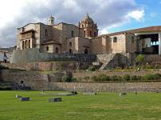
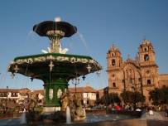
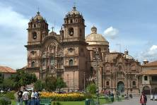

PM: Transfer Hotel / Airport (private)
At the appropriate time, you will be transferred to the Cusco Airport for your international departure flight; assistance with all departure formalities.

End of services

B: breakfast / L: Lunch / D: Dinner / BL: Box Lunch

2016 GROSS RATES

3 stars | Per person | Sharing double/twin | Single Supplement
 | 2 pax | USD 2,264.00 | USD 624.00
 | 3 pax | USD 1,980.00
 | 4 pax | USD 1,825.00
 | 5-9 pax | USD 1,751.00
 | 10-14 pax | USD 1,561.00

4 stars | Per person | Sharing double/twin | Single Supplement
 | 2 pax | USD 2,515.00 | USD 840.00
 | 3 pax | USD 2,231.00
 | 4 pax | USD 2,077.00
 | 5-9 pax | USD 2,003.00
 | 10-14 pax | USD 1,812.00

5 stars | Per person | Sharing double/twin | Single Supplement
 | 2 pax | USD 3,085.00 | USD 1,334.00
 | 3 pax | USD 2,801.00
 | 4 pax | USD 2,647.00
 | 5-9 pax | USD 2,572.00
 | 10-14 pax | USD 2,383.00

-Additional for second entrance to Machu Picchu + second roundtrip bus ticket to/from Aguas Calientes on Day 04: USD 72.00 net per person, subject to change (no guide services included)

-Additional for second entrance to Machu Picchu + entrance to Huayna Picchu + second roundtrip bus ticket to/from Aguas Calientes on Day 04: USD 80.00 net per person, subject to change (no guide services included)

-Additional for twin accommodation may apply depending on the hotel category that is chosen. Please verify.

INFORMATION

NOTES
- No reservations have been placed
- This is a preliminary costing; hotels may vary according to availability
- All services stipulated above are subject to availability at the time of booking/ reservation
- No airfare nor airport taxes included in above given rates
- Air fares are referential only. Actual rates are subject to availability at time of purchase and type of ticket (refunds and changes allowed/not allowed, penalties apply/not apply, etc). Tickets are non-refundable and non-endorsable in case of cancellation

Route | Flight | Frecuency | Depart | Arrives
Bogotá - Cusco | AV 145 | Monday, Wednesday, Friday | 7:44 | 10:53
Cusco - Lima | AV 842 | Monday, Wednesday, Friday | 11:50 | 13:15
Lima - Cusco | AV 843 | Monday, Wednesday, Friday | 14:00 | 15:25
Cusco - Bogotá | AV 144 | Monday, Wednesday, Friday | 16:01 | 19:14

- All entrance fees are subject to change without previous notice.
- Important: On the train journey to Machu Picchu, you will be limited to one piece of luggage weighing no more than 11 ponds and a total linear dimension (length + width + height) of 62 inches. You may keep excess luggage at your hotel in Cusco city
- For payments with credit card, we are forced to charge 5% more out of the total price due to bank fees
- Rates valid for 2016, except on Inti Raymi dates (Jun22/27), Christmas & New Year (Dec23/Jan02), Easter Holiday Weekend and any other National or Religious Holidays which may have special rates; please verify
- Rates are subject to change without prior notice in case supplier conditions change and/or if there are USD exchange rate variations in Peru
- Tax exemption in hotels in Colombia will only apply to foreigners who enter the country for tourism and leisure purposes; this means that all passports must be marked with the tourism stamp (different from business stamp) when passing through immigration. Metropolitan Touring Colombia won’t be responsible for the lodging taxes if and when passengers enter the country with a different stamp.

INCLUSIONS
- Private services with local English speaking guides as indicated in the itinerary except where otherwise specified
- All entrance fees to the sites mentioned in the itinerary
- Meals: As indicated in the itinerary
- 01 Roundtrip train ticket to Machu Picchu via Vistadome coach per person
- 01 Entrance ticket to Machu Picchu per person
- 01 Bus ticket to and from the Machu Picchu ruins per person
- 04 nights’ accommodation
- All tips (except hotel staff & guides); additional tips are optional and voluntary. However, the following amounts may be uses as guidelines:
  - Guide/transferman: USD 5.00 per guest per day
  - Driver: USD 2.00 per guest per day
  - Restaurant Tips: 10% of the total check
- Permanent assistance during the trip

EXCLUSIONS
- International air fares or domestic air fares
- Meals or any other item not described in the itinerary
- Early check-in, late check-out, services and non-mentioned meals in the itinerary
- Personal expenses
- Drinks during meals, hotel extras and personal spending
- Tips for hotel staff
- Local VAT taxes (18% applicable only to Peruvian and foreign residents of Peru; in order to be exempted you will need to show your passport)
- Health and travel insurance

HOTEL INFORMATION

Colombia:

3* | City | Hotel name | Room category
 | Bogotá | Virrey B3 Hotel or similar | Standard
 | Cartagena | Kartaxa Hotel or similar | Standard
 | Bogotá | Movich Buró26 or similar | Standard

4* | City | Hotel name | Room category
 | Bogotá | Cité Hotel or similar | Deluxe
 | Cartagena | Anandá Boutique Hotel or similar | Superior
 | Bogotá | Movich Buró26 or similar | Standard

5* | City | Hotel name & web link | Room category
 | Bogotá | Sofitel Victoria Regia or similar | Superior
 | Cartagena | Bastión Luxury Hotel or similar | Bastión Superior
 | Bogotá | Movich Buró26 or similar | Standard

Perú:

3* | City | Hotel name | Room category
 | Sacred Valley | Inkallpa Sacred Valley or similar | Standard
 | Aguas Calientes | El Mapi or similar | Superior Deluxe
 | Cusco | Portales Hotel Cusco or similar | Standard

4* | City | Hotel name | Room category
 | Sacred Valley | Sonesta Posadas del Inca Yucay or similar | Standard
 | Aguas Calientes | El Mapi or similar | Superior Deluxe
 | Cusco | Sonesta Hotel Cusco or similar | Standard

5* | City | Hotel name & web link | Room category
 | Sacred Valley | Aranwa Sacred Valley or similar | Deluxe
 | Aguas Calientes | Sumaq Machu Picchu or similar | Superior Deluxe
 | Cusco | JW Marriott El Convento Cusco or similar | Classic Inca Wall

